
In the name of God, Most Gracious, Most Merciful

Judgment Day

Zakaria Kamal

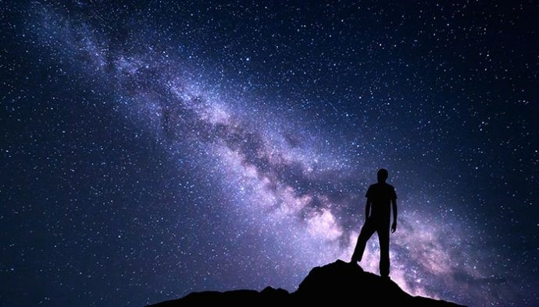

www.alqurantafsir.com

_{Notice}
Any that will not claim any right can do the followings:
- Can print, publish, distribute and sale the book.
- Can translate in any language and can print, publish, distribute and sale this book.
- Can correct spelling and grammatical mistakes before publishing except in cases of Arabic words written with English alphabets.
- Can use parts of this book in own writings with or without referring the book.
- Can quote parts of this book with or without referring the book.
No permission will ever be required to do the above.
- [A Publisher may remove the Notice while publishing the book]

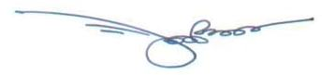
Zakaria Kamal (Author)
Ph: 8801913960069
zakaria.kamal@gmail.com
Present Address: HA-27, East Merul, Badda,
Dhaka-1212, Bangladesh.
Permanent Address: Village- Hoglakandi,
Post Office- Jhitka, PS- Horirumpur,
District- Manikganj, Bangladesh

CONTENT

CHAPTER | SUBJECT | PAGE
1 | General Appearance of the Universe | 8
2 | Origin and Evolution of the Universe | 20
3 | Future of the Universe | 64
4 | The Jannaat (Paradise) | 81
5 | Fire of Hell | 104
6 | Skies | 147
7 | Arsh | 179
8 | Qiyamah (Doomsday) | 184
9 | The Final Judgment | 230

Note

The Chapters are not independent; please read sequentially from the beginning.
Introduction

The book puts religion and science in a single framework to probe into the deepest future where one can form a perfect vision of the Judgment Day and the Afterlife.

Theme of the Book

1. The Universe is expanding:

“And the Sky (Universe), We constructed it with Support, and indeed We surely are Expanders” [Al Quran 51:47]

“What! Are you more difficult to create, or the Sky (Universe)? He has constructed it. He has raised its thickness and proportioned it. Its night does He endow with darkness, and its splendor does He brings out...”
[Al Quran 79: 27–33]

2. The Universe will collapse to the state of Big Crunch, as the following Verse indicates:

“On the day when We will roll up the Skies (Universe) like the rolling up of the scroll for writings…” [Al Quran 21:104]

Subsequently, the Universe will revive. The initial reviving universe is the point of the Resurrection. The resurrected humans will be assembled in a specially created land (Land of Judgment) in the Super Space, and the Final Judgment will be carried out:

“And not they honored Allah—true honor—while the Land (Land of Judgment) is assembling in His hand on the Day of Resurrection and the Skies (Samawaat / the Universe) rolled-up in His Right Hand. Glory be to Him! And high is He above what they associate.”
[Al Quran 39: 67]

3. The Quran mentions that there is another universe (Jannaat) beyond this universe (Samawaat / Samawaat-wal-Ard):

“Be quick in the race for forgiveness from your Lord and for a Jannaat (another Universe), whose width is that of the Skies and Lands (Samawaat-wal-Ard / this Universe), prepared for the righteous…” [Al Quran 3:133]

“Race to forgiveness from your Lord and the Jannaat (another Universe), the width of which is as the width of the Sky and Land (this Universe)” [Al Quran 57:2]

“Because only a few will be saved, God has created two universes, instead of only one”
[2 ESDRAS 7:50, Holy Bible, GNB]

After the Judgment, a part of mankind will be shifted to the Jannaat where they will live forever in peace and satisfaction, as empowered Vicegerents of God. Their verbal orders will be materialized instantly.

4. The sinners will be left in the Land of Judgment. Subsequently, they will be thrown into the reviving Universe.
The super compact galaxies will revive just by gaining the volumes of space. Each reviving galaxy will capture a sinner. The sinner will live in the galaxy forever in disasters and pains, as a forgotten Vicegerent of God. He will not have any divine power:

“Allah created the ‘Skies and Lands’ (Samawaat-wal-Ard / this Universe) for just ends, and in order that each soul may find the recompense of what it has earned and none of them be wronged.”
[Al Quran 54:22]

“We created not the ‘Skies and Lands and all between them’ (this Universe) merely in sport. We created them not except for just ends. But most of them do not understand. Verily, the day of sorting out is the time appointed for all of them.”
[Al Quran 44:38–40]

“It will also be said: “This day We will forget you, as ye forgot the meeting of this day of yours! And your abode is the fire, and no helpers have ye!”
[Al Quran 54:34]

5. It is the Master Plan of Allah: To create, develop and delegate His vicegerents (human beings) throughout the creations, the Jannaat and the Samawaat, with a view to infuse life in the universes, deploy intelligence and freedom of thought in the creations, and open a flexible and interesting way of ruling.
The matter will be amply clear in subsequent Chapters. The Book narrates the Creation, Evolution, Dooms Day, Resurrection, Judgment and Salvation in a well-planned chronology on the basis of the Quran and Science.

CHAPTER 1: General Appearance of the Universe

Scientific elaboration of the Final Judgment is a complex subject. The last Chapter of this book narrates the Final Judgment. The preceding Chapters give the background knowledge required to read the Last Chapter.
In this Chapter, the general appearance of the Universe is discussed. It is prepared for the readers who may not know the basic structures of the Universe. The subject is presented in the following sequence:
1. The Solar System
2. The Milky Way Galaxy
3. Other Galaxies
4. Group, Cluster, Super-Cluster
5. Orientation
6. Conclusion
7. Summary
The Chapter is inspired by Bertrand Russell who described the 'General Appearance of the Universe' in similar fashion in his book, “ABC of Relativity”.

1. The Solar System

Our Earth is one of the planets of the Solar System. The shape of the Earth is like an orange. It spins on its axis once in a day and revolves around the Sun once in a year.

The Solar System comprises eight planets and their moons, three dwarf planets (Ceres, Pluto, Eris) and their moons, billions of small bodies (asteroids), free dust and gas. These are bound to the Sun by gravity.

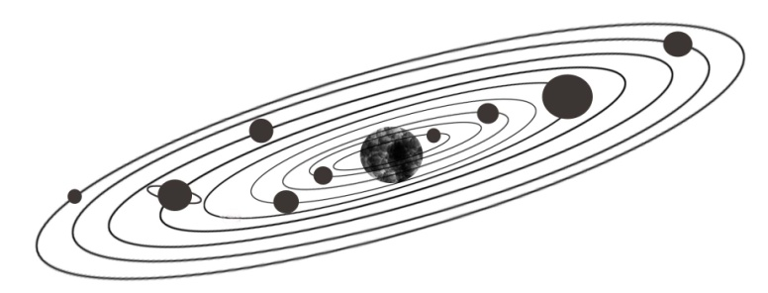

FIGURE 1.1: Solar System

2. Milky Way Galaxy

The stars are not haphazardly scattered throughout the space. They are grouped into systems called galaxies.
The galaxy in which our Solar System is located is called Milky Way Galaxy. There are about two hundred billion stars in this system. The Sun is a medium size yellow star among them.
There are huge quantities of free dust and gas scattered in the interstellar space of the galaxy. These free dust and gas would be enough to produce another twenty billion stars.
The stars, free dust and gas form a central hub (nucleus) and several spiral arms. The whole galaxy is slowly rotating in the space like a giant Catherine wheel.
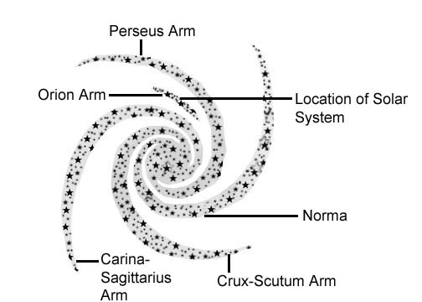

FIGURE 1.2: Milky Way Galaxy (Overhead View)

The average distance between the stars is four light years (one light year is ten million-million kilometers, approximately). The galaxy measures one hundred thousand light years from edge to edge. The central hub is twenty thousand light years in diameter.
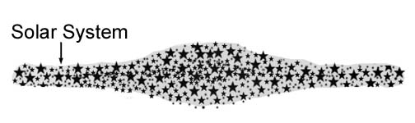
FIGURE 1.3: Milky Way Galaxy (Side View)

The width of the galaxy is ten thousand light years at the center and two thousand light years at the edge.
The scientists predict that every galaxy holds a super-massive black hole in its center.
Our Solar System is located in the Orion Arm (also called Orion Spur). It is a small arm between Perseus and Carina-Sagittarius Arms (see figure 1.2). The distance of the Solar System from the galactic center is twenty-six thousand light years, approximately.
As the galaxy is rotating, the Solar System is speeding at a rate of 220 km per second. Despite the enormous speed, the galaxy is so huge that one complete orbit takes about two hundred million years.

3. Other Galaxies

There are many galaxies in the Universe. The galaxies are called “Mawaqin-Nujumi” in the Quran. “Mawaqi” means “Houses” and “Nujumi” means “Stars”. So, “Mawaqin-Nujumi” means “Houses of Stars”. It is only a galaxy that can be called a house of stars. So, “Mawaqin-Nujumi” means “Galaxies”.

“But nay, I swear by the Houses of Stars (Mawaqin-Nujumi). And, indeed it surely a swear, if you know great (structures)”
[Al Quran 56: 75–76]

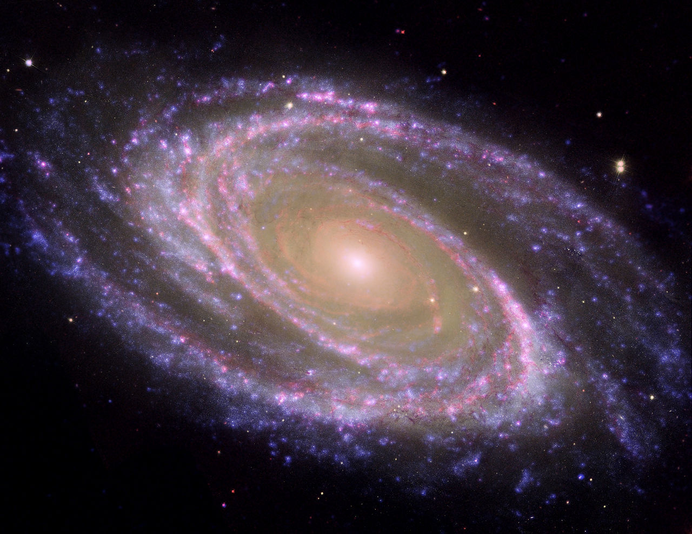

FIGURE 1.4: A House of Stars (Galaxy M81)

In the Quran, a galaxy is called a “ship” as well:

“It is He Who created the Night and the Day, and the Sun and the Moon; each in a Ship (Milky Way Galaxy) they are floating.” [Al Quran 21:33]

“It is not permitted to the Sun to outstrip the Moon, nor can the Night outstrip the Day. And all are in a ship (Milky Way galaxy) they are floating.”
[Al Quran 36: 40]

In above Verse, the “ship” means “Milky Way Galaxy”. A galaxy is a giant space-ship, floating in the space and carrying the stars.
Humans had no idea about the galaxies when the Quran was revealing. The galaxies were discovered in 1920s when people began to know the great structures of the Universe. During this time, an American Astronomer, Edwin Hubble, demonstrated that the Milky Way was not the only galaxy in the Universe. There are many others. Depending on the shape, Hubble classified the galaxies into four types:
- Elliptical galaxy
- Spiral galaxy
- Barred Spiral galaxy
- Irregular galaxy

3a. Elliptical galaxy

The Elliptical Galaxies are oval shaped galaxies.

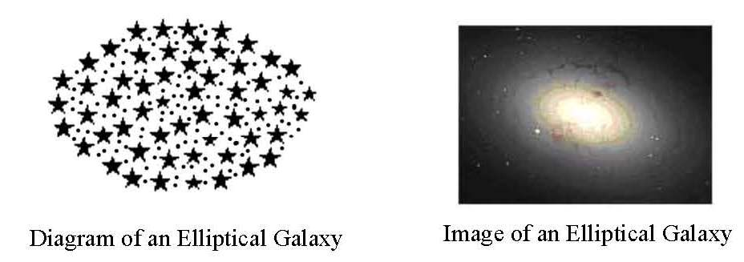

FIGURE 1.5: Elliptical Galaxy

3b. Spiral Galaxy

The Spiral Galaxies swing out arms from their central hubs.

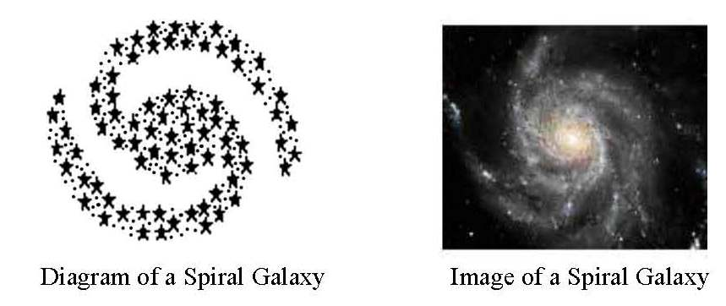

FIGURE 1.6: Spiral Galaxy

3c. Barred Spiral Galaxy

A Barred Spiral Galaxy looks like a Spiral galaxy, but it has a bar across its center. The spiral arms begin from the ends of the bar.
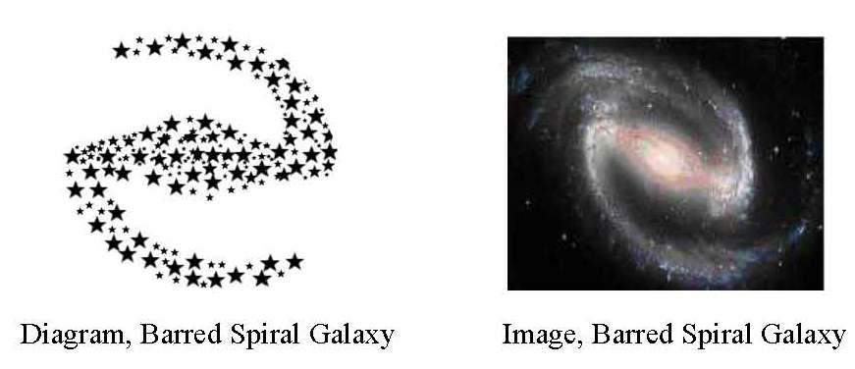

FIGURE 1.7: Barred Spiral Galaxy

3d. Irregular Galaxy

The Irregular Galaxies have no particular shape. These are normally smaller bodies.
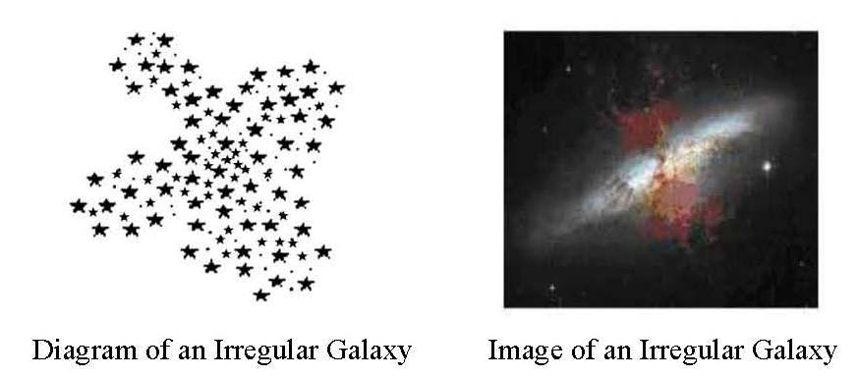

FIGURE 1.8: Irregular Galaxy
There are about 170 billion galaxies in the visible universe. A large galaxy may contain 100 trillion stars when a dwarf galaxy contains as few as ten million.
The galaxies are in general 3,000 light years to 300,000 light years in diameter.
The typical distance between two neighboring galaxies is 3 million light years.
Scientists predict that the visible universe is 92 billion light years across (including co-moving distance).

4. Group, Cluster, Super-Cluster

The galaxies show distinct tendency to be collected into groups. The smallest concentration is called “Group”. A Group generally contains less than fifty galaxies. The Milky Way Galaxy belongs to a Group called “Local Group”. There are about thirty-two galaxies in the Local Group.
The Clusters are bigger formations. A Cluster may contain several thousand galaxies. The Local Group belongs to the Virgo Cluster. The Virgo spans about one hundred and ten million light years and contains about two thousand galaxies.
Clusters, Groups, and additional isolated galaxies together form a Supercluster, e.g., Hydra-Centaurus Supercluster, Coma-Virgo Supercluster, etc. There are about ten million Superclusters in the visible universe.
There are further types of concentrations, such as “Walls” and “Filaments”, discussed in this book later.
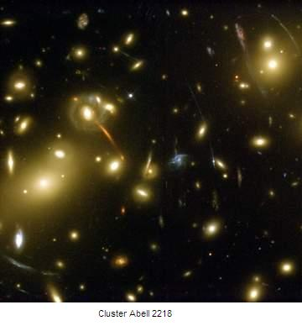

FIGURE 1.9: Cluster Abell

5. Orientation

We see many stars in the night-sky. It seems innumerable. In fact, in a clear dark night, maximum three thousand stars become visible to the naked eye. From two hemispheres of the Earth, maximum six thousand stars can be seen without a telescope, whereas Milky Way Galaxy possesses two hundred billion stars, approximately. We see a very small part of the galaxy. And, because we are located inside the galaxy, we see these visible stars scattered throughout the space. Mainly, this is our “Naked eye Universe”.
From northern hemisphere of the Earth, we see a long glowing band of light in the night-sky. It is a part of the Perseus Arm. It glows due to the lights of innumerable stars extending in that direction. The Arm is seven thousand light years away from the Earth.
From Southern hemisphere of the Earth, one observing toward the galactic center with a telescope can see a part of the Carina-Sagittarius arm laid at about the same distance (7000 LY).
Four neighboring galaxies are visible to the naked eye. Due to huge distances, they look like faded dots in a clear dark night. From Northern Hemisphere of the Earth, M 31 (Andromeda) is visible like a faint fuzzy patch. It is a Spiral Galaxy located at about 2.5 million light years away from the Earth. Another, M 33, is smaller than Andromeda and harder to see. The M 33 is a Spiral Galaxy. It is located at about 2.3 million light years away. From the Southern Hemisphere of the Earth, two Irregular Galaxies, namely “Large Magellanic Cloud” and “Small Magellanic Cloud”, are faintly visible to the naked eye.
Each night the stars seem to sweep across the sky due to the rotation of the Earth on its axis. At the same time, due to the yearly rotation of the Earth around the Sun, everyday a part of the day sky enters the night sky, and a part of the night sky goes behind the sunlight. Therefore, the appearance of the sky changes night to night (4 minutes per night). If one will not consider these apparent movements, one will find the stars static.
But, actually, the stars are not static; if one could go out of the Milky Way galaxy quite a big distance, one could see the entire galaxy, slowly rotating in the space.

6. Conclusion

The advent of great telescopes has extended our horizon far beyond our imagination. But, so far a boundary could not be distinguished beyond which there be no galaxy. The farther cosmologists are able to observe, the more galaxies are discovered. Therefore, the volume of the Universe is not known.
Moreover, no reliable way could be found out so far to measure the distance of a galaxy. Therefore, it is not possible to draw the structure of the overall Universe.
The scientists assume that the matter is uniformly (homogeneously) distributed throughout the space when averaged over a very large distance—that is the same number of galaxies occupies a large part of the Universe as any other large part. They assume that the Universe is isotropic too, where no direction of observation should seem different from any other direction. The hypothesis, that the Universe is uniform and isotropic, is known as the Cosmological Principle.
However, it is an old assumption, introduced by some scientists, including Einstein, to apply gravitational dynamics to the Universe as a whole. In reality, the Universe may not look same from all points.

7. Summary

The Universe is full of galaxies with vast tracts of empty space between them.
There are many stars, free dust and gas inside a galaxy. Our Solar System lies in a galaxy called Milky Way Galaxy.
The galaxies show a distinct tendency to be collected into Group, Cluster, Supercluster, etc.
The Universe is unimaginably huge.

Ref:

- Russell, Bertrand. A B C of Relativity. New York, United States: Harper Brothers.
  - Henbest, Nigel. The Framework of The Stars in The Encyclopedia of Space Travel and Astronomy edited by John Man. Great Britain, Octopus Books Limited, 59 Grosvenor Street, London, 1979.
CHAPTER 2: Origin and Evolution of the Universe

In previous Chapter, I have discussed the General Appearance of the Universe. In this Chapter, I shall discuss how the Universe is created.
The Quran is not meant to teach the theories of creation; it is a Book of religion. The Quran talks about the creation in bits and pieces in context of praising the Creator with a view to acquaint us with Him. It talks about the Future of the Universe in context of the Final Judgment mainly. I have put these Verses in the creation story of the Universe. If one removes the Verses and religious talks, one will find the story deeply inspired by “The Encyclopedia of Space Travel and Astronomy” edited by John Man.
Past helps to predict the future. In subsequent Chapters, knowledge of this Chapter will help us predict plausible future evolution of the Universe. It will help us understand how the Universe is heading toward the Doomsday. Should the nature of space-time allow the Resurrection of the Dead? Does the Universe possess any hell? Is there any everlasting paradise?
Several landmark discoveries of 20th Century enable us to describe how the Universe is evolving. The discoveries have given rise to many theories. I have used the common frame of the theories. Accordingly, the discussion will progress as under:
1. Receding Galaxies
2. Expanding Universe
3. Mystery of Darkness
4. Singularity
5. Radiation
6. A Soul Single (Nafsin-Wahidatin)
7. Smoke
8. Formation of Skies and Galaxies
9. The Creator
10. Conclusion
11. Summary

1. Receding Galaxies

In 1920s, Edwin Hubble demonstrated that the galaxies were moving straight backward. Hubble carried out his experiment on many galaxies in different directions and depths. He found all distant galaxies were receding. It showed that the Universe was expanding.
This discovery has introduced the modern idea about the Universe. Because of this magnificent discovery, Edwin Hubble is sometimes called Modern Galileo. In his honor the first space telescope has been named “Hubble’s Telescope”.
The discovery has opened the door of understanding the Quran’s Model of the Universe. The following Verse says that the galaxies (ships) are receding:

“So verily I swear by the receding ships disappear—and the night, as it departs; and the dawn, as it breathes.”
[Al Quran 81: 15–18]

In above Verse, “receding ships” means “receding galaxies”.
In the Quran, the galaxies are called Mawaqin-Nujumi (Houses of Stars), but it is called a ship as well.

“But nay, I swear by the Houses of Stars (Mawaqin-Nujumi). And indeed, it surely a swear, if you know great”
[Al Quran 56:75-76]

“It is not permitted to the Sun to outstrip the Moon, nor can the Night outstrip the Day. And all are in a ship (Milky Way galaxy) they are floating.”
[Al Quran 36:40]

“It is He Who created the Night and the Day, and the Sun and the Moon; each in a Ship (Milky Way Galaxy) they are floating.” [Al Quran 21:33]

At a large distance, the lateral movement of an object is noticeable, but if it moves straight forward or backward, it seems static. The galaxies are moving straight backward. Therefore, in normal telescopes they appear to be fixed.
The recession of a galaxy can be detected by a telescope fitted with spectroscopy, where Doppler Shift shows how fast the object is receding.
“If a train is moving towards you then the pitch of its whistle is higher than if it is standing still, while if it is moving away from you, the pitch are lower. The effect is very similar in the case of light. If the source of light is moving towards you, then the whole spectrum of the light is shifted towards the violet, if the source is moving away from you, the whole spectrum are shifted towards the red. The amount of the shift depends on the speed of the source of light relative to you”
– ABC of Relativity by Bertrand Russell.
To explain further:
The light is a kind of wave. Lights with different wavelengths (different frequencies) create sensations of different colors in our eyes, e.g., the red light has longer wavelength (lower frequency) than the blue light.
The light with longer wavelength bends less when it changes a media, e.g., the red light bends less than the blue light.
Therefore, when the sunlight passes through a prism, the lights of different colors change the direction by different amounts and produce a spectrum of light, as seen in a rainbow.
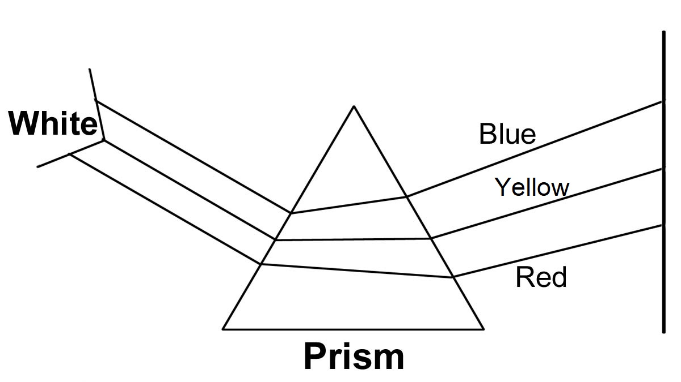

FIGURE 2.1: Spectrum of Light

When a wave moves through the surface of the water, its wavelength gradually increases. The phenomenon is known as the Doppler Effect. The effect is similar in case of light.
Therefore, if a spectrum of light is moving toward the red side, the wavelengths of the lights are increasing. And if the wavelengths are increasing, the source of the light must be receding. The rate of shift indicates the recession velocity.
“The speed of recession of nearby galaxies measured in this way is about 300 miles per second. This is very fast by our every day standard, but because of the great distance between the galaxies it would be millions of years before there was any noticeable change in their position” – ABC of Relativity by Bertrand Russell.
It may be mentioned that a few nearby galaxies are approaching Milky Way galaxy. It is a local phenomenon. All distant galaxies are receding.

2. Expanding Universe

All distant galaxies are receding. The recession velocities are exactly proportional to their distances. The farther away a galaxy is, the faster it is moving away.
The nearby galaxies are receding at 200 to 300 miles per second. On the other hand, the farthest galaxies, discovered so far, are receding at speeds nearing the speed of light. This observation indicates that the Universe is expanding.

“And the Sky (Universe), We constructed it with Support, and indeed We surely are Expanders” [Al Quran 51:47]

The rate of expansion is expressed as “Hubble’s Constant”.
“Hubble’s constant, as it is known, it is estimated at between 50 and 100 kilometers per second per mega-parsec. In other ward, for every 75 km per second of measured recession velocity, a galaxy is about 1 megaparsec (3.25 million light years) away from us.”
– The Expanding Universe by John Gribbin in The Encyclopedia of Space Travel and Astronomy edited by John Man
“Hubble’s discovery suggests a curiously egocentric picture in which all the galaxies seemed to be receding from our own Milky Way galaxy. So we may be inclined to think that the Milky Way is at the center of the universe. The idea may also be wrong because, with each galaxy moving further away from every other, produces just the same kind of picture where ever you happen to be in the universe.”
– The Expanding Universe by John Gribbin in The Encyclopedia of Space Travel and Astronomy edited by John Man

3. Mystery of Darkness

"See they not We have made the night for them to rest in and the day to give light. Verily, in this are signs for any people that believe” [Al Quran 27: 86]

Before Hubble’s discovery, the scientists had the idea that the Universe was static. A static universe is a universe that does not expand or contract.
Newton discovered gravitational force. It showed that a static universe would collapse due to gravitational attraction. So, the scientists were trying to explain how a static universe could avoid gravitational collapse. They guessed that the Universe was infinite and the gravitational force was repulsive at a very large distance.
“Even those who realized that, Newton’s theory of gravity showed that the universe could not be static, did not think to suggest that it might be expanding. Instead, they attempted to modify the theory by making the gravitational force repulsive at a very large distance. This did not significantly affect their predictions of the motions of the planets, but it allowed an infinite distribution of stars to remain in equilibrium with the attractive forces between nearby stars balanced by the repulsive force from those that were farther away. We now believe such equilibrium would be unstable; if the stars in some region got only slightly nearer each other, the attractive forces between them would become stronger and dominate over the repulsive forces so that the stars would continue to fall towards each other. On the other hand, if the stars got little farther away from each other, the repulsive forces would dominate and drive them farther apart”
– A Brief History of Time Stephen Hawking.
A static universe had to be infinite where the attractive forces between nearby objects could be balanced by the repulsive forces of those that were farther away. Moreover, an infinite universe would not have a center to collapse.
The concept of “Infinite Static Universe” implied that the Universe existed forever. So, the idea of creation and a Creator was meaningless.
In nineteenth century and early twentieth century, the idea of “Static Infinite Eternal Universe” coupled with the “Darwin’s (1809-1882) Theory of Biological Evolution” gave a viable philosophical basis to the Marxism formulated by Marx (1818-1883) and Engels (1820-1895). Many so-called Progressive People became Atheist and headed to the hell after death.
In those days too, when the advanced instruments of Cosmology were not invented, the Quran was calling to look into the darkness of night to perceive the reality. The existence of dark nights was countering the concept of “Static Infinite Eternal Universe”:
In a “Static Infinite Eternal Universe” there would be infinite number of stars. And the ‘infinite number of stars’ would be emitting light. Energy has no destruction. The lights emitted by the stars would come to the Earth at some time. And once the light of a star had arrived, it would continue to come forever. Then, our every line of sight would end on the surface of a star, and the whole sky would appear as bright as the sun—the Universe would be infinitely bright.
But the reality was different. There were dark nights and sunlit days. Where the light was going? How the Universe was dark? In 1826, it was thought up by a German astronomer, Wilhelm Olbers.
“The key question - a deceptively simple one was asked by a man who we might justly regard as the first cosmologist: de Cheseaux (1744). It was he who first wondered why a supposedly infinite universe full of bright stars should be dark at night. Alas for de Chesaux no one else at that time seemed able to realize the significance of his question. It was thought up again independently by a German astronomer Wilhelm Olbers in 1826. For this reason, the puzzle is known “Olber’s Paradox””
– The Expanding Universe by John Gribbin in the Encyclopedia of Space Travel and Astronomy edited by John Man.
“To look at the problem, imagine thin layers, or shells of stars surrounding the Earth. The intensity of light from all stars in any one shell can easily be worked out. The distance cancels out the increase in star light. Never the less in an infinite universe, there would be an infinite number of shells so that we might guess that the universe should have an infinite bright sky. In fact, though nearby stars block out some of the light from further away when this is taken into account, we can say that the night sky should be ‘only’ as bright as the surface of an average star in total, just 40,000 times the brightness of the Sun at noon. The puzzle is not therefore, why is the sky dark at night. It is why the sky is so dark even in day time.
– The Expanding Universe by John Gribbin in the Encyclopedia of Space Travel and Astronomy edited by John Man.
The sky should have been crammed with the stars forming a carpet far brighter than the Sun.
With the Concept of “Static Infinite Eternal Universe” in mind, nobody could answer why the nights were dark—it was a paradox; it became known as the “Olber’s Paradox”.
In 1929, the paradox was resolved when Edwin Hubble demonstrated that the Universe was expanding. Expansion solves the problem. As the Universe is expanding, the light and heat emitted by the stars are spreading out to fill the increasing space. It effectively weakens the light to cause the darkness of night.
“Expansion solves the problem. The light and heat from all the objects in the sky has to spread over more thinly into the void to fill the increasing space between them. This effectively weakens the light, lowering the density of the energy of starlight- the brightness of the sky- everywhere. The faster each light source recedes, the weaker its contribution will be, and in a universe with the more distant shells receding more rapidly than those nearby, only the very nears are left making any noticeable contribution to conditions here on the Earth.”
– The Expanding Universe by John Gribbin in the Encyclopedia of Space Travel and Astronomy edited by John Man.
If the Universe was static, there would be no night; always there would be forty thousand times brighter light than the sun at noon. Darkness exists because the Universe is expanding. In other words, only an expanded Sky can be dark at night.

“What! Are you more difficult to create, or the sky? He has constructed it. He has raised its thickness and proportioned it. Its night does He endow with darkness, and its splendor does He bring out”
[Al Quran 79: 27–29]

Only Hubble’s discovery was not enough to confirm that the Universe was expanding. Some scientists were arguing that there might be some unknown reason for the Red Shifts of lights coming from other galaxies. But, only way to get the solution of the Olber’s Paradox was to accept that the Universe was expanding.
Now it is said that long before Hubble’s discovery, the scientists should have understood the expansion of Universe, only by the Olber’s Paradox, because the nights can be dark in an expanding universe only.

“And a Sign for them is the Night—We withdraw there-from the Day, and behold they are plunged in darkness”
[Al Quran 36:37]

The Universe is expanding. So, the lights emitted by the galaxies are fading out in the expanding space. So, there is darkness everywhere; and once the sunlight is withdrawn by rotating the Earth, we plunge in darkness.
The receding ships (galaxies) are disappearing. So, the light everywhere is fading out to the darkness of nights. So, a dawn can appear:

“So verily I swear by the receding ships (galaxies) disappear—and the night, as it departs; and the dawn, as it breathes.
Verily this is the word of a most honorable Messenger, endued with Power, with rank before the Lord of the Arsh. With authority there; faithful to his trust; and your companion is not one possessed”
[Al Quran 81: 15–22]

4. Singularity

The Universe is expanding. The galaxies are going away from each other. Then, it is obvious that they were closer to each other in any earlier point of time. Yesterday they were closer than today. The day before yesterday they were even closer. In this way, at some point of time, far enough into the past, all the galaxies of the Universe were joined together into a small volume of space. And, the expansion of the Universe might have started from a great original explosion.
For, as many astronomers were quick to see, if the universe is expanding now, then it must have started form some great original explosion. This is the Big Bang model of the universe.
– The Expanding Universe by John Gribbin in The Encyclopedia of Space Travel and Astronomy edited by John Man

“Do not the unbelievers see that the Skies and Lands were joined together (as one unit of creation) before We clove them asunder” [Al Quran 21:30]

The separation of galaxies and the rate of expansion suggest that the Universe came into existence 8,000 to 14,000 million years ago from the explosion of Big Bang.
“By timing the expansion of universe, we can now say that it came into existence no longer than 20,000 million years ago in a monumental fire ball that provided raw material from which galaxies, stars and planets are still formed. We see around us the effect of that violent birth. The galaxies as we know form studying energetic dense quasar like 3c 273 are fleeing from us at speed up to 80 percent of the speed of light.”
– The Encyclopedia of Space Travel and Astronomy edited by John Man.

The scientists predict that the Universe began as a “Singularity”. The “Singularity” is defined as a “super-hot, super-dense point of space-time”. The Singularity at the beginning of the Universe is called Big Bang.
Of course the fact that the universe is expanding implies that at some point in the past, all the objects in it were closer together. But we see very clear evidence that the universe we know today began as a super dense, super hot, ‘Singularity.”
– The Encyclopedia of Space Travel and Astronomy edited by John Man.
The entire matter of the Universe was closed into the Singularity. The matter could not exist in that state; it was in the form of energy. As the Universe expanded, the temperature reduced, and the radiation turned into matter.
The “Singularity” is a mathematical point; it is a controversial starting state of the Universe. In modern science, there are many models of the starting state. The above Verse does not exactly indicate a state of Singularity; it only indicates a state when the Universe was very small and the objects in it were joined together. So, it stands out of controversies.
The Universe might have begun from a “Singularity”, or from a “tiny false vacuum under extreme inflation”, or from something else; so far it started from a state of unity, it satisfies above Verse.

5. Radiation

The Big Bang left a residue of radio noise known today as Cosmic Microwave Background Radiation (CMBR). The Discovery of CMBR has demolished the idea of Static Universe completely. It is considered as the most remarkable scientific advancement made in modern times.
There is one piece of evidence, which seems to have settled the issue once for all. It is the most remarkable scientific observation made in modern time, equaled in philosophical importance only by Olber’s Paradox. This observation was made by radio astronomers, and it was again a breakthrough of the 1960s although with hindsight it is difficult to understand why it wasn’t made at least ten years earlier. The discovery was of cosmic radiation that permeates all of space and is a distant cosmic echo of the Big Bang itself. With that as evidence, who could remain a steady stater?
– To the Edge of Eternity by John Gribbin in The Encyclopedia of Space Travel and Astronomy edited by John Man

The Big Bang not only produced matter; it released a tremendous blast of radiation, detectable today as background radio-noise. Scientist George Gamow predicted its presence in 1948 and then Ralph Alpher and Robert Herman in 1950. As the Universe has expanded, its intensity has reduced. Princeton University theorist P.J.E. Peebles calculated that the radiation would be less than 10 degree K at present.
In 1964 Arno Penzias and Robert Wilson, two Radio Astronomers, detected a faint radio noise coming equally from all directions of space. The thermal radiation measured 2.7 degree Kelvin (K).
The calculation of P.J.E. Peebles linked the radio-noise detected by Arno Penzias and Robert Wilson with the Big Bang. This remnant radiation of Big Bang is now called Cosmic Microwave Background Radiation (CMBR). The discovery has finally proved the reality of Big Bang. Arno Penzias and Robert Wilson were awarded the Nobel Prize for their work.
“This immediately explained the observations and caused enormous excitement as the mews spread throughout the world’s astronomical community, not least because the detection of the ‘Echo of the Big Bang’ firmly nailed the lid on the coffin of the steady state theory”
– To the Edge of Eternity by John Gribbin in The Encyclopedia of Space Travel and Astronomy edited by John Man
The smaller the Universe was the higher was the temperature. The scientists calculate the temperature of Big Bang as 10³² degree K. In such high temperature, matter could not exist. It was in the form of radiation. As the Universe expanded, temperature reduced, and the radiation turned into matter.
“Pick up the story from the time just after the beginning when the temperature of the fireball was a million million degrees. At such temperature, particles of matter such as protons and electrons interacted continuously with their sub atomic mirror image- their antiparticle equivalent- and with the high temperature (that is highly energetic) radiation background in a maelstrom of reactions. All the while, as the seconds passed, radiation was being turned into matter and matter into radiation”
– To the Edge of Eternity by John Gribbin in The Encyclopedia of Space Travel and Astronomy edited by John Man
Therefore, everything is created from Radiation. But, from where the Radiation came?

5a. Origin – Idea 1

The Singularity at the beginning of the Universe is viewed as the Big Bang. The Singularity can be viewed as a supermassive black hole. All matter and energies were closed in the Singularity. The explosion of the Singularity has formed the Universe.
In this idea the Universe existed forever. The idea is not acceptable to us, as according to the Quran, Allah created the Universe.

5b. Origin – Idea 2

Alan Guth, Andrei Linde, Paul Steinhardt and Albrecht developed the Inflationary theory. In a little deviated form, it proposes an extremely rapid exponential expansion of the Universe for a very short period of time (inflation) prior to the Big Bang expansion. Within a fraction of a second, a false vacuum that was smaller than a proton grew million and million times, and a kind of “vacuum energy” produced matter and radiation that is the Big Bang.
The Vacuum Energy is an underlying background energy that exists in space throughout the entire universe
– Wikipedia, the free Encyclopedia
It seems that the space bleeds light in inflationary expansion of a point. Science at higher level comes near to the religious faith. In the Quran, Allah calls Himself the light of the 'Skies and Lands' (Samawaat-wal-Ard / the Universe)”.

“Allah is the light of the Skies and Lands…”
[Al Quran 24: 35]

Thus the “Vacuum Energy” should be the light of Allah permeating the space.
The light of Allah permeates the entire space, but it is not exposed to our dimensions. According to Hadith, light of Allah is beyond seventy veils, which may mean that the light is beyond many dimensions.

5c. Origin – Idea 3

Stephen Hawking’s latest model of the Universe proposes light as positive energy and gravity as negative energy.
“The no boundary proposal predicts that the universe would start at a single point, like the North Pole of the Earth. But the point wouldn't be a singularity like the Big Bang. Instead, it would be an ordinary point of space and time, like the North Pole is an ordinary point on the Earth … According to the no boundary proposal, the universe would have expanded in a smooth way from a single point. As it expanded, it would have borrowed energy from the gravitational field, to create matter…”
– The Beginning of Time Stephen Hawking
Hawking infers that energy might have been borrowed from the gravitational field. This idea also is close to Islamic faith, because according to the Quran, gravity is a force of Allah.
The Quran says that Allah is the Sustainer of the universes.

“Praise be to Allah, the Cherisher and Sustainer of the universes. Most Gracious; Most Merciful. Master of the Day of Judgment.” [Al Quran 1: 1–4]

The gravity sustains planets in the solar system, stars in the galaxies, galaxies in the clusters, clusters in the skies, skies in the Universe. So, gravity is a force of Allah. It is indicated in the following Verse too.

“Do they not see towards the birds controlled in the atmosphere (air) of the Sky (Samah)? None holds them except Allah; most surely there are signs in this for a people who believe”
[Al Quran 16:79]

“Do they not observe the birds above them, spreading and folding (wings)? None holds them except (God) Most Gracious; truly it is He that watches over all things.” [Al Quran 67:19]

In the above Verses, Allah has cited the example of flying birds. A bird flies by spreading and folding its wings. But, it would be weightless and off balanced and would be thrown out if it were not held by gravity through its center of gravity (CG). The holding of birds by gravity is expressed in above Verses as an act of Allah.
Allah holds and drives the astral objects too:

“He covers the night with the day, seeking it rapidly (He rotates the Earth rapidly), and the sun and the moon and the stars controlled by His deed”
[Al Quran 7:54]

So, gravity is a force of Allah. Therefore, when Hawking says ‘energy was borrowed from gravity’ he does not differ much from the theological idea. It otherwise means that ‘energy was borrowed from Allah’.
However, Hawking’s idea has a negative aspect: The gravity can be considered as negative energy and the light as positive energy. Then, light and gravity can cancel each other. It gives an idea that the Universe evolved from nothing (zero).
But nothing can be added or subtracted in the nature; total remains the same (Law of Conservation). Even if we do not consider the “Law of Conservation” at this level, the total will be a mathematical zero only; reality will be different. Matter and gravity will make some kind of force field / soul / something unknown and will return to Allah.

6. A Soul Single (Nafsin-Wahidatin)

The Universe is created from a huge Soul provided by Allah. Allah provided the Soul from His own Soul (Nafs).
What is a soul? From the description of soul, it seems that a soul and a force field are the same things; they do similar activities.

6a. Soul and Force Field

A soul should be a kind of spiritual stuff that should determine one’s shape and nature and sustain one’s body as a living being. A Magnetic Field does similar acts in an atom. It may be an ingredient of the soul of an atom. According to Hadith, matter too has soul.

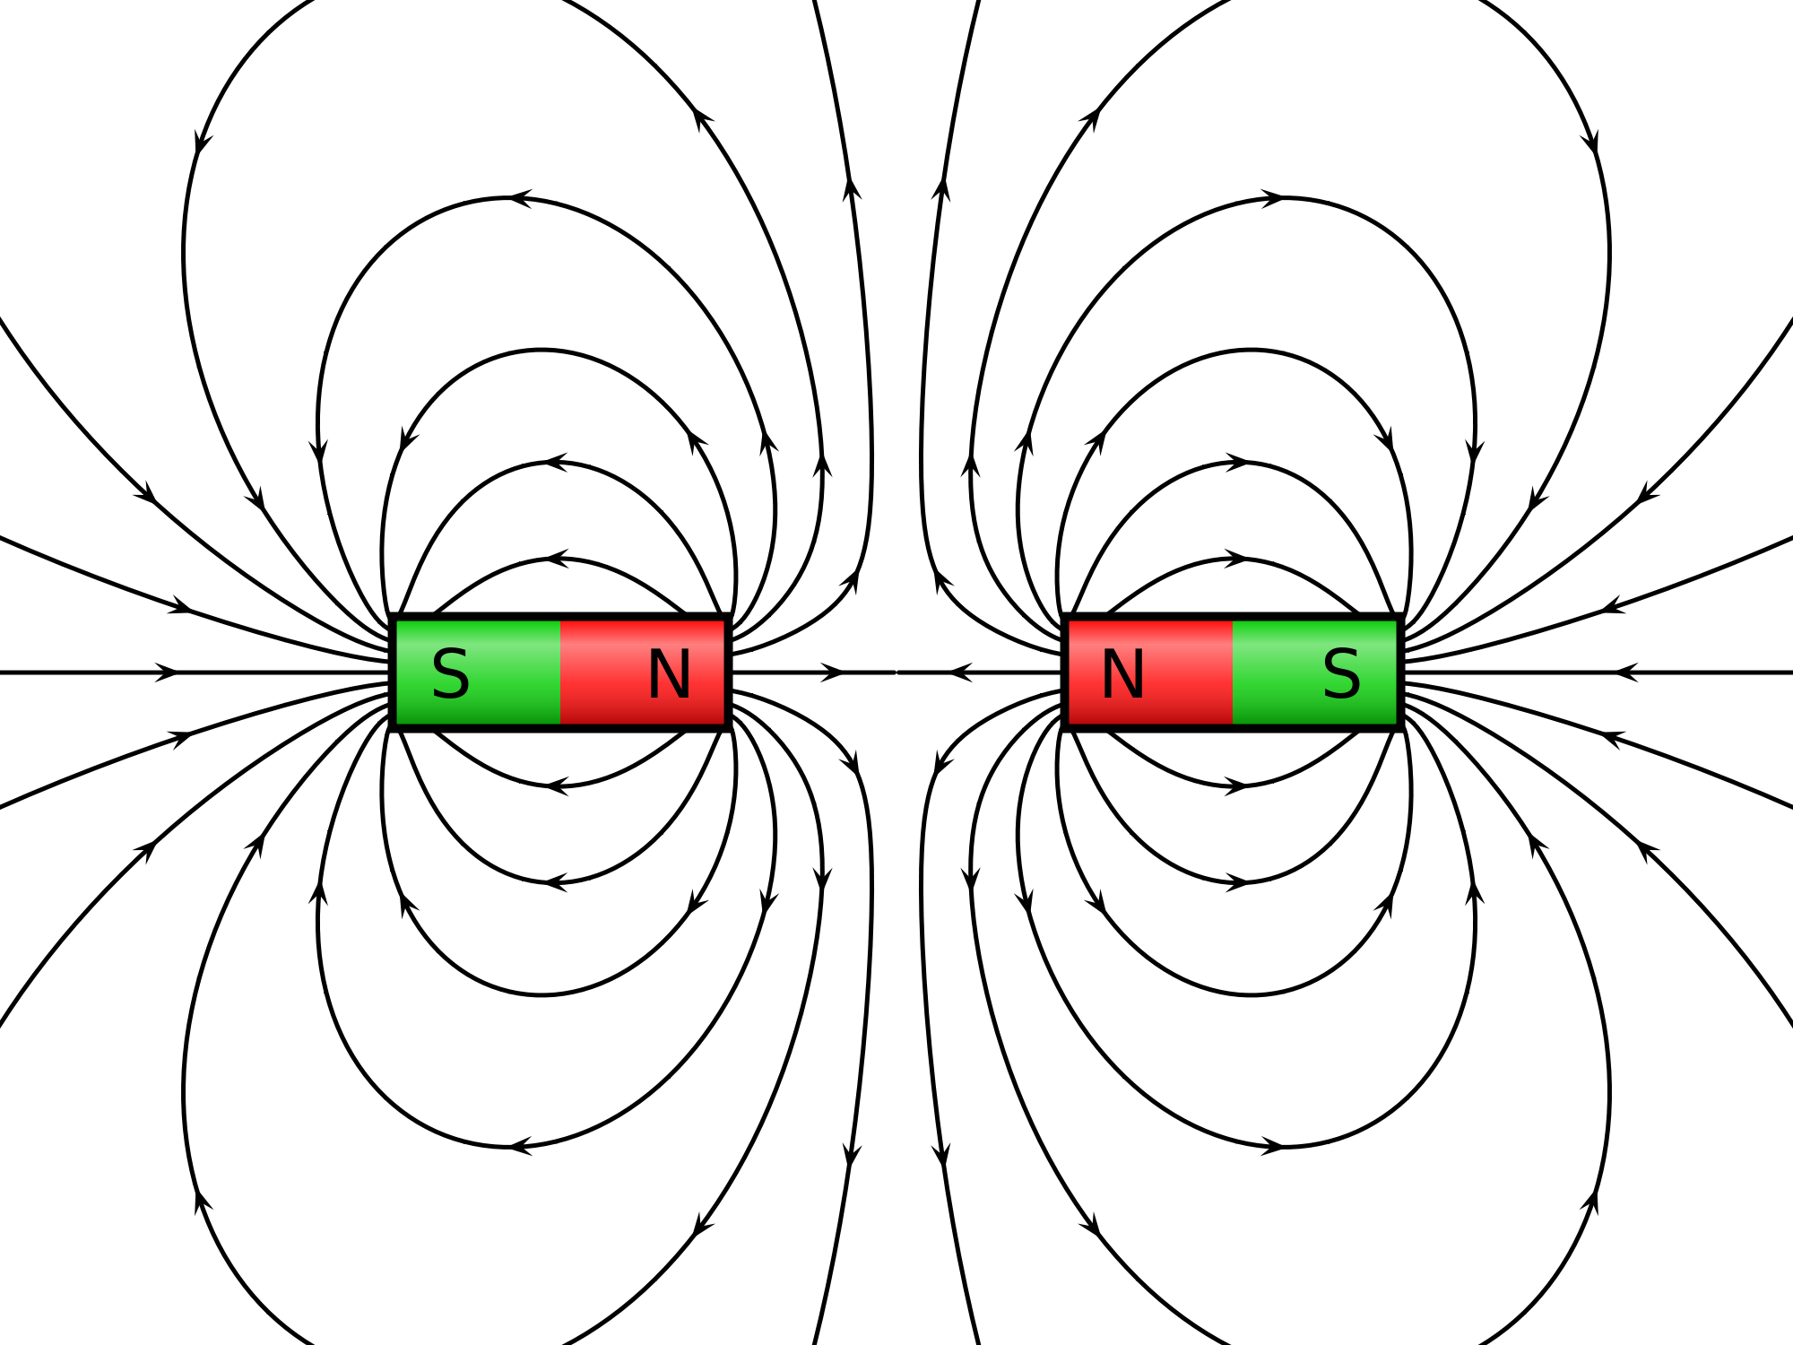

FIGURE 2.2: Magnetic Field

My identification of magnetic field as a kind of soul is supported by the following Verse and Hadith:

“They ask thee concerning the ruhh (soul). Say: The ruhh is command of my Lord. Of knowledge, it is only a little that is communicated to you.”
[Al Quran 17: 85]

The above Verse says that a soul (ruhh) is a command of Allah.
The Earth has a huge magnetic field that resists the Solar Wind from entering the Earth. Figure-2.4 shows how the Earth’s Magnetic Field is acting against the Solar Wind as a command: “Do not to enter the Earth.”

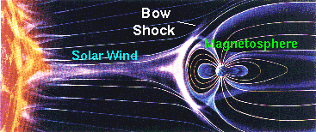

FIGURE 2.3: Earth’s Magnetic Field working as a command to the Solar Wind: ‘Do not enter the Earth’.

The Hadith expresses soul as an attractive and repulsive force:

“Prophet said: “The souls are like conscripted soldiers; those whom they recognize, they get along with; and those whom they do not recognize, they will not get along with.”” [Bukhari, Muslim]

A magnetic field recognizes electrons and get along with those to produce electricity. The magnetic field does not recognize protons, so it does not get along with those. So, in light of the Hadith too, a magnetic field is a soul.
Therefore, force field and soul are the same things. Scientists call a soul force field, but it is the difference in name only.
A Magnetic field can be explained as the flow of electrons, but an electron in the form of wave looks like a soul.
A subatomic particle shows wave-particle duality, and it has a little sense as well. Its duality and sense can be detected by the following test:
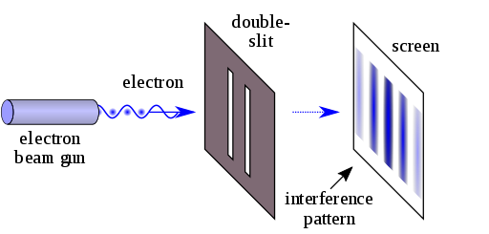

FIGURE 2.4: Wave-Particle Duality

“A laser beam illuminates a plate pierced by two parallel slits, and the light passing through the slits is observed on a screen behind the plate. The wave nature of light causes the light waves passing through the two slits to interfere, producing bright and dark bands on the screen—a result that would not be expected if light consisted of classical particles. However, the light is always found to be absorbed at the screen at discrete points, as individual particles (not waves), the interference pattern appearing via the varying density of these particle hits on the screen. Furthermore, versions of the experiment that include detectors at the slits find that each detected photon passes through one slit (as would a classical particle), and not through both slits (as would a wave). However, such experiments demonstrate that particles do not form the interference pattern if one detects which slit they pass through. These results demonstrate the principle of wave-particle duality.”
– Wikipedia, the Free Encyclopedia

Thus, when a subatomic particle is observed, it is a particle, otherwise it is wave. So, it senses that it is being observed.
A subatomic particle is a soul in the form of wave.

6b. Different Types of Soul

The Quran talks about two types of souls: Ruhh and Nafs.

6b-I. Ruhh (Elementary Soul)

“Ruhh” is an Arabic word. It is translated as “soul”. I use “ruhhs” in plural form.
The Quran says that a ruhh is a command of Allah. Allah can imprint information in a force field; He can design the force field to act in set patterns and can make it fixed. Once an object falls into a designed force field, it acts as forced. For example, every atom has a Strong Nuclear Force Field that holds the repulsive protons in the nucleus of the atom. The Strong Nuclear Force Field is a Ruhh; it acts as a Command of God to the protons that they are to remain in the nucleus, even if they are repulsive to each other.
Therefore, a ruhh (an elementary soul) can be defined as a designed force field that sustains intended entities and influences them to act in specific ways.

6b-II. Nafs (Composite Soul)

Another kind of soul is called “nafs”. “Nafs” is an Arabic word. It also is translated as “soul”. But, there is difference between ruhh and nafs. I use “nafses” in plural form.
A combination of two or more force fields (elementary souls / ruhhs) makes a nafs. For example: Magnetic Force Field (a ruhh), Weak Nuclear Force Field (a ruhh) and Strong Nuclear Force Field (a ruhh) jointly make the nafs of an atom. The nafs of the atom holds the particles, such as electron, proton, neutron, etc., and forms the atom. The atom as a whole achieves a nature.
Therefore, a nafs (a composite soul) can be defined as a combination of force fields (elementary souls / ruhhs), which is designed to sustain a system.
A human nafs is a combination of known and/or unknown force fields (elementary souls / ruhhs). The unknown force fields are not yet discovered.

6b-III. To Conclude the discussion of Soul

Some kinds of souls work as Force Fields in the nature, e.g., Magnetic Force Field, Weak Nuclear Force Field and Strong Nuclear Force Field. And some kinds of souls work as subatomic particles, e.g., electron, proton, neutron, etc., (the subatomic particles are souls, because they are conscious and show wave-particle duality).
Therefore, an atom is a mixture of different kinds of souls.
Once the atoms were created, the Universe was created.
Therefore, Allah has created the Universe from different kinds of souls. He provided the souls as a super-giant 'composite soul' (Nafs). The provided soul is called Nafsin-Wahidatin (a Nafs Single) in the following Verses. Allah provided it from His own Nafs, permeating His body in form:

“It is He Who hath produced you from a Nafs Single (Nafsin-Wahidatin); here is a place of dwelling and storage; we detail Our signs for people who understand.”
[Al Quran 6:98]

“He created you from a Nafs Single (Nafsin-Wahidatin), then created favorable Pairs (DNA Double Helix), and he sent down for you of the cattle eight Pairs, He creates you in the wombs of your mothers—creation after creation—three tortures (on Allah). That Allah is your Lord; for Him is the dominion. There is no god but He. Then how are you turned away?” [Al Quran 39:6]

Allah fragmented the Nafsin-Wahidatin and produced different kinds of force fields. He created different kinds of creatures out of the force fields. Thus, He transformed the Nafsin-Wahidatin into creation.
The scientists have so far discovered four kinds of force fields: Strong Nuclear Force Field, Weak Nuclear Force Field, Electromagnetic Force Field (Light) and Gravity. In the Grand Unified Theory (GUT), the scientists predict that all force fields except gravity originated from a Unified Force (GUT Force).

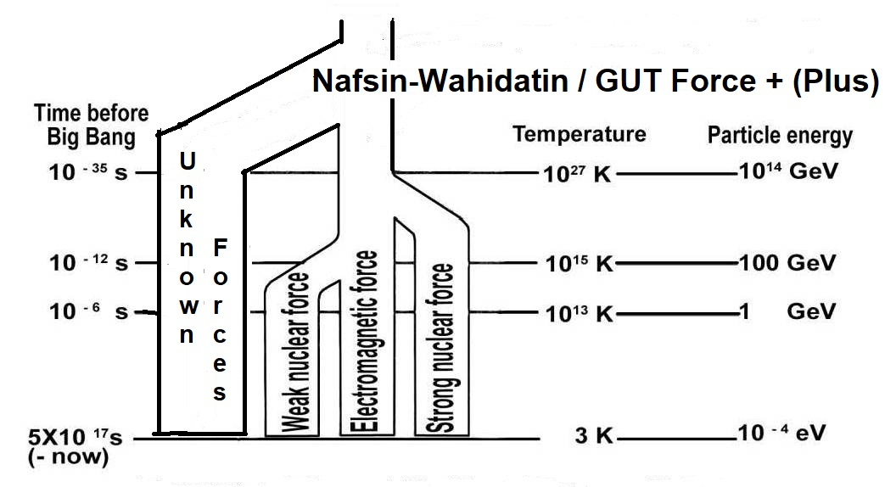
FIGURE 2.5

The GUT Force and the Nafsin-Wahidatin are the same thing. But it included many unknown force fields (not yet discovered) as well, with which the nafses (composite souls) of living creatures were created. So, the Nafsin-Wahidatin should be called GUT Force + (Plus).

7. Smoke

In the beginning, the radiation of forces turned into simplest form of matter, hydrogen, created out of one proton and one electron. Later twenty-five percent of hydrogen turned into helium along with a small amount of heavy hydrogen and other elements. The stars of the early Universe could form out of these two gases.

“The primordial fireball contained reactions which led to the present distribution of hydrogen and helium 75% and 25% respectively a balance that explains the evolution of stars…”
– Dawn of A New Era by Sir Bernard Lovell.

“Moreover, He put His attention to the Sky, and it had been smoke’’
[Al Quran 41:11]

Scientists predict that elements heavier than helium produced inside the stars at later times.

8. Formation of Skies and Galaxies

The smoke (mixer of hydrogen and helium mainly) that evolved from the Big Bang got together into the clouds of gases. In the collapsing clouds, the stars could form out of irregularities.
Subsequently, groups of proto-galaxies were attracted together by gravity and collided, which resulted in the formation of the larger galaxies, we have today.
“The standard picture of galaxy formation envisage to gas collapsing first into a roughly elliptical shape under the influence of gravity, with stars forming out of irregularities in the collapsing cloud. At first large hot stars, composed just of hydrogen and helium, will form in a young galaxy, run through their life cycle quickly and explode, scattering heavier elements into interstellar medium. From these materials, ‘Second Generation’ stars can form.”
– To the Edge of Eternity by John Gribbin in The Encyclopedia of Space Travel and Astronomy edited by John Man.
After the gases concentrated into the clouds of gases, the formation of stars and planets was a matter of time and evolution only. Here difficult part is to visualize, how the gases could concentrate into the clouds as big as galaxies? In a uniform universe the gases should have spread out uniformly.
“In a perfectly uniform universe, there is no way in which large concentration of gas could ever occur, indeed it is quite difficult to explain how concentration of matter as big as the galaxies could have formed in time since the Big Bang, no more than 20,000 million of years ago. How this happened is not known, but it is straight forward to calculate how a galaxy would form once these clouds of gas, held together by gravity, and containing enough material to form thousands of millions of stars.”
– To the Edge of Eternity by John Gribbin in the Encyclopedia of Space Travel and Astronomy, edited by John Man.
The Quran indicates that the space of the initial universe was designed into seven spherical waves, one inside another, like peels of onion. These seven super-giant waves of space are Seven Skies. In the expanding Skies, the gases could accumulate into the clouds of gases to form the galaxies.

“Moreover, established Himself (did istawa) into the Sky (single-sky-universe), and it had been smoke. He said to it and to the lands (formed after His establishment), “Come ye together, willingly or unwillingly”. They said, “We do come in willing obedience”. So, He completed them as Seven Skies (seven-sky-universe) in two days...”
[Al Quran 41: 11–12]

Large-scale structure of the Universe is yet to be discovered. I have discussed a likely structure (seven-sky-universe) in Chapter-7.

9. The Creator

I have discussed that an elementary soul (ruhh) and a force field are the same things.
I have also discussed that a composite soul (nafs) is a combination of two or more force fields (elementary souls / ruhhs) sustaining a system, living or inert.
For instance, Magnetic Force Field (an elementary soul / ruhh), Strong Nuclear Force Field (an elementary soul / ruhh) and Weak Nuclear Force Field (an elementary soul / ruhh) jointly make the composite soul (nafs) of an atom. The nafs holds the subatomic particles and keeps the atom functional /living.
For another instance, a human nafs (main / composite soul) is a combination of known and/or unknown force fields (elementary souls / ruhhs). All kinds of force fields are not yet discovered.
Similarly, the Nafs of Allah is a combination of many known and unknown Force Fields (elementary Souls / Ruhhs). His Nafs permeates His body in form.
Allah has a form.
According to the Quran, Allah has face, eyes, ears, hands, legs, etc.
According to Holy Bible, Allah created human in His own image:

“And Elohim created the man in His own image; in the image of Elohim He created him. He created them male and female.”
– Genesis 1:27, Holy Bible

So, Allah has a form. He in form looks like a human.
'Allah in form' stays in the Arsh mainly. The Arsh is a universe beyond this Universe.
Allah has a “Kursi” (Thorne) in the Arsh. 'He in form' sits in the Kursi. He extends His Kursi into the Universe as well. He feels no fatigue to run the universes.

“…Extends His Kursi into the Skies and Lands (Samawaat-wal-Ard / this Universe), and not tiers Him guarding of both of them (Samawaat and Jannaat), for He is the Most High, the Supreme”
[Al Quran 2:55]

We know about matter, forces and energies only, when the physique of Allah may include elements that are not available in the creation. He is beyond our imagination. He is extremely capable, intelligent and wise. He is eternal and has no weakness.
Allah has a form. At the same time, He exists everywhere. How He can exist everywhere is discussed below:
The Nafs of Allah permeates His body in form. He has extended several elementary Souls (Force Fields / Ruhhs) of His Nafs beyond His body in form. He has designed the 'extended elementary Souls' at His will to act in fixed patterns and has infused those into the space (did istawa) to sustain and evolve the creations. We view some of their acts as natural laws.
For example, Gravitational Force Field is an extended elementary Soul (Ruhh) of Allah, but we view Gravitational Force as natural law.
The following Verses clearly indicate that the Gravitational Force is an extended elementary Soul (Ruhh) of Allah:

“Do they not see towards the birds controlled in the atmosphere (air) of the Sky (Samah)? None holds them except Allah; most surely there are signs in this for a people who believe”
[Al Quran 16:79]

“Do they not observe the birds above them, spreading and folding (wings)? None holds them except (God) Most Gracious; truly it is He that watches over all things.” [Al Quran 67:19]

A bird flies in the air by spreading and folding its wings. But, it would be weightless and off-balanced if it were not held by gravity through its center of gravity (CG). The holding of birds by gravity is expressed in above Verses as an act of Allah, and Allah only.
Allah not only holds the birds, He drives the astral objects too. The following Verse talks about the act:

“He covers the night with the day, seeking it rapidly (He rotates the Earth rapidly), and the sun and the moon and the stars controlled by His deed”
[Al Quran 7:54]

Allah holds the birds. He covers the night with the day (rotates the Earth). He drives the astral objects, like the stars. So the Gravitation Force is a force of Allah.
A force field in living entity (Allah) should be called soul. So, the Gravitational Force Field is an extended elementary Soul (Ruhh) of Allah.
To be clear: The Gravitational Force Field is a constituent of His Nafs that permeates His body in form. He has extended the elementary Soul (Gravitational Force Field / a Ruhh) beyond His body in form, like hand / wing extended from a body. He has designed the elementary Soul at His will to sustain the objects, and has infused it (did istawa) into the space. He sustains the objects of this Universe (Samawaat) with the right hand extension. He sustains the Arsh and Jannaat with the left hand extension.
Thus, He established Himself (did istawa) into the Universe and concentrated the smoke to form the heavier elements:

“Moreover (He) established Himself (did istawa) into the Sky while it had been smoke. He said to it (smoke) and to the lands (formed after His establishment), “Come ye together, willingly or unwillingly.” They said, “We do come in willing obedience.” [Al Quran 41:11]

However, Allah need not to remain concentrated in running the astral objects. The extended elementary Soul (Gravitational Force) is designed to act in fixed patterns and the objects are configured to react as intended.
The Gravitational Force is not the only elementary Soul (Ruhh) that Allah has extended and infused into the space. There are several more:
In 1990’s “1A Supernova Cosmological Project” and “High-Z Search Team” observed that the expansion rate of the Universe was accelerating. The scientists deduce from the observation that the Universe possesses “Dark Energy” that is causing the expansion to accelerate.
The Dark Energy filling the vast space can be viewed as a repulsive force, which opposes self-attraction of matter and causes the expansion of the Universe to accelerate. The Quran says that Allah is the Expander:

“And the Sky, We constructed it with Support, and indeed We surely are Expanders” [Al Quran 51:47]

So, the Dark Energy may be one of His extended elementary Souls (Force Fields / Ruhhs), which He has infused into the space to cause the expansion of Skies (Samawaat / this Universe).
In Inflationary Theory, the scientists predict the presence of Vacuum Energy, permeating the entire space. The Quran says that the light of Allah permeates the entire space:

“Allah is the light of the 'Skies and Lands' (this Universe)”
[Al Quran 24: 35]

The Light is held in one or more of His extended elementary Soul(s). Or, the light itself may be an extended elementary Soul of Allah. Probably, the scientists visualize His light as Vacuum Energy. The Vacuum Energy is highly intense (10¹¹³ joules per cubic meter) but it does not destroy us.
Many of His extended elementary Souls are viewed in the Quantum Mechanics as Fields sustaining the subatomic particles. He sustains the creations from the deepest level. He says, “Be”, and it is.
The experiment carried out in 1982 by Alain Aspect and his Team provides strong evidence that even at great distances atomic particles remain connected to one another—they are entangled. If two sub-atomic particles are emitted from the same source, one influences the other instantly whatever is the distance.
The extended elementary Souls of Allah, which sustain the creations, are unbroken singular entities. The creations remains entangle to each other through His extended elementary Souls. He comes to know everything instantly.
However, one must not mix up creation with Allah. The products of the Nafsin-Wahidatin are sustained in the extended elementary Souls (Force Fields / Ruhhs) of Allah. But, the products, such as the subatomic particles, and the force fields that make the nafses of atoms and animals, do not mix up with His elementary Souls. The products are sustained as separate entities and they are entangled to one another by design.
Allah in appearance in the Kursi and Allah existing everywhere by extending His elementary Souls is one. The Nafs of Allah, permeating His body in form, is comprised of many (may be a hundred) elementary Souls (Force Fields / Ruhhs). He has extended 8 to 12 elementary Souls as His hands to sustain the universal objects. These hands are hands of Nafs. He is sustaining this Universe (Samawaat) with His right hand. He is sustaining the Arsh and Jannaat with His left hand.
'Allah in form' has physical hands as well. If one could go in front of the Kursi, one would see Allah like a human.
However, He is sustaining and evolving the universes with extreme forces and power, exposed from His body in form. None can go near to Him at present due to the exposure of extreme power.
Allah has extended several of His elementary Souls though His front. These are not designed to act in fixed patterns. He sees everything and knows everything instantly. He can do anything He may want to do at any place at any time.
From a simple eternal entity, Allah has become the Creator, Sustainer and Evolver of the giant universes. So, it is proven that He is an extremely intelligent hard working God, with high level of determination and capabilities. It is most likely that He will be able to fulfill His plan, and the cycle of creation and re-creation will be complete.
Once the cycle will be complete, the creations will be fixed. He would not relax before the cycle is completed—He is an extremely Arrogant Creator. Our existence depends on the fulfillment of His plan. He must be thanked and praised day and night; we can do nothing else for Him.
Following Verses give the idea about Allah as the Sustainer and Evolver of the creations:

“It is God Who causes the seed-grain and the date-stone to split and sprout. He causes the living to issue from the dead, and He is the One to cause the dead to issue from the living. That is God. Then how are you deluded away from the truth?
He it is that cleaves the day-break. He makes the night for rest and tranquility, and the sun and moon for the reckoning. Such is the judgment and ordering of the Exalted in Power, the Omniscient.
It is He Who makes the stars for you that you may guide yourselves with their help through the dark spaces of land and sea. We detail Our Signs for people who know.
It is He Who has produced you from a Nafs Single (Nafsin-Wahidatin / GUT Force+), so a place of dwelling, and a storage. We detail Our signs for people who understand.
It is He Who sends down rain from the skies. With it We produce vegetation of all kinds. From some We produce green, out of which We produce grain, heaped up; out of the date-palm and its sheaths the clusters of dates hanging low and near, and gardens of grapes, and olives, and pomegranates each similar yet different. When they begin to bear fruit, feast your eyes with the fruit and the ripeness thereof. Behold! In these things there are Signs for people who believe.”
[Al Quran 6: 95-99]

When a seed-grain gets water and air, series of chemical reactions take place, which cause it to split and sprout. In above Verses, Allah says that He causes it. Allah provides water and air. He has designed water, air and seed-grain to act, which we see as natural laws. And they can exist and act in His extended elementary Souls only—He is the Sustainer; He is the Evolver. So, He causes the seed grains to split and sprout.
Allah has placed stars suitable to find direction in the desert or ocean. The Pole Star is widely used for direction finding. The star had to be so far away that the whole orbit of the Earth, around the Sun, becomes a point in relation to its distance. And it had to be bright enough to be visible. It had to be on the celestial North Pole exactly.
Allah inspired the Skies by designing their initial configurations to perform their affairs. From the Big Bang, every object is moving to its destiny. The flow is driven by Him, directly or indirectly. He is Time:

“On the authority of Abu Hurayrah, who said that the Messenger of Allah said, Allah says: “Children of Adam inveigh against Time; I am Time; I change the day and night”” [Bukhari, Muslim]

Two dates from the same tree are different, because they develop in different points of constantly changing nature, evolving in a time-scale.
“The primordial fireball contained the reactions which led to the present distribution of hydrogen and helium 75% and 25% respectively a balance that explains the evolution of stars. Very small changes in the nature of the primordial fireball would have had an immense effect on the universe. If certain atomic forces had been only slightly greater, then all the hydrogen would have become an isotope of helium and no long-lived stars could exist as they do at present. They would have been explosive. Stars would have formed but they would have used up all their energy in a very short time. There would have been no star like the sun, which gives an output of energy for thousands of millions of years. It is only with the stability on this time scale the life can evolve. If things had been just a little bit different at the beginning, therefore, there could have been no life, and the universe would be unknowable.”
– Dawn of a New Era by Sir Bernard Lovell in The Encyclopedia of Space Travel and Astronomy edited by John Man.
“These things are to me immensely strange. Is it not extraordinary that the possibility of talking here this afternoon depends on events which were very narrowly determined over 10,000 million years ago in the very earliest moments of the universe?”
– Dawn of a New Era by Sir Bernard Lovell in The Encyclopedia of Space Travel and Astronomy edited by John Man.

In this huge Universe standing on a huge time-scale nobody has a way to interfere.

“Say: of your ‘Partners’, can any originate creation and repeat it? Say: It is Allah Who originates creation and repeats it. Then how are ye deluded away”
[Al Quran 10:34]

The Universe has been created from a state of unity by a Single God, and it is sustained and evolved as a unit by the same Single God. There is no room for another God / god. He is one and only.

“Say: Have you seen ‘Partners’ of yours whom ye call upon besides Allah? Show me what it is they have created in the land. Or have they a share in the Skies? Or have We given them a book from which they clear? Nay the wrongdoers promise each other nothing but delusions. It is Allah who sustains the ‘Skies and Lands’ (Universe) lest they cease, and if they should fail, there is none—not one—can sustain them thereafter. Verily He is most Forbearing, oft-Forgiving”
[Al Quran 35: 40–41]

Return to a Creator who is able to create such a vast Universe. Return to a Creator who sustains and evolves this Universe. Only He can sustain and evolve it—an atom is too small and the Universe too big to be sustained and evolved by anybody except Him.
We have not seen Him. We cannot imagine Him. But He exists. We come and pass away with a hope of resurrection, because He exists forever, and He does never forget.

“Say: He is Allah, The One and Only. Allah, the Eternal, Absolute. He begets not, nor is He begotten. And there is none Like unto Him.” [Al Quran 112: 1–4]

10. Conclusion

The scientific theories change, but it will not change much on the matters that are similarly described in the Quran. For instance, the Quran says that the Universe is expanding; the Quran says that the night is dark, because the Universe is expanding; the Quran says that the Universe has been created from the smoke. In these matters scientific theories will not change.
The theories differ in the point of initial state of the Universe mainly. The Quran does not give deliberate description of the initial state. It only says that at some time in the past, the Universe was very small and all the materials in it were joined together: ‘’Do not the unbelievers see that the skies and lands were joined together before We clove them asunder‘’ [Al Quran 21:30]
If a theory is found in disagreement with the Quran, it should be understood that the theory is wrong. For example, in 19th century, the theories of all scientists, including Einstein, were telling that the Universe was static, but the Quran was telling that the Universe was expanding. Now scientists have stood corrected.
In explaining the initial state of the Universe, almost all theories contradict Islamic thought at one point or another. The theory I have used is popularly known as the Big Bang Theory. Its evolution started with Fridmann’s Assumption. The theory got firm footing after Hubble’s discovery. In response to Hubble’s discovery, scientist Howard Robertson and Arthur Walker developed the theory deliberately in 1935.
Hubble’s discovery suggests that in the beginning, the Universe was very small. Theorists have created different models of the Initial Universe. The most renowned idea is the idea of “Singularity”. The Singularity was a super-hot, super-dense point of space-time, which contained all matter/energies of the Universe. If the Universe originated from a “Singularity”, it existed forever. It is a contradiction to the Islamic thought. So, I have not accepted this part of the theory; I have said that the matter of the Universe was created from a Soul Single (Nafsin-Wahidatin) provided by Allah.

11. Summary

The Universe is expanding. The galaxies are receding from each other.
In the beginning, the radiation turned into matter. It produced the smoke (hydrogen and helium mainly). The smoke produced the galaxies.
The Quran is found correct about the creation of universe. It presents the future in the same scientific framework. So, the future should be believed. The future includes Doomsday, Resurrection, Final Judgment, etc.

Ref:

- Lovell, Bernard, Sir. Dawn of a New Era in The Encyclopedia of Space Travel and Astronomy edited by John Man. Great Britain: Octopus Books Limited, 59 Grosvenor Street, London, 1979.
- Gribbin, John. “The Expanding Universe” and “To The Edge of Eternity” in The Encyclopedia of Space Travel and Astronomy edited by John Man. Great Britain: Octopus Books Limited, 59 Grosvenor Street, London, 1979.
- Russell, Bertrand. A B C of Relativity. New York, United States: Harper Brothers.
- Hawking, Stephen. A Brief History of Time. United States: Bantam Dell Publishing Group, 1988.
CHAPTER 3: Future of the Universe

Present discoveries are not enough to predict a specific future of the Universe. Therefore, scientists present different models. There are four broad models: Open Universe Model, Closed Universe Model, Cyclic Universe Model, and Flat Universe Model.
In this Chapter, I shall identify the model that is supported by the Quran and Holy Bible. In later chapters, when we will discuss Doomsday, Resurrection and Final Judgment, the model close to the Quran and Holy Bible will be kept in view. The discussion will progress in the following sequence:
1. Factors of Expansion and Contraction
2. Open Universe
3. Closed Universe
4. Cyclic Universe
5. Likely Course
6. Confirmation of Flat Universe
7. Model of the Universe in the Quran
8. Model of the Universe in Holy Bible
9. Conclusion

1. Factor of Expansion and Contraction

Will the Universe expand forever, or it will collapse? The answer critically depends on the gravitation force that is working against the force of expansion. If the gravitational force is powerful enough, it will eventually slow down the expansion of the Universe to a halt. Or else, the Universe will expand forever.
In the previous Chapter, we have discussed that the gravitational force is a force of Allah. He can increase or decrease the force at will. He is ever powerful on everything of the Universe.
However, gravitation force is designed by Allah to sustain the deposits of matter in the space. So, its exposure depends on the amount of matter—the more is the amount of matter the more is the exposure of gravitational force.
Therefore, from the religious point of view as well, we may talk about the amount of matter. Allah, most likely, has designed the Universe in such a way that it would fulfill its course by itself.
“Will the universe expand forever or it will collapse again? The answer to this question depends critically on the amount of matter in this universe. If the density at present is more than 10⁻²⁹ grams per CC, then scientists calculate that there is enough matter in the universe to overcome by gravitational attraction the present expansion and the universe will eventually collapse again to another state of Singularity. If the density is less than that value, the universe will continue to expand forever. We do not know the answer yet.”
– Dawn of a New Era by Sir Bernard Lovell in The Encyclopedia of Space Travel and Astronomy edited by John Man.
The density, 10⁻²⁹ grams per CC, is known as the critical density.
To know the density, one needs to know the volume and the mass. The boundary of the Universe could not be detected in any direction, so the volume of the Universe is not known. Therefore, the overall density of matter cannot be calculated. By counting the numbers of galaxies in a volume of space, the scientists have assessed likely overall density. It is much less than the density needed to close the Universe.
However, there may be dark matters beyond the galaxies, which are not observable, may increase the density.
As the density of matter is not known, the ultimate model of the Universe cannot be determined. So, all likely models of the Universe are discussed below. We will accept the model that is close to the Quran.

2. Open Universe

The Universe may expand and continue cooling forever. Eventually the galaxies will move so far away from each other that the Universe will not exist as a unit. The stars will die by radiating energy. Much of the matter will disappear through black holes scattered at great distances. Ultimately, the black holes will evaporate leaving the photons that never decay.
In ever stretching space, the objects will explode, and the atoms will be broken. The sub-atomic-particles will decay. What will remain forever are the photons.
If the Universe expands forever, it is open.

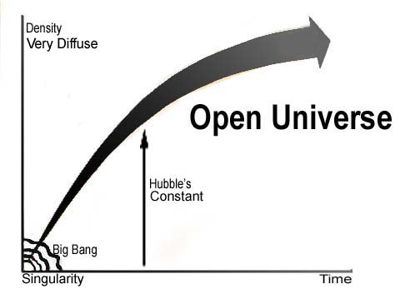
FIGURE 3.1: Ever Expanding Universe

“And what is the fate of the universe? It is possible that the beginning can only be explained by a ‘Rediscovery of God’ and the end will be infinite dissipation in an infinite void.”
– To the Edge of Eternity by John Gribbin in the Encyclopedia of Space Travel and Astronomy edited by John Man.
Above figure depicts the ever-expanding universe. Here the rate of expansion, expressed as Hubble’s constant, is high. I have not found any Verse in the Quran or Holy Bible that directly or indirectly supports the idea of ever-expanding universe.

3. Closed Universe

The Universe is expanding. But, the overall gravitational force is trying to stop the expansion. If gravity wins over the force of expansion, the Universe will slow down to a halt, and the contraction will begin.
The Universe is expanding for billions of years. If it starts contracting, it will continue for an equal period of time. At the end, everything of the Universe will join together.
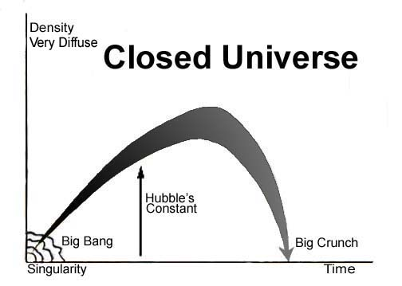
FIGURE 3.2: Closed Universe

The huge accumulation of matter, possessing extremely powerful gravitational force, will continue squeezing toward the higher densities. Finally, the Universe may be squeezed into a super-hot, super-dense point called Singularity. The Singularity at the end of the Universe is called Big Crunch.
Above figure depicts the Closed Universe Model where the expansion of the Universe stops and the contraction begins. Eventually, the Universe collapses into a Big Crunch.

4. Cyclic Universe

In a closing Universe, eventually all the matter will join together. Due to the intense gravitational force, the Universe will continue squeezing toward higher densities. Finally, the Universe may collapse into a point, called Big Crunch.
Singularity, Big Bang and Big Crunch are the same things. The Singularity at the beginning of the Universe is called Big Bang, and the Singularity at the end of the Universe is called Big Crunch. It is a super-hot super-dense point of space-time where the known natural laws break down.
From the Big Crunch (Big Bang–2) the Universe may be born again.
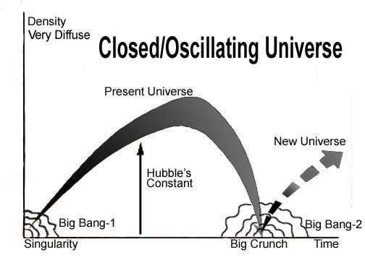
FIGURE 3.3: Oscillating Universe

“But it is also possible that expansion will be reversed by the pull of gravity, that all matter will collapse once again into a super-dense ‘singularity’ and that another universe will be born in another Big Bang a cycle that could be repeated forever.”
– To the Edge of Eternity by John Gribbin in The Encyclopedia of Space Travel and Astronomy edited by John Man
Alternatively, due to enormous pressure and temperature, the rapidly contracting Universe may bounce back out from the state of Fireball, and a new Universe may be born.
The Fireball is defined as the state of the Universe, less than a million years before or after the Singularity.
“For just as galaxies are combined by the attractive force of gravity the total mass of the whole universe provides an insistent tug on every galaxy and cluster of galaxies within the universe. As the universe expands out ward from the initial explosion of the Big Bang, the gravitational tug gradually decreases. But it is always present, and if there is enough matter, eventually gravity will overcome the expansion, and the universe will slow to a halt. The whole drama will then be played out in reverse. The universe will collapse faster and faster under the overwhelming pull of gravity until it is squashed into another fireball, perhaps then to bounce back out again.”
– To the Edge of Eternity by John Gribbin in The Encyclopedia of Space Travel and Astronomy edited by John Man
Therefore, after the contraction, the Universe may be born again from a Big Crunch, or from a Big Bounce.
This is the Cyclic Model of the Universe. In Cyclic Model, the Universe existed forever.

5. Likely Course

Will the Universe close?
By observational evidence less than 10 percent of matter needed to close the Universe has been found so far. However, there may be invisible dark matter at the outside of the galaxies, which are undetectable. Dark Matter has gravitational influence on visible matter.
“We are not going to find any less matter in the universe, while there might well be material we don’t yet know about– cold gas between the galaxies, for instance, or black holes at present undetected. So even now the two versions of the fate of the universe should be given equally serious considerations.”
– To the Edge of Eternity by John Gribbin in The Encyclopedia of Space Travel and Astronomy edited by John Man
The most promising dark matter that can provide enough mass to collapse the Universe is neutrino. Previously it was thought to have no mass. In 1998, it has been discovered that the neutrinos possess mass. It indicates that the Universe has just enough mass to stop it from expanding forever.

6. Confirmation of Flat Universe

According to Einstein’s Theory, the presence of matter curves space-time. The gravity is not a force like other forces; it is felt due to the tendency of matter to move along the curved space-time. The argument is proved by observation. Light passing through the side of a massive object bends.
But no reliable way to measure the distance of a far-off object is discovered so far. The galaxies at very large distances are not even visible. So, it is not possible to find out the distribution of galaxies and understand the curvature of space. In a supposed uniform and isotropic Universe, the overall space may be Positively Curved, Negatively Curved or Flat.

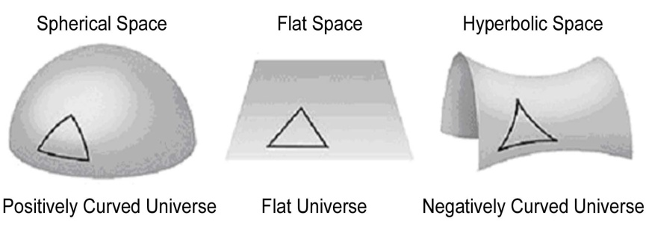
FIGURE 3.4: Curvature of Overall Universe

The space of a Positively Curved Universe is bent round onto itself. The light travelling in an apparently straight line will return to the point of origin—the space is like the surface of the Earth, where one moving through a straight line returns to the start-point. A Positively Curved Universe is closed; it will collapse.
If the space is Negatively Curved, it is like the saddle of a horse. Light follows a parabolic path. The Negatively Curved Universe is open; it will expand forever.
The space may be flat, where light follows a straight path. The Flat Universe is the dividing line between the Open Universe and the Closed Universe: there is either just enough matter to ‘close’ the Universe and make it eventually collapse, or there is not quite enough so that it will expand forever.
Recent explorations have provided an indirect way to find out the overall curvature of the space. It has tipped the balance towards the Flat Universe Model.

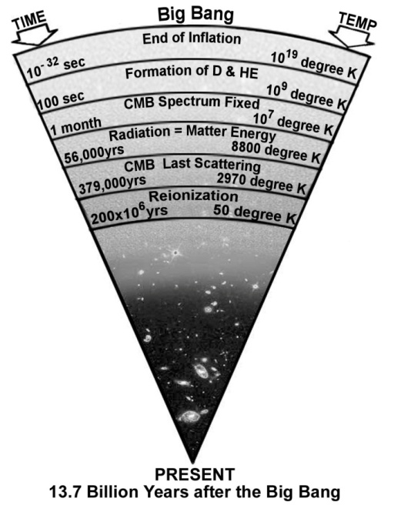
FIGURE 3.5: CMB Last Scattering

The Big Bang left a residue of radio noise, known today as Cosmic Microwave Background Radiation (CMB). The pattern of CMB shows the physical conditions of the Universe in the epoch of CMB Last Scattering, when the age of the Universe was 379000 years only.
The Wilkinson Microwave Anisotropy Probe (WMAP) launched by NASA collected CMB data in 2010s. The Probe was equipped with advanced instruments to detect minor fluctuations in the radiation. The data has produced the map of the Baby Universe (at the age of 379000 years). It shows that the Universe contains 4.6% matter, 24% dark matter, and 71.4% dark energy.

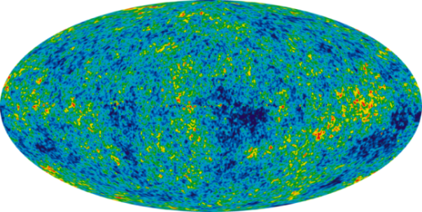

FIGURE 3.6: CMB Map of the Universe

The map shows temperature fluctuations. The fluctuations contain information about the total energy density and curvature of the Universe.
Tiny variations in the temperature correspond to the distribution of matter. These irregularities have become galaxies and clusters of galaxies. By comparing the lateral dispersion of matter in the ‘distant microwave sky’ and in the ‘distant real sky’, the geometry of the space is found out to be flat.
Moreover, “1A Supernova Cosmological Project” and “High-Z Search Team” discovered in 1990s that the expansion rate of the Universe was accelerating for last five billion years. A Universe with fluctuating rate of expansion should be flat.

7. Model of the Universe in the Quran

The Quran and Holy Bible support none of above Models. However, the Books suggest that the Universe will collapse, and it will be created again. Broadly the model looks like the Cyclic Universe Model. A few related Verses are given below:

“On the day when We will roll up the Skies like the rolling up of the scroll for writing; as We originated the first creation, We shall reproduce it—a promise on Us; surely We will bring it about.” [Al Quran 21: 104]

“Say: Is there any one among your associates who can bring into existence the creation in the first instance, then reproduce it? Say: Allah brings the creation into existence in the first instance, then He will reproduce it; how are you than turned away”
[Al Quran10: 34]

“And He it is Who originates the creation then reproduce it, and it is easy to Him; and His are the most exalted attributes in the Skies and Lands (Universe), and He is the Mighty, the Wise” [Al Quran 30: 27]

According to the Quran, the Universe is designed into Seven Skies. The Skies are waves of space, one inside another, like the peels of onion. Above Verses suggest that the Skies will be rolled up, which means that the Universe will be closed. The likely way of Rolling-Contraction is discussed in Chapter-8.
The Verses suggest that the Universe will be opened again.

8. Model of the Universe in Holy Bible

The Verses of Holy Bible, related to this Model, are given below:

“And I saw the lamb break open the sixth seal … The stars fell down to the earth, like unripe figs falling from the tree when a strong wind shakes it. The sky disappeared like a scroll being rolled up, and every mountain and island was moved from its place”
– Revelation 6: (12–14), Holy Bible

The sky being rolled-up will disappear. It means that the Universe will collapse.

“Soon after the trouble of those days, the sun will grow dark, the moon will no longer shine, the stars will fall from the sky, and the powers in space will be driven from their courses.”
– Matthew 24:29, Holy Bible (GNB)

“In the days after that time of trouble the sun will grow dark, the moon will no longer shine, the stars will fall from the sky, and the powers in space will be driven from their courses.”
– Mark 13: (24–25), Holy Bible (GNB)

The Sky will be rolled up, as the powers in space will be driven from their courses. The stars will fall on one another into the center of the Universe. Thereby, the Universe will collapse.
Holy Bible indicates that the Universe will be created again, but the description is mixed with the narration of Final Judgment. Therefore, the view of Holy Bible about the re-creation of the Universe is discussed in Chapter-9, dealing with the Final Judgment.

9. Conclusion

The Universe is expanding. The expansion will stop, and the contraction will begin. Finally, all the objects of the Universe will join together. The Universe may be squeezed to a state of super-dense Singularity.
The Singularity at the end of the Universe is called Big Crunch. From the Big Crunch, a new Universe may be born (Big Bang–2).
Alternatively, the contracting Universe may bounce back out from a non-singular state (Fireball) and a new Universe may be born.

9a. The Creator

The “Open Universe Model” suggests that the Universe was created. So, the idea of a Creator can be accommodated in the Open Universe Model. But, in the “Cyclic Universe Model”, the Universe is oscillating—there was a contraction phase, before current expansion phase; before that contraction phase, there was another expansion phase, and so on. This cycle of expansion–contraction–expansion existed forever. So, the question of creation does not arise in the “Cyclic Universe Model”. So, a Cyclic Universe does not need a Creator.
But, the Quran supports the Cyclic Universe Model. However, the Book does not agree that the Universe existed forever. It claims with proofs that the Universe has been created by God.
Otherwise, the end-state of an Open Universe is meaningless. Allah has not created such a vast Universe with a meaningless end.

9b. Al Quran, the Last Testament

Both the Quran and the Holy Bible compare the Sky with a written scroll:

“On the day when We will roll up the Skies like the rolling up of the scroll for writing; as We originated the first creation We shall reproduce it—a promise on Us; surely We will bring it about” [Al Quran 21: 104]

“…The sky disappeared like a scroll being rolled up, and every mountain and island was moved from its place”
– Revelation 6: (12–14), Holy Bible

Therefore, one may be inclined to think that some of the Verses of the Quran might have been copied from Holy Bible. But one may notice that in none of the Verses, Holy Bible complete the statement—it talks about the collapse of the Universe, but does not talk about the re-creation concurrently. Collapse and re-creation of the Universe are related events. Both should be stated together, as it has been stated in the Quran: “On the day when we will roll up the Skies like the rolling up of the scroll for writings; as We began the first creation, We shall repeat it—a promise We have undertaken, truly shall We fulfill it.”
Therefore, the Quran, as expected, has updated Holy Bible. The Quran fulfills the revelation that has been sent to the descendants of Abraham time to time. Similarities show that both the Books are from the same source.

Ref:

- Lovell, Bernard, Sir. Dawn of a New Era in The Encyclopedia of Space Travel and Astronomy edited by John Man. Great Britain: Octopus Books Limited, 59 Grosvenor Street, London, 1979.

- Gribbin, John. To The Edge of Eternity in The Encyclopedia of Space Travel and Astronomy edited by John Man. Great Britain: Octopus Books Limited, 59 Grosvenor Street, London, 1979.

- Hawking, Stephen and Penrose, Roger. The Nature of Space and Time. Great Britain: Oxford University Press New Delhi, 1997.
CHAPTER 4: The Jannaat (Paradise)

The Universe is evolving toward the Dooms Day – Resurrection – Final Judgment – and a New Beginning. In this dance, a few other entities are related. The entities are discussed from this Chapter to Chapter-6.
In this Chapter, depending on the Verses of the Quran, Holy Bible and Hadith, I am going to confirm Jannaat (Paradise) as a universe beyond this Universe, and describe its large scale structure. The discussion will proceed in the following sequence:
- Traditional Description of the Jannaat
- This Universe is not fit to possess the Objects of Jannaat
- The Jannaat is an independent universe, located beyond this Universe (Samawaat)
- Location of Jannaat
- General Appearance of the Jannaat
- Large scale Structure of the Jannaat
- Conclusion
- Summary

1. Traditional Description of the Jannaat

The Jannaat is created by Allah Who willed that it will not be demolished. The Jannaat has flowing water and flowering trees. There are maidens with lustrous eyes restraining their glances.
The idea of Jannaat is not given in Holy Bible. It is given to the last Prophet, Muhammad (pbuh). Prophet Muhammad (pbuh), in the Night Journey (Miraj), visited the Jannaat physically, as an eyewitness. The Hadith related to Jannaat are the Hadith of the Night Journey (Miraj) mainly.
Prophet Muhammad (pbuh) said, “I entered the Jannaat; most of its inhabitants were from the poor.”
The Jannaat have levels. The distance between two adjacent levels is like the distance between the Skies.
According to Prophet Muhammad (pbuh), the Jannaat is located beyond the Seventh Sky. But, the Jannaat is not connected to the Seventh Sky. From the Land of Final Judgment, people will move into As-Sirat (Path leading to Jannaat). They will reach the space of Jannaat after crossing the Barzakh.
“Barzakh” means “Barrier”. It seems to be a space with different nature, which separates the domain of the Jannaat from the domain of the Samawaat (this universe).
The people entering the Jannaat will come across a river, where they will take bath. It will make their physiques nice, sound and fit for the Jannaat. They will move further and reach another river. They will drink its water. It will make them good heart people. They will not dispute or hate each other. Their hearts will be like one heart, loving each other.
The people of Jannaat will have the form of Adam. One will be 60 cubits tall. They will not have body hair that bothers people but will have head hair and eyebrows. Men will not have beards. A man will be identifiable by light green mustache, as men too will wear ornaments.
There is no urinating or defecating in the Jannaat. A person will sweat and release gas in the process of metabolism. The perspiration will not produce bad smell. They will never be tired or sad.
They will not have children and will not wish to have children.
The pebbles of Jannaat are precious stones and pearls. The Jannaat has trees with trunks of gold. There are huge trees; if one spends 100 years riding a quick horse, one will not depart the shade. There are trees, named Tuba, from which the clothes of the people come. There are trees, which produce the sound of Music when they sway in the wind.
The Jannaat have animals. The animals can talk; they obey humans. The horses of Jannaat can fly.
The buildings of Jannaat are made of gold and silver bricks. The mortar for these bricks is musk with fragrance. Some homes are one gigantic hollowed pearl, 60 miles high. In each building there will be many maidens (Hurrayiins). They will belong to the person owning the building. The Hurrayiins are not from the Earth.
The women wear something that does not hide their beauty. If a finger of a woman of Jannaat appeared in this world, it would illuminate all of it.
Each person in Jannaat will have many servants, who are ever delightful. The poorest in the Jannaat will have 10,000 servants, carrying trays of gold and silver. They are youths, not from the Earth. They are beautiful like untouched pearls.
The Prophet (pbuh) said that there are many gardens in the Jannaat. There are special gardens, which have furniture and the containers made of gold and silver. In some Hadith, these gardens are called markets. In the Markets of Jannaat, there are free women who do not belong to a particular person.
The Jannaat have goblets, put next to the water to drink. The Jannaat have pillows to lean. The Jannaat have the finest carpets. The combs are made from gold. The incense burners contain al-Ud, a high-quality fragrance. The Ud of Jannaat does not need fire in order to release scent.
Wine is not haram (forbidden) in the Jannaat. There are rivers of wine. The most precious is “Zanjawir”. It will not cause headache (it would not cause hangover if they would sleep). People, drunk, will be flying for years.

“And near above them, its shades, and hang low its cluster of fruits in humility.
And amongst them will be passed round vessels of silver, and goblets of crystal—crystal-clear—made of silver; they will determine the measure thereof.
And they will be given to drink there of a cup mixed with Zanjabil—a fountain there called Salsabil.
And round about them will be youths perpetual. If thou see them, thou would think them scattered Pearls.
And when thou look, then thou will see blessing and a kingdom great.
Upon them will be green garments of fine silk and heavy brocade, and they will be adorned with bracelets of silver, and their Lord will give to them to drink of a wine pure and holy.”
[Al Quran 76: 14-21]

According to Hadith, there are pictures available in the markets of Jannaat, in which one can enter. Entering into a picture may mean entering into a virtual world. It may allow getting tough and risky enjoyments, such as sky diving, dangerous expeditions, etc.
The Jannaat has places to sit—made of gold, decorated with jewels, rubies and emeralds.
In the Jannaat, there are facilities to “command view” as has been said in the following Verses.

“Truly the Righteous will be in Bliss.
On Thrones will they command view.
Thou will recognize in their faces the beaming brightness of Bliss.
Their thirst will be slaked with Pure Wine, sealed:”
[Al Quran 83: 22-25]

The facility to “command view” may be something like computer. It may include something like internet, but in higher form, because with this system they will be able to see and talk to the people of hell living billions of light years away. It has been said in the following Verses:

“But on this Day the Believers will laugh at the Unbelievers. On Thrones they will command. Will not the Unbelievers have been paid back for what they did?”
[Al Quran 83: 34-36]

The system may work on the technique of teleportation—the objects of hell are located in this Universe (Samawaat). A person in the Jannaat will just command view and 3D vision of the person in hell will be presented in front of him with the facilities to talk on one-to-one basis, without any buffering.
After a time is passed, Allah will meet the people of Jannaat, when He will declare that He is happy on them forever.
If the enjoyment of Jannaat is compared with the ocean, then the enjoyment of total life on Earth is like the trace of water on the tip of a needle.

2. This Universe is not fit to possess the Objects of Jannaat

In the following, I have put forward the arguments that confirm Jannaat as a separate universe.

2a. Nature of this Universe (Samawaat)

We, living in the protected Earth, do not understand how violent the universe (Samawaat) is! The universe (Samawaat) is full of violent quasars and burning galaxies—the entire space is showered with harmful radiation; here nothing can remain unchanged; it is a dangerous place indeed. One tuning a radio set can hear the noise of gigantic explosions occurring in distant galaxies and quasars.
The universe is natural living place of the jinns and similar creatures that are created from anti-matter (from the “fire of hole” / black hole). They are not earth-bound creatures; they fly through the Skies. The jinns are original Sons of the Skies (this universe).
On the contrary, the Jannaat is full of rivers and flowering trees. That is a place where people do not age. That is a place where verbal orders are materialized instantly. The nature and evolution of this universe (Samawaat) negates the creation of such object. Here everything is put into the flow of Time—aging is a must; here natural objects do not obey the command of a human.

2b. This Universe is destined to Perish

This Universe (Samawaat) has two likely futures. It may expand forever, or it may collapse. In both ways the Universe will perish:

“All that on it will perish, but will abide the Face of thy Lord, Full of Majesty, Bounty and the Honor.”
[Al Quran 55: 26–27]

The Jannaat being an everlasting creation cannot exist in this Universe. It has to be found out at the outside.

2c. Eternal Salvation

No object of this Universe is suitable for Eternal Salvation. Therefore, the Jannaat should be a separate universe altogether.

3. The Jannaat is an independent Universe, located beyond this Universe (Samawaat)

Divine Verses and Hadith point out the Jannaat as a separate universe. I have discussed it as under:

3a. More Universes

The following Verses suggest that there are more universes.

“Praise be to Allah the Cherisher and Sustainer of the universes (Alamin), Most Gracious, Most Merciful; Master of the Day of Law” [Al Quran 1: 2–3]

The Quran and the Hadith frequently talk about two universes, those are: the Samawaat (this Universe) and the Jannaat (another universe).
The Quran and the Hadith talk about the Arsh and the Araf as well, but those are not for human living.

3b. Different Origin

This Universe is called Samawaat (Skies) in the Quran. It is called Samawaat-wal-Ard (Skies and Lands) as well. The Samawaat has been created from the Big Bang:

“Do not the unbelievers see that the 'Skies and Lands' (Samawaat-wal-Ard / this Universe) were joined together before We clove them asunder” [Al Quran 21:30]

Therefore, from the Big Bang, the Samawaat has been created, not the Jannaat. So, the Jannaat is a separate creation by origin.
The Quran frequently mentions that the Jannaat is full of water. The rivers of Jannaat flow from the water of underground sources.

“…their portion is Jannaat; flow from underneath it the rivers.” [Al Quran 2:25]

“…For the righteous are Jannaat in nearness to their Lord; flow from underneath it the rivers.” [Al Quran 3:15]

“…and Jannaat, flow from underneath it the rivers, an eternal dwelling”
[Al Quran 3:136]

“…verily, I will blot out from them their iniquities, and admit them into Jannaat; flow from underneath it the rivers…”
[Al Quran 3:195]

“On the other hand, for those who fear their Lord are Jannaat; flow from underneath it the rivers…”
[Al Quran 3:198]

“Those are limits set by God; those who obey God and His Messenger will be admitted to Jannaat; flow from underneath it the rivers …”
[Al Quran 4:13]

In above Verses, “tajri min tahtihal anhar” is normally translated as “with rivers flowing beneath”. But the word-to-word translation is: “flow from under it the rivers”. It means that the rivers of Jannaat are not dependent on the supply of rain-water; water flow from the ground, like artesian well.
From the Hadith we know that the poorest person in Jannaat will be given a land that will be ten times bigger than the Earth. Such a big land should be a planet. The Jupiter, the biggest planet of the Solar System, is ten times bigger than the Earth in volume.
There will be billions of humans. Each will be given one or more of such planets. So, a huge quantity of water was needed to create the planets. The following Verse indicates that the water was created before the creation of this Universe.

“He it is Who created the “Skies and Lands” (this Universe) in six days and His Arsh was over the waters.”
[Al Quran 11:7]

Holy Bible too talks about the same water:

“In the beginning when God created the Universe; the Earth was non-existent. The raging ocean that covered everything was engulfed in total darkness, and the Soul of God was hovering over the water.”
– Genesis 1: (1–2), Holy Bible, GNB

The water was created before the Big Bang through some other Process. It was floating in the Super Space like a huge ball of water.
The Holy Bible indicates that that the Universe (Samawaat) was created inside that water-ball.

“Then God commanded: Let there be dome to divide the water and to keep it in two separate places—and it was dome. So, God made a dome, and it separated the water under it from the water above it. He named the dome “Sky”. Evening passed, and morning came that was the second day”
– Genesis 1: (6–8), Holy Bible, GNB]

So, the Big Bang occurred in the center of the water-ball. It produced smoke (gas). The smoke produced a huge bubble. The bubble is the dome—bubble and dome look same, so it has been called dome.
When a bubble is produced in the water, it rises up on the surface of the water. But the enormous water-ball was floating in the Super Space—it had no up or down. Therefore, the bubble (dome) was expanding in the center of the water-ball in an explosive speed. The expanding bubble, full of smoke, has formed the Sky. In Holy Bible too, the Sky means this Universe.

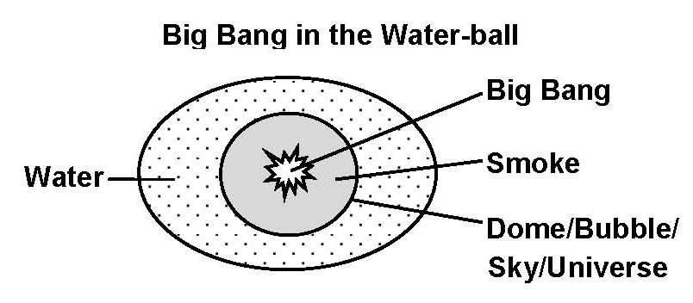
FIGURE 4.1

Due to the pressure of evolving gas, the water-ball burst. The water gaining greater momentum scattered and drifted away from the smoke. The water has been used to create the Jannaat.

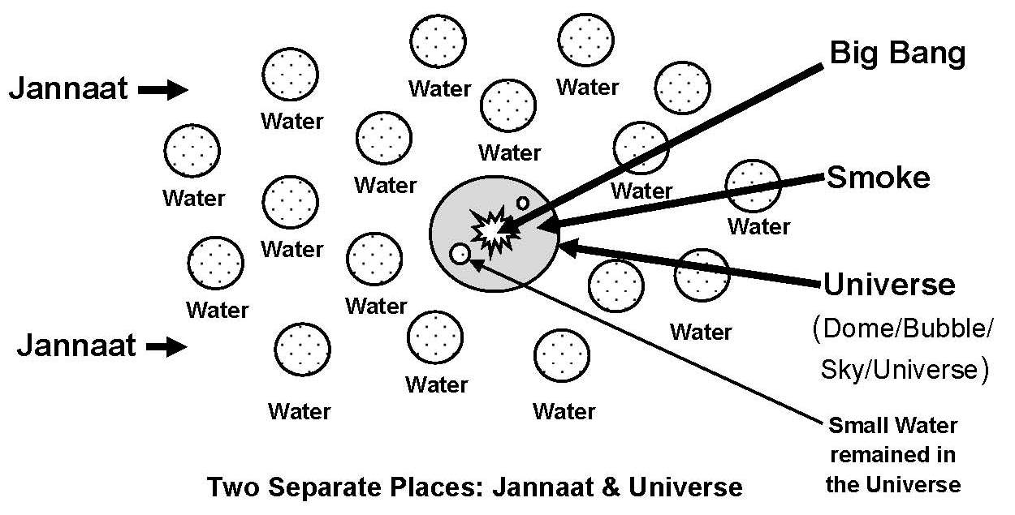

FIGURE 4.2

The Verses talk about “Two Separate Places”: “Let there be dome to divide the water and to keep it in two separate places”. These two Separate Places are two universes: the Samawaat (this universe) and the Jannaat (another universe).
Later, the Earth has been provided with water from this source. The vast oceans were filled up with the fall of water bearing meteors.
It seems that due to the pressure of water, the expansion of the initial universe (bubble / dome / sky) slowed down and halted. The water moved away, and the universe began to contract. The contraction produced silicon and lighter elements.
With silicon and lighter elements, some dust and asteroids (lands) formed in the contracting universe. Eventually, the Universe had a Big Bounce and began to expand again. It seems that the following Verse is talking about the Big Bounce re-initiation of the Universe.

“Do not the unbelievers see that the Skies and the Lands were joined together before We clove them asunder”
[Al Quran 21:30]

The above Verse says that the early Universe had lands (dust and asteroids). It could have lands if it started from a Big Bounce.
From the Big Bounce, the Universe could revive as a Seven-Sky-Universe. The Skies are waves of space, one inside another, like the peels of onion. The Skies ensured balanced distribution of matter and balanced expansion of the Universe. The gases could concentrate into the conglomerates to form the galaxies.

“Moreover, (He) was established into the Sky while it had been smoke. He said to it and to the lands: “Come ye together, willingly or unwillingly.” They said: “We do come, in willing obedience.” So, He completed them as Seven Skies in Two Days, and He assigned to each Sky its duty and command. And We adorned the lowest Sky with lights and with guard. Such is the Decree of the Exalted in Might, Full of Knowledge.”
[Al Quran 41: 9-12]

The Universe was fine tuned by assigning the duties and commands to the Skies (for example, the atmospheric layers fulfill their duties by obeying the commands of God).
In this model, the first generation stars were not required to produce the elements for the long lasting second generation stars, like the sun. And, the Universe could form in a shorter time.
The elements heavier than silicon were supplied to the Earth about 4.6 billion years ago from a Supernova Explosion.
However, in the discussion of Judgment Day, I will remain close to the commonly accepted scientific theories.

3c. Two completely separate Entities

From the Hadith we know that there are Seven Skies and Eight Jannaat, and they are not connected to each other, directly. None is able to go out from this Universe (Samawaat) except through Special Path (As-Sirat):

“O ye assembly of jinns and men, if it be ye can pass beyond the boundary of Skies and Lands (this Universe), pass ye! Not without authority shall ye be able to pass!” [Al Quran 55:33]

During the Night Journey (Miraj), Prophet (pbuh) went into the Jannaat through the Special Path. On the Day of Final Judgment too, people will move to the Jannaat through the Path.
Therefore, Jannaat and Samawaat are completely separate universes.

4. Location of Jannaat

“Be quick in the race for forgiveness from your Lord and for a Jannaat, whose width is that of the Skies and Lands (this Universe), prepared for the righteous…”
[Al Quran 3:133]

“Race to forgiveness from your Lord and the Jannaat; the width of which is as the width of the Sky and Land”
[Al Quran 57:2]

Two entities with equal width cannot remain one inside another. Therefore, the Samawaat and the Jannaat are separate universes altogether.
Holy Bible too talks about a separate universe as the place of Salvation.

“Because only a few will be saved, God has created two Universes instead of only one”
[2 ESDRAS 7:50, Holy Bible, GNB]

Therefore, according to the Quran, Holy Bible and Hadith, there is another Universe, named Jannaat, at the outside of this Universe. We may not have a scientific basis of it, but the idea of its existence is supportive to the salvation scenario, pertaining to the Universe that culminates into a Point of Doom and resurrects as Hell (confirmed in subsequent Chapters).
Scientists would tell that there is nothing beyond the Big Bang; that the time began at the Big Bang; that the Universe has no outside, and so on—because they do not know.
This fine-tuned universe proves the existence of God. And the Quran is proven Message from Him.

5. General Appearance of the Jannaat

The Jannaat is full of habitable planets (objects). The planets of Jannaat are scattered in eight layers of space (Space of Jannaat).

"One in the lower level of Jannaat will observe a higher one like a rising star in the eastern or western corner of the sky."
[Bukhari]

"Martyrs live in the Jannaat located beneath the Arsh, which look like bright stars from the Seventh Sky" [Hadith]

A person from a planet of Jannaat will see the planet of another person like a bright star, as we see planet Mars, Venus, etc., like bright stars.
The planets of Jannaat are big—the smallest one is ten times bigger than the Earth.

“The poorest in the Jannaat will own an area, ten times bigger than the Earth”
[Hadith]

In this Universe, gravity of such a big object (ten times bigger than the Earth) would be too strong. It would explode due to high pressure and temperature resulting from its gravitational contraction. It seems that some of the natural laws of the Jannaat are different from those of this universe. Construction of the planets/objects may be different too. The objects of Jannaat may have the cores of water.
The nature of Jannaat is not exactly same as the nature of the Earth. According to the Hadith, there is no night and day in the Jannaat; even after a long period of time, people will feel that they have entered the Jannaat shortly; they will not become tired; they will not sleep (but will rest sometimes in the beds). The Jannaat is a static universe, probably so sense of time will be different over there. One’s time will flow if one works.
They will never be old. Their orders will be materialized instantly—plants, animals and physical objects will obey their orders (matter is conscious).

6. Large scale Structure of the Jannaat

According to Hadith, the planets of Jannaat are scattered in eight layers of space (Space of Jannaat). The distance between two adjacent layers is like the distance between two adjacent Skies. If a “sphere of voids” between two adjacent Skies is 150 million light years thick, then the distance between two adjacent layers of the Jannaat is 150 million light years too (Skies are discussed in Chapter-7 where the “sphere of void” is clarified). The names of the layers are as follows:
Firdaws (May be the Highest)
Nayeem (May be the Highest)
Mawa
Makam
Karar
Salam
Adan
Khuld (Lowest).
In the Samawaat (this Universe), one Sky surrounds the inner Sky the way white part of a boiled egg surrounds the inner yellow part. But the layers of Jannaat do not surround each other; the layers stand side by side, as all layers fall directly under the Arsh:

“All Jannaat have single roof that is the Arsh of Allah” [Hadith]

The Layers of Jannaat stand side by side, but in ascending order, as it is mentioned in the following Hadith:

“The Layers of Jannaat are laid out like the steps of a staircase” [Hadith]

We know from the Hadith that the Jannaat is a vast creation. Nobody other than Allah knows how big it is? There must be billions of planets in each layer of Jannaat. Each human will be given one or more of those planets.
Angel Gabriel has 500 wings. With one swing of a wing, he can travel a distance of 500 years. Once he was flying through the Jannaat. Suddenly, he felt that it (the Jannaat) was not ending! To see the end of Jannaat, he started to use more number of wings. At the end, he was found thrusting all of his wings to the pick of his power, but there was no end. After some time, Allah checked him, and he realized that it was an audacity to try finding the end of creation when he stopped and turned to Allah for forgiveness.

7. Conclusion

Allah created Adam and Eve in the Jannaat. Therefore, humans are designed to live in the Jannaat. But we are living in the Earth. The Earth has been made suitable for our exile living.
But, the Earth is not that good. Here gravity is strong; everybody suffers from the back problem at least once in his lifetime. After a lot of processing a man eats, but it creates diseases and constipation. Our intestines are not created for these foods. We are helpless without doctors and hospitals.
However, the Earth is okay for this short earthly life. In this Universe, there is no other planet suitable for us.

7a. Women in Jannaat

An earthly woman (a child of Adam) is as good as a man. A woman will get an independent domain in the Jannaat—she will not be under her husband.
However, relatives will often meet each other. In Jannaat, people will have means of transportation and will have visits and gatherings. A man who guides his family in the path of Islam will be sent to Jannaat with his family. But, in the Jannaat, each of them will have dedicated domain.
Humans are created as Vicegerents of Allah. So, human males and females have inherent tendency to command. Two Commanders, may be one male and one female, in one domain do not make a peaceful living.
Original women of Jannaat (hurries) are created differently. They are not from Adam and Eve. So, they are not human beings. They cannot be jealous of one another.

7b. Anti-Universe and Jinns?

The Jannaat is not anti-universe of this Universe. A universe and an anti-universe should originate from the same source (Big Bang). But the Jannaat is created separately.
However, the perception of anti-universe is not a fiction in religious view. This universe (Samawaat) really has an anti-universe. The anti-universe is the domain of jinns. The universe that contains five times more dark matter than matter should possess anti-creatures made out of dark matter (anti-matter is a kind of dark matter). The anti-universe exists in this universe—one inside another, but in different dimensions.
The anti-universe is the domain of jinns and their supporting creatures. The Samawaat (this Universe) is suitable for them—they are often called “Sons of the Skies (Samawaat)”.
The Quran says that jinns are created from the fire of hole (black hole).

“And the Jinn race, We had created before from the fire of hole”
[Al Quran 15:27]

The Arabic word “samumi” means “hole” but it is normally translated as “scorching”, because when there is a hole in the body, it scorches. “Samumi” actually means “hole”.
In above Verse, the “hole” (samumi) means black hole. A black hole produces fire in the accretion disc by splitting the atoms through friction. According to Hawking’s idea, the particles gain energy from gravitational field and join the accretion disc. The anti-particles have opposite momentum and fall into the black hole. The black hole loses its energy then.
Therefore, a black hole is a depot of anti-matter. So, the “fire of hole” means “anti-matter”. The jinns are created from the anti-matter.
With every galaxy there is an invisible anti-galaxy, the abode of jinns. The same gravitational force bound both the galaxies. So, the visible objects of a galaxy and the invisible objects of the anti-galaxy make two different dimensions, with the black holes as the connectors.
This Universe (Samawaat) is a two-in-one Universe: one is for the creatures of ordinary matter (baryonic matter), and another is for the creatures of anti-matter. We are top creatures of the ordinary matter; the jinns are top creatures of the anti-matter.
If dark matter constitutes 80% of Milky Way galaxy, then 80% of the galaxy is not visible to us. The invisible part includes many animals made out of anti-matter. The jinns are top creatures among them. They are intelligent. They will face the Final Judgment.
This Universe (Samawaat) will perish and revive, including its anti-universe. But the Jannaat is everlasting. So, Jannaat cannot be anti-universe of this universe.

8. Summary

The Jannaat is located at the outside of this Universe (Samawaat). It is a different Universe altogether. The Jannaat is original home and desired final destination of mankind.
CHAPTER-5: Fire of Hell

In this Chapter, I shall identify the Objects of Hell in light of the Quran and Hadith. The discussion will progress in the following sequence:
1. Location of Hell
2. Identifying the Fire of Hell
3. The Fire
4. The Objects of Hell
5. The Objects of Hell, as said in the Hadith
6. Hell in General
7. Living in the Hell
8. Conclusion

1. Location of Hell

There are many Verses in the Quran as well as there are many Hadiths, which confirm that the Objects of Hell are evolving in this Universe (Samawaat).

“And We have adorned the Sky of the World with lamps (stars), have made such missiles (meteorites) to drive away the satan, and have prepared for them the penalty of the blazing fire of hell”
[Al Quran 67:5]

According to above Verse, the Sky of the World holds lamps, missiles and “blazing fire of hell”. What about higher Skies?

“During Miraz, I saw in the Seventh Sky: there were thunder and roaring sound and a group of people. Their bellies were as big as houses. In those, there were many snakes, which were being seen from the outside. I asked to Gabriel, which kind of people they were? He said, “It is the scene of those, who devoured usury.”
[Hadith, Bukhari]

One may read the description of Miraz, when Prophet Muhammad (pbuh) observed the Objects of Hell in each of the Seven Skies. This Universe (Samawaat) will be known as the Hell after the Final Judgment.
We have already discussed in Chapter-4 that the Jannaat (paradise) is a separate Universe altogether.

2. Identifying the Fire of Hell

Following Hadith identifies the Fire of Hell:

"After burning for thousands of years, the fire of hell becomes red. Again, after burning for thousands of years, it becomes white. Then, after burning for thousands of years, it becomes dark black and remains in that state" [Tirmizi]

The above Hadith narrates major stages, through which the Fire of Hell is produced. These “Stages” and the “Stages of Stellar Evolution” are the same. So, a massive star produces the Fire of Hell through a process of evolution when it turns red – white – and black.
For the ease of explanation, I have divided the Hadith in three parts, as follows:

Part 1 of the Hadith: “After burning for thousands of years, the fire of hell becomes Red…” [Tirmizi]

Part 2 of the Hadith: “…Again, after burning for thousands of years, it becomes White…” [Tirmizi]

Part 3 of the Hadith: “…Then, after burning for thousands of years, it becomes Dark Black, and remains in that state.” [Tirmizi]

2a. Part 1 of the Hadith

“After burning for thousands of years, the fire of hell becomes Red...” [Tirmizi]

This part of the Hadith points out the formation of Red Giant Stars. After burning for a long time, a massive star becomes a Red Giant. In stellar evolution, it is the end state of the first phase.
The Big Bang produced hydrogen. Later 25% hydrogen turned into helium. A star can form out of these two gases. Helium being heavier than hydrogen deposits below the hydrogen and forms the core of the star.
The star gradually contracts due to gravitational force. So, the pressure and density in its center continue to increase. The increasing pressure and density raise the heat progressively. At one stage, the pressure and heat initiate nuclear fusion reaction. Hydrogen near the center undergoes fusion reaction and produces tremendous heat. The heat tries to expand the star.
In one hand, gravity tries to squeeze the star; on the other hand, extreme heat produced in and around the core tries to expand the star—it brings a balance. A balanced star burns for millions of years and produces helium through nuclear fusion reaction. The helium being heavier than hydrogen deposits into the core.
Due to the continuous supply of helium from the shell of burning hydrogen, the helium-core gets bigger and bigger. The growing helium-core has no energy source of its own. When it reaches to a critical mass, it starts collapsing due to its own gravitational force, and the outer hydrogen layer expands. The hydrogen layer growing in many folds stretches out into the space. This is the Red Giant State of a star.

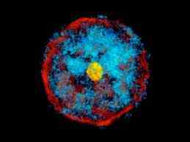

FIGURE 5.1: The Red Giant

In a Red Giant, the outer hydrogen layer is inflated like a huge balloon when the inner helium core is contracting.
“At first, hydrogen burns in a shell, rather like an eggshell, surrounding the core of helium left behind by the main-sequence burning stage. The shell of burning hydrogen dumps its ‘ashes’ on to this core, building it up progressively with supplies of more and more helium. But the core with no energy sources of its own cannot grow indefinitely. When it reaches to a critical mass the center collapse and the outer layer of the star expands stretching out into space and growing in size one hundred-fold.
– The Life and Death of Stars by Geoffrey Bath in The Encyclopedia of Space Travel and Astronomy edited by John Man

So, after burning for a long time, a star becomes a “Red Giant”. And, this Part of the Hadith says: “After burning for thousands of years, the fire of hell becomes Red…” [Tirmizi]

2b. Part 2 of the Hadith

“…Again, after burning for thousands of years, it becomes white…” [Tirmizi]

This Part of the Hadith points out the White Dwarf state. In the stellar evolution, it is the end state of the second phase.

The gravitational force continues to squeeze the helium core of a massive Red Giant Star. It progressively increases pressure and density in the center. The increasing pressure and density develops the heat. Eventually, the center of the helium-core becomes hot enough to ignite fusion reaction in helium nuclei. Helium in the center undergoes fusion and produces more complex elements, mainly carbon and oxygen. Carbon and oxygen being heavier than helium deposit into the core.
“As the central regions are taken over by helium burning, the outer regions expand in the way we have described. The star has mush-roomed into a huge, inflated gas-bag with a tiny, dense nuclear burning region in the center. In this way, the cool red giant stars found in globular clusters are produced; the red giants have exhausted their central hydrogen fuel and are on the road to senility and death. What about the even more massive Stars”
– The life and Death of Stars by Geoffrey Bath in The Encyclopedia of Space Travel and Astronomy edited by John Man

“The central region continues trying to disappear down to a central point, collapsing towards higher densities and increasing in temperature, until the center becomes hot enough for helium to ignite and undergo fusion reaction which yield more complex elements, principally carbon and oxygen. Thus, helium formed as the ashes of hydrogen burning becomes the fuel for the next chapter in a star life, the Red Giant State”
– The Life and Death of Stars by Geoffrey Bath in The Encyclopedia of Space Travel and Astronomy edited by John Man

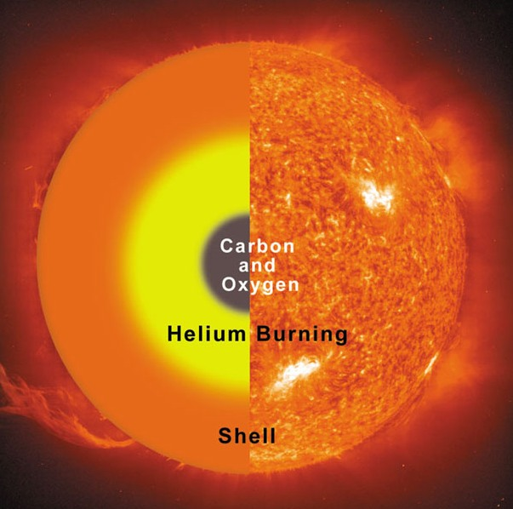

FIGURE 5.2: Carbon and Oxygen deposit in the Core

“The ignition of helium is only the first in a whole series of stages in which more complex nuclei are successively burnt. As each nuclear fuel is burnt out and exhausted in the center, collapse of the inner core sets in again. Collapse continues until the temperature is high enough for the ashes of the previous burning stage to ignite. Helium burns to carbon and oxygen, carbon and oxygen burn to silicon, silicon burns to iron”
– The Life and Death of Stars by Geoffrey Bath in The Encyclopedia of Space Travel and Astronomy edited by John Man

In this way, a massive star produces the cores of heavier elements one after another:
- Hydrogen undergoes fusion and produces helium; helium being heavier than hydrogen deposits into the core.
- Helium undergoes fusion and produces carbon and oxygen mainly; carbon and oxygen being heavier than helium deposit into the inner core.
- Carbon and oxygen undergo fusion and produce silicon mainly; silicon being heavier than carbon and oxygen deposits into the even inner core.
- Silicon undergoes fusion and produces iron mainly; iron being heavier than silicon deposits into the center.

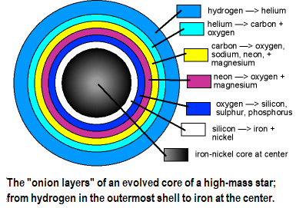

FIGURE 5.3: Star at the end of Red Giant State

Iron is the last element produced in this way, because elements more complex than iron, such as uranium, have tendency to undergo fission (splitting apart spontaneously) and produce less complex elements.
“What halts the sequence of burning to even more complex nuclei? At the point when iron is being forged in the center of a massive star, with surrounding shells of silicon, oxygen, carbon, helium and hydrogen, the end of the road is near. When the iron core collapse there is no hope of a new reaction stepping in, to save the star, for it is not possible to fuse iron into more complex element (such as uranium) and release energy at the same time. Indeed, elements much more complex than iron have a tendency to undergo fission, splitting apart spontaneously into less complex elements”
– The Life and Death of Stars by Geoffrey Bath in The Encyclopedia of Space Travel and Astronomy edited by John Man

The iron core gradually cools and shrinks due to gravitational force. Eventually, it is squeezed to such density that a glass of matter weighs several tons. At certain stage, the electrons exert a special kind of pressure (exclusion principle repulsion between the electrons in its matter), as they become “degenerated”. The pressure balances the star against the gravity. So far the star remains below a critical mass, the electron pressure can save the star from further collapse. A star at this stage can cool without collapsing. These are called “White Dwarfs”.

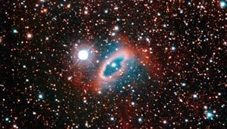

FIGURE 5.4: White Dwarf

The evolution of many stars ends at the state of White Dwarf. A White Dwarf is a compact star slowly cooling off in the space. Normal gas on its surface heats up when it is squeezed. It leads to series of nuclear burning reactions in the outer layers of the object. Thereby, the White Dwarf shines.
So, we find that after burning for a long time, a Red Giant becomes a White Dwarf. And this Part of the Hadith says: “…Again, after burning for thousands of years, it becomes White…” [Tirmizi]

2c. Part 3 of the Hadith

“…Then, after burning for thousands of years, it becomes dark black and remains in that state.” [Tirmizi]

Finally, the fire of hell becomes dark black and remains in that state forever. These are Black Holes—the final state of a massive star.
A white dwarf radiates and gradually cools off in the space. Electron pressure cannot stop the collapse of a massive white dwarf. If the mass of a white dwarf is more than one and a half time of the mass of the Sun (known as Chandrasekhar’s Limit), then the gravity is strong enough to squeeze the object further.
Down to further collapse, electrons and protons bind together and become neutrons. At this state, a star is called Neutron Star where density of matter per cubic inch would be hundreds of million tons. Neutron exerts Neutron Degeneracy Pressure (the exclusion principle repulsion between neutron and proton) which can hold a star of up to three solar masses from further gravitational collapse.
“The white dwarf cools off in space and becomes steadily fainter and fainter as they slowly freeze. Eventually they form completely dead stellar stumps. In atoms electrons and protons are crushed together even more than they are in a white dwarf. They bind together forming neutrons. Neutrons exert their own ‘Neutron Degeneracy Pressure’, which is even more powerful than that of electrons. It is able to support a star of up to three solar masses. A neutron star with the mass of the Sun would be about the size of Manhattan”
– The Life and Death of Stars by Geoffrey Bath in The Encyclopedia of Space Travel and Astronomy edited by John Man

If a star possesses more mass than three solar masses, the gravitational force can overcome Neutron Degeneracy Pressure, and the star squeezes further. Eventually, it turns into a Black Hole.

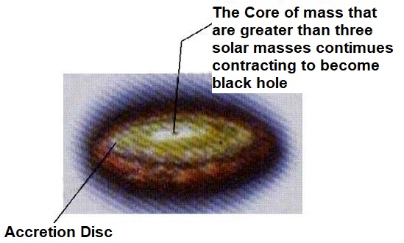

FIGURE 5.5: Formation of Black Hole

“The collapse continues indefinitely. All the matter showers into a central point, squashed by gravity to infinite density and form a black hole. Densities are reached which are so enormous that light itself cannot escape from the surface. With the increasing strong gravitational fields associated with the increasing density the velocity needed for escape increase. Eventually a stage is reached at which this escape velocity is greater than the velocity of light. Nothing can escape, then or even after. The collapsing star disappears behind an impenetrable horizon, the Event Horizon, and is hidden forever from our eyes”
– The Life and Death of Stars by Geoffrey Bath in The Encyclopedia of Space Travel and Astronomy edited by John Man

In some cases, the stars having less mass than three solar masses grasp matter from the surrounding space (if available) and overcome the neutron degeneracy pressure at some points of time. The stars then squeeze further and turn into black holes.

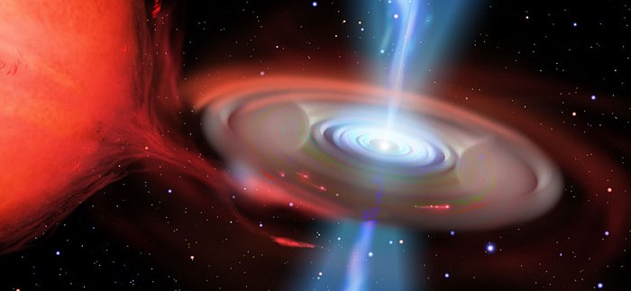

FIGURE 5.6: Black Hole

In some cases, due to intense gravitational force, the outer layers of the white dwarf or the neutron star collapse. All of a sudden, the gas becomes extremely compressed and overheated. Consequently, the outer layers of the star explode. The explosion is called “Super Nova Explosion”.

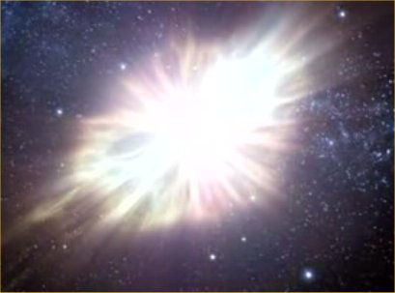

FIGURE 5.7: Crab Supernova Explosion

The core of the star shrinks due to extreme implosive pressure and becomes a Black Hole.
The elements that are heavier than iron, such as gold, platinum, uranium, etc., are produced due to the extreme pressure and temperature of supernova explosion. All elements that were produced and deposited in the outer layers of the star are flung out into the space.

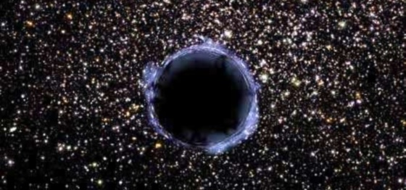

FIGURE 5.8: Black Hole

So, after burning for a long time, a White Dwarf becomes a Black Hole. And Part 3 of the Hadith says: “…Then, after burning for thousands of years, it becomes Dark Black and remains in that state.” [Tirmizi]
All stars cannot cross all the stages. A star having less mass possesses less gravitational force. It burns slowly for a long time. Depending on the amount of matter, some stars end at Red Giant State and some at White Dwarf State. Only a massive star can turn into a Black Hole at the end of its evolution.
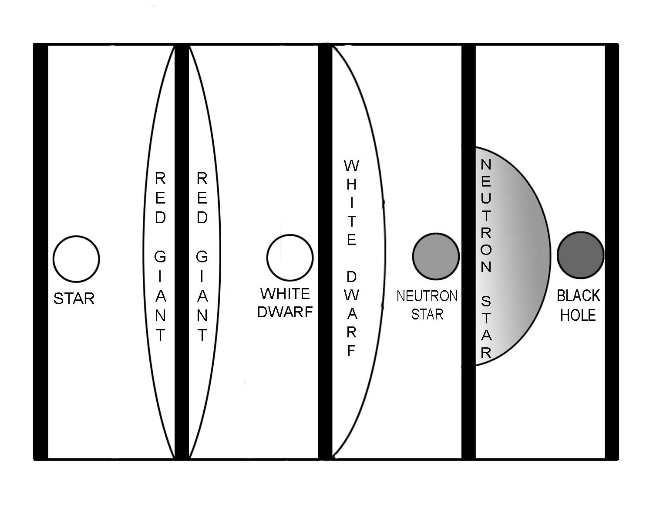
FIGURE 5.9: Stages of Collapsing Star

If a star of one solar mass turns into a Red Giant, its diameter will increase to one hundred forty million km. When our Sun will turn into a Red Giant, it will expand, and its perimeter will cross the orbit of Mars. If it turns into a White Dwarf, it will squeeze, and its diameter will reduce to thirteen thousand km. If it becomes a Neutron Star, its diameter will be sixteen km only. And, if it becomes a Black Hole, it will be half a km across (Stars with the mass of the Sun end at Red Giant stage).

Note:

A Black Hole is a theoretical end state of a massive star. If it is found wrong, then the Neutron Star is the end state. The Neutron Stars too are black, as they have nothing to radiate. They too serve the purpose of hell.

3. The Fire

The evolution of the ‘fire of hell’ and the evolution of a black hole are the same according to the Hadith. But we cannot address a black hole as the fire of hell, because a black hole itself is absolutely cold.
But, if we explore further, we find that a black hole produces the most violent and the hottest fire of the universe. They make the pivots of the objects of hell.
A black with its extremely powerful gravitational force sucks matter from the surrounding space; sometimes it tears off matter from a nearby star; sometimes it sucks up a whole star. A black hole may even squeeze the whole galaxy around itself.

A black hole can absorb matter without releasing much of energy when the amount is small. If a stone is thrown into a black hole, it will just vanish being squeezed to a size smaller than a dust. But, if the amount of matter is huge, a black hole cannot absorb it immediately.
“But if the mass of several million stars is compressed around it, there will be a massive pile up of material- gas, dust and even whole stars- sucked in by the intense gravity field but unable to squeeze immediately into the tight ‘throat’ funneling down into the hole”
– The Life and Death of Stars by Geoffrey Bath in The Encyclopedia of Space Travel and Astronomy, edited by John Man

Inside the collapsing material, a black hole rotates in a tremendous speed winding its strong magnetic field around itself. Due to rotating magnetic field, the collapsing material cannot fall into the black hole directly. It spreads a blanket of in-falling material in the plane of rotation—like the ring of the Saturn, but on a vastly greater scale. The swirling material then releases energy due to friction (the friction causes fission).
Thus, the magnetic fields associated with a rotating black hole produce the Accretion Disk, where tremendous heat is produced.
“A central black hole surrounded by a swirling mass of material which is constantly being fed from outside and heated up by collision. These are called ‘Quasars’. As much as 20% of this whirlpool mass can be turned into energy. This is how a quasar can shine for a hundred million years or more while devouring the heart of a galaxy”
– The Life and Death of Stars by Geoffrey Bath in The Encyclopedia of Space Travel and Astronomy, edited by John Man

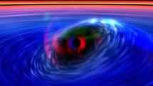

FIGURE 5.10: Black Hole

“Quasars come in a variety of shapes and size, sometimes with a radio structure spreading across millions of light years, but all of them deriving their energy from some tiny central source, which may produce bursts of energy up to ten thousand times the energy of all the stars in our Milky Way galaxy put together. Einstein’s most famous equation E = mc² tells us how much energy could be obtained by converting all of a mass into energy and assuming that only a fraction of this mass-energy is being liberated in the quasars. We know that the total mass involved must be much more than a million times the mass of the Sun. Yet it is typically squeezed with in a volume of space no larger across than our solar system, the size of the largest stars. Such an object can only be a giant black hole. But black holes in theory, absorb radiation; they cannot shine as the brightest phenomena in the universe. But there is no paradox. It is not the quasar that shines; it is the matter around it.”
– The Life and Death of Stars by Geoffrey Bath in The Encyclopedia of Space Travel and Astronomy, edited by John Man

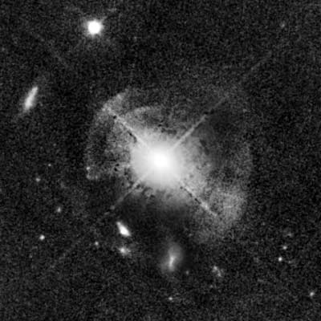

FIGURE 5.11: Quasar MC2 1635+119

“The whole picture hangs together in a thoroughly satisfactory way, given the reality of black holes and the efficiency with which gravity can turn a million or so solar mass into energy. Of course, the energies are like nothing we experience on the Earth. But why should they be? The universe is not only much bigger than we can really imagine, it is unimaginably more violent than anything conceived of only a few years ago”.
– The Life and Death of Stars by Geoffrey Bath in The Encyclopedia of Space Travel and Astronomy, edited by John Man

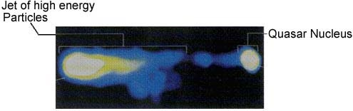

FIGURE 5.12: Quasar (3C273)

A black hole, surrounded by a swirling mass of material, producing immense heat through friction, is called a Quasar. The Quasars are the most violent objects in the Universe.
It is thought that every galaxy harbors a super-massive black hole in its central hub. The central hubs are associated with hot gas in violent motion and immense radiation.

4. The Objects of Hell

The following Verses of the Quran prove the quasars and the galaxies as the objects of hell.

4a. Mother of the Sinner

“But he whose balance will be light, his mother will be endless hole. And what will explain to thee what this is? A fire blazing fiercely” [Al Quran 101:8-11]

The endless hole that is blazing with fierce fire should be a quasar. It may be the central super-massive black hole of a galaxy as well. The fierce heat is produced around the super-massive black hole in the hot gas in violent motion.

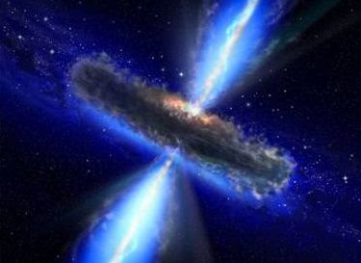

FIGURE 5.13: Quasar

In this Universe, only a black hole can be termed as the “endless hole”. It is a perfect place to arrest and punish a jinni. A nearby planet can be an abode of a sinful human, under punishment.

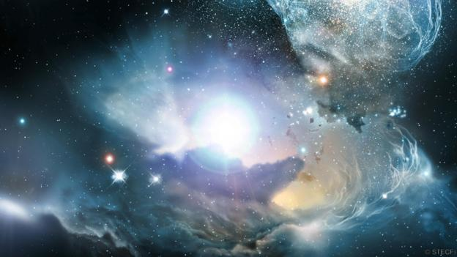

FIGURE 5.14: Quasar

4b. No means to Turn Away

A sinner will be put into an object close to a black hole so that he is punished with the fierce heat. The planet will be so close to the black hole that the sinner will always be in tension that his object of abode may run into the Accretion Disk any time! As it is said in the following Verses:

“One Day He will say, "Call on those whom you thought to be My partners," and they will call on them, but they will not listen to them. And We shall set a Crucible (Mawbiqan) between them, and the sinful shall see the fire and apprehend that they have to fall therein—no means will they find to turn away from there.”
[Al Quran 18: 52-53]

The extremely powerful magnetic fields, associated with a rotating black hole, produce the Accretion Disk. The matter, falling into a black hole by following the spiral of gravitational force, swirl in the Accretion Disk at a violent speed and gets destroyed due to friction and produce devastating heat. In above Verse, the “Accretion Disk” is called “Crucible” (Mawbiqan). A crucible is a container in which metals or other substances are melted or subjected to very high temperatures.
In one galaxy, there will be one human. But, there will be a good number of other creatures, such as poisonous snakes, insects, the jinni who was invested by Iblis (Chief Satan) to misguide him, the idol-jinns that he used to worship, and so forth. The jinns will not answer his call because they will be in a different dimension of the galaxy.
We cannot see a complete galaxy. We see objects of visible (baryonic) matter only. In a galaxy, there are dark matters, five times more than the visible matter. The visible matter and the dark matter form two different dimensions of a galaxy. The same gravitational field binds matter and dark matter. So, a black hole can be viewed as a door connecting the dimensions.
The jinns created from anti-matter live in the dimensions of dark matter; humans live in the dimensions of visible matter. If the jinns are called, they are supposed to come out through the black hole, but they will not be able to come out easily, because of the Mawbiqan (Crucible / Accretion Disk).
If the jinns are creatures of different dimension, how humans can see them and call them? But, in above Verses, Allah is asking the hell dweller to call the jinns. It means that a human has potential ability to see the jinns and call them, or he will have such ability after the resurrection. How it may be possible is discussed below:
The nafs (main / composite soul) of a hell-dweller may be enhanced so that he possesses the nafs aided vision (third-eye-vision), suitable to see the anti-creatures, like the jinns.
A human nafs is a combination of known and/or unknown force fields (elementary souls / ruhhs). Some of the force fields interact with the anti-matter. For example, the Gravitational Force Field works on both matter and anti-matter.
The nafs of a human spreads throughout his body, and it has vital points. The vital point of the forehead will work as the third eye. The eye will receive the anti-energy reflected from the body of an anti-creature and will create vision in his mind.
The mind (qalb) is the virtual extension of brain in the chest. The mind is produced by the special ruhh (an elementary soul / force field), given by God directly to a human. The ruhh sets in some muscles of the chest and produces the mind by the help of nerves and brain. Mind is the basis of vision.
So, it will be possible to see the anti-creatures through developed nafs and qalb (mind). A resurrected human will see the creatures with his baryonic eyes and anti-creatures with his third eye. So, on the Day of Judgment he will see the angels, jinns and humans. He will find them equally real.
[For detail discussion on these matters, read my Tafsir, “The Scientific Tafsir of the Quran”]

“…I will fill Hell with jinns and men all together” [Al Quran 11:119]

“…I will fill Hell with jinns and men all together”[Al Quran 32:13]

“…We made the satans (jinns) friends to those without faith.” [Al Quran 7:27]

A person will be a Vicegerent of God over a whole galaxy, but a jinn does not obey so easily, as Azazil (now the Chief Satan / Iblis), a jinni, denied to prostrate himself before Adam.
Moreover, a crucible surrounding a black hole works as a barrier. So, it will be difficult for a jinni to come into human dimension and help.

4c. The Mighty Adjuration

“But nay, I swear by the Houses of Stars (Mawaqin-Nujumi / Galaxies). And, indeed it surely a swear if you know great” [Al Quran 56: 75–76]

The stars are not haphazardly scattered throughout the space; they are collected into systems called galaxies. So, “Mawaqin-Nujumi” (Houses of Stars) means “Galaxies”.
There are billions of galaxies in the Universe. We live in the Milky Way galaxy.
But why, in above Verse, Allah is trying to scare us by pointing out the galaxies? There could be no other reason but that one day, many humans will be destined to live in those galaxies.
Subsequently, I have quoted the Verses that clarify that a sinner will be posted into a galaxy as a Vicegerent of God. But they will be forgotten Vicegerents; they will not get any divine help. They will be in pain due to the very nature of their abodes (Galaxies / Mawaqin-Nujumi).

Humans are Vicegerents of God by birth. When Allah intended to create Adam, He did not say, “I am going to create a new species of animal;” He said: “Behold, thy Lord said to the angels: “I will create a vicegerent on a land”” [Al Quran 2:30]. In this Verse, the “land” does not mean Planet Earth only; any object in this Universe is a land. The good ones will be Vicegerents of God in the objects (lands) of the Jannaat, and the bad ones will be Vicegerents of God in the objects (galaxies holding lands) of this Universe.
Every galaxy holds a super-massive black hole in its center. The matter falling into the black hole rotates at a violent speed and release devastating energy. A sinner placed in an object near a black hole will be burning, but he will not die.
An exploding galaxy is called Seyfert Galaxy. The N-galaxies are more violent than the Seyferts. Observation shows that the amount of matter in the central hub determines how violent a galaxy should be.
“The classic examples of exploding galaxies are called Seyfert galaxies. These galaxies were first identified in 1943 by Carl Seyfert, after whom they are named. He found that about one percent of all spiral galaxies have very insignificant spiral arms but very bright central regions. Such systems have now been studied across the spectrum. The observation shows that the radiation of the nucleus is produced by hot gas in violent motion with a central condensation, concentrating the mass of millions of Suns in a small volume”
– The Life and Death of Stars by Geoffrey Bath in The Encyclopedia of Space Travel and Astronomy, edited by John Man

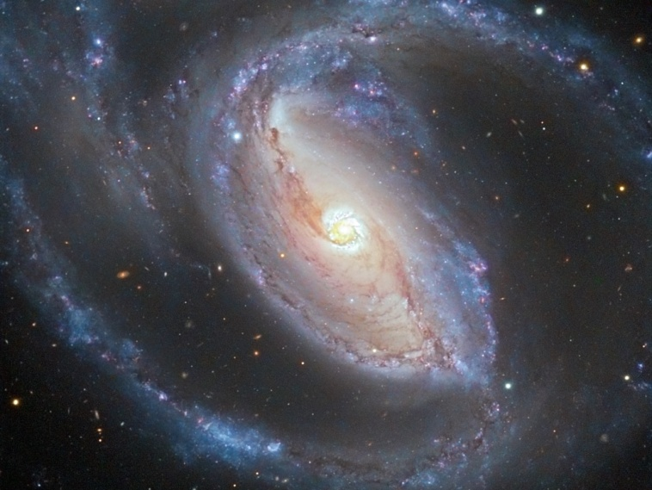

FIGURE 5.15: Potw1128 a Seyfert

Allah is not pushing humans into those objects; it is some humans who are moving there by following the satan jinns. Allah is Merciful; He will just make one robust enough to survive over there. But even a giant too feels pain.

4d. That collects and hides

“By no means! For it would be the Fire of Hell! Plucking out right to the skull! Inviting such as turn their backs and turn away their faces, and collect and hide it!
[Al Quran 70: 15-18]

A black hole pulls everything from the surrounding space with its immensely powerful gravitational force. So, it invites and collects!
The escape velocity of a black hole is so high that even the light cannot come out. An object fallen into a black hole gets hidden forever. So, a black hole collects and hides!
However, a sinner will not fall into a black hole. He will only feel its devastating attraction and heat, as the Verse say: “…Inviting such as turn their backs and turn away their faces…!”
In the life on the Earth, he used to collect and hide the wealth so that he doesn’t have to spend it in charity. In the afterlife, he will have the object of like nature.

4e. Fire of God

“Woe to every scandalmonger and backbiter!
Who piles up wealth and counts it.
Thinking that his wealth would make him last forever!
By no means! He will surely to be thrown into the Crusher.
And what will explain to thee what the Crusher is?
The Fire of God kindled, which mount up to the Hearts.
Verily, it upon them closed over in columns extended.”
[Al Quran 104]

In above Verses, the “Accretion Disk” is called “Crusher” where falling objects get crushed. The debris swirl round the black hole in a violent speed, and produce devastating energy due to friction.
The fire is produced due to intense gravitational force of a black hole. The Gravitational Force Field is an extended elementary Soul (Ruhh) of Allah. So, in the above Verses, the Fire is called “Fire of God”.
The burning matter and energies erupt through the contours of the magnetic fields associated with a rotating black hole. Thus, the Verse says: “Verily, it upon them closed over in columns extended.”

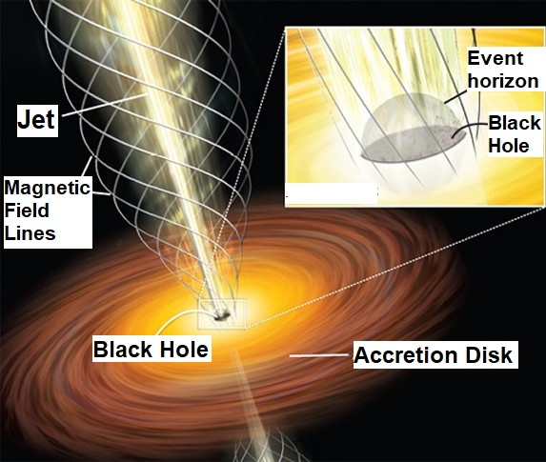

FIGURE 5.16: Column of Magnetic Field

So, the whole galaxy will be affected by the Fire. There will be no object to hide.

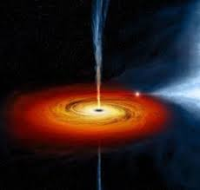

FIGURE 5.17: “closed over in columns extended.”

5. The Objects of Hell, as said in the Hadith

In the following, I have discussed several Hadith indicating galaxies as the objects of hell:

5a. The Boundary of Hell

The Hadith says that the boundary of hell will be four thick barriers of fire:

“Boundary of the hell will be four thick barriers of fire. Width of each barrier will be a distance of 40 years” [Tirmizi]

“They shall have Layers of Fire above them and Layers below them; with this does God warn off his servants: "O My Servants! Then fear ye Me!”
[Al Quran 39:16]

A rotating super-massive black hole may spread layers of magnetic fields. The hot gas spreading in the fields may produce the barriers / layers of fire.

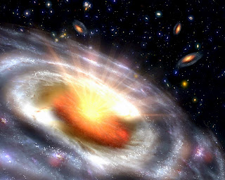

FIGURE 5.18: Quasar

A spiral galaxy has three basic components: nucleus or central bulge, disc with spiral arms, and halo containing globular clusters. No place is safe. One has no reason to be happy that one is going to own a complete galaxy as a Vicegerent of God. A forgotten Vicegerent will be in great problems.

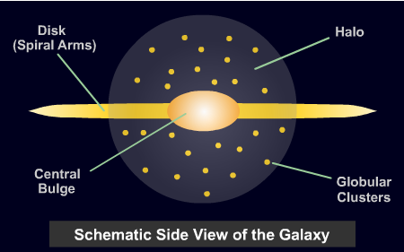

FIGURE 5.19: Three Basic Components of a Spiral Galaxy

A hell dweller will live forever. One day he may be able to make a space ship and move to an object far away from the central hub, but no object is shady and protecting against the sparks produced by the central super-massive black hole. It will throw sparks as forts over him.

“Proceed to that which ye used to reject as false! Proceed to a shadow having three columns, no shade of coolness and is of no use against the fierce Blaze. Indeed, it throws about sparks as Forts, as if there were yellow camels."
[Al Quran 77: 29-33]

In the old times, if one was standing beside a busy trade route, one would see endless camels coming day and night. Such will be the sparks of fire, coming endlessly.
In above Verse, the ‘shadow’ represents the cooler zones of a galaxy. For example, the Earth is in the shadow because the central hub of the Milky Way galaxy or any other Quasar cannot shower the Earth directly. There are obstructing objects. But the shadows of a hell-dweller’s galaxy will be under ‘three columns’ that will throw ‘sparks’ from the ‘fierce blaze’ produced in the Accretion Disk. These are the columns of magnetic fields.

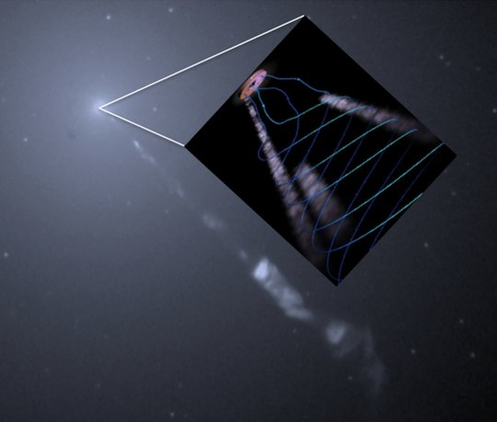

FIGURE 5.20: Hubble Telescope observation of the M87 jets from the accretion disk [Turbulent Mass Injection Process]

5b. Hot and Cold Region

“In the hell, the people suffering from the extreme heat will ask for cold; then they will be thrown into the extreme cold”
[Hadith]

The hell is not full of fire only; it has different regions, hot and cold. Such hot and cold objects should be available in a galaxy. The black hole itself is absolutely cold, when the Accretion Disk is extremely hot.

5c.One part of hell eats another part.

“Hell urges to Allah saying that: ‘O Lord, my one part has eaten up another part’. Then Allah allows it to expel two breathes—one is in the summer, another is in the winter. The extreme heat or cold we may observe in a summer or in a winter are caused due to those breathes.”
[Hadith]

The objects that seem breathing are known as the “Pulsating Stars”. The brightness of a Pulsating Star increases and decreases periodically, like a beacon in the space. These objects (pulsars) have peculiar structures with neutron stars in their centers.
In these breathing objects, one part eats another part by matter–antimatter interaction and produce energy (photons).
The surface layers of the pulsars dam up the photons in their flight. The barrier presented by the outer layers causes the temperature and pressure to build up. It expands the outer layers. In the expanded state, the radiation escapes easily, and the brightness of the star increases rapidly to the pick. Once the radiation is released, the outer layers cool and collapse.
There are various classes of Pulsating Stars including the RR Lyrae, the Mira Variables, and the Cepheids. The RR Lyrae oscillate in a period of less than a day, the Cepheids oscillate in a typical period of five days, whereas the Mira Variables oscillate in a period as long as several years.
If a summer is too hot, it may be because of these objects. The objects radiate anti-particles that may make some of the winters colder than usual.
However, all stars breath. The Sun breaths in a cycle of eleven and half years, but one part of the Sun does not eat another part—it is not divided in matter and anti-matter zones.

5d. Fuel of Hell

According to the Quran and Hadith, stones and iron are fuels of hell.

“…Then fear the fire whose fuel is Men and Stones…” [Al Quran 2:24]

Here it is interesting to notice that only black holes and neutron stars can use iron and stones as fuels. It proves black holes and neutron stars as pivots of the objects of hell.
All stars cannot become black holes or neutron stars. They produce matter that will be used as the fuel of hell. On the Day of Judgment, matter produced in average stars (like the Sun) will be thrown into the hell, as fuel.

Hadith: “On the day of Final Judgment, the Sun and the Moon will be thrown into the hell” [Mashnad-i-Ahmed]

It is mentioned in the Hadith that if a bucket of waste from the hell were thrown into the Earth, the Earth would be destroyed. A bucket of matter that can destroy the Earth is available around a black hole or a neutron star only.

6. Hell in General

The Verses of the Quran and the Hadith point out the galaxies as the objects of Hell. There are many kinds of objects in a galaxy. We have discussed Quasars, Pulsars, etc. But everybody will not be thrown into an extreme object. According to the Quran and Hadith, there are boiling water, trees (Zaqqum) with bitter fruits, poisonous snakes and insects in the hell. These may be available in the planets.

“These two antagonists dispute with each other about their Lord. But those who deny, for them will be cut out a garment of Fire. Over their heads will be poured out boiling water. With it will be scalded what is within their bodies as well as skins. In addition, there will be maces of iron (to) them. Every time they wish to get away from there from anguish, they will be forced back therein—and "Taste ye the Penalty of Burning!”
[Al Quran 22: 19-22]

“Is that the better entertainment, or the Tree of Zaqqum?
For We have truly made it a trial for the wrong-doers.
For it is a tree that springs out of the bottom of Hell-Fire.
The shoots of its fruit-stalks are like the heads of devils.
Truly they will eat thereof and fill their bellies therewith.
Then on top of that they will be given a mixture made of boiling water.
Then shall their return be to the Fire.
Truly they found their fathers on the wrong Path.
So, they were rushed down on their footsteps!
And truly before them many of the ancients went astray!”
[Al Quran 37: 62-71]

The black holes produce the fire of hell. If an object is showered with the energy produced in a black hole, the object should be considered as an object of hell. In this sense, our Earth too is an object of hell, because radiation produced by the black holes comes here too. Our Earth is an object in the region of Jahannam (a level of hell). However, the Earth has got protections at present.

Hadith: “At that time, the lands (planets) and its rivers will be full of fire. Present region of the world will be the region of Jahannam” [Tafsir-e-Mareful Quran]

A hell-man will be thrown into a region of his galaxy according to the verdict of punishment. Each object of hell (each galaxy) is divided in seven levels basing on the degree of punishment; those are: Habia, Laza, Hotama, Sayeer, Sakkar, Zahim, Jahannam.
A person getting the verdict of highest punishment will be thrown into “Habia”. “Habia” means “endless hole”. Therefore, the central super-massive black hole of a galaxy and its surrounding space is the Habia. We know that it is the most violent region of a galaxy.
The more is the distance from the central super-massive black hole, the less is the extremity. So, the outermost region of a galaxy, called “Jahannam”, is the least punishing zone.
If a person is destined to this Universe (hell), his level of sin will indicate in which object of his galaxy he deserves to land. Is it the Central hub, or a Pulsar, or a Star, or a Planet, or an object of any other kind? A galaxy has billions of objects; all are eagerly waiting to receive him, because he is the Vicegerent of Allah over that galaxy. There will one human in a galaxy, or in a group of galaxies.

7. Living in the Hell

How can one survive in such a violent object?
The Quran indicates that a person will not only survive, one day hell will be his home, though he will not get any direct divine help.

“If then they have patience, the Fire will be a home for them! And if they beg to be received into favor, into favor will they not be received (no divine help will be provided). And We have destined for them intimate companions who made alluring to them what was before them and behind them, and the sentence among the previous generations of jinns and men who have passed away is proved against them; for they are utterly lost.”
[Al Quran 41:24-25]

On the Day of Judgment, each person will be resurrected with fully matured soul permanently fixed in his body. His body will be suitable for the object where he will live:

“Do ye then see what ye throw out (sperms carrying haploid chromosomes / DNA Double Helix Molecules)? Is it ye who create it, or are We the Creators?
We have decreed Death to be your common lot, and We are not to be frustrated from changing your forms and creating you in that ye know not.
And ye certainly know already the first form of creation; why then do ye not celebrate His praises?”
[Al Quran 56:58-62]

It is indicated in the Hadith that a person in hell will be huge in size. He will be hundreds of kilometers tall. He will need a space from Makkah to Madinah to sit. His skin will be very thick.
The jobs of ninety-eight percent DNA Double Helix are unknown. And we see on the Earth, how many varieties of living creatures the same DNA Double Helix can produce! The genomes differ in the code only.
So, it is possible to create giants with the same DNA Double Helix molecule. A human will be created suitable for the object where he will live. The Hadith says that if a person from the hell were put into the fire of the Earth, the person would fall sleeping due to excessive comfort.
Their skins will burn, but it will regenerate:

“Those who reject our Signs, We shall soon cast into the Fire. As often as their skins are roasted through, We shall change them for fresh skins that they may taste the penalty; for God is Exalted in Power, Wise.” [Al Quran 4:56]

8. Conclusion

“Most quasars must now be dead, their central black holes starved of matter to swallow up and turn into energy, so they sit quietly at the center of galaxies. Some like Centaurus A, are dying. Some holes never quite got enough mass together to become quasars but have had active past. The universe is a violent place, but less violent then it was, and getting less violent still as time goes by, will it fed away into an ever expanding sea of ever quieter galaxies, with the light of the stars and galaxies going out one by one until all that is left is a void filled with a scattering of black holes? Or, some more interesting fate is prospect?”
– To the Edge of Eternity by John Gribbin in The Encyclopedia of Space Travel and Astronomy, edited by John Man

“We created not the Skies and Lands and all between them merely in sport. We created them not except for just ends. But most of them do not understand. Verily the day of sorting out is the time appointed for all of them.”
[Al Quran 44:38-39]

It is the Day of Final Judgment when people will be sorted out. Some will be shifted to the Jannaat, which is a different universe altogether. The Jannaat is peaceful and original home of humans.
But, the Universe (Samawaat) has not been created in sport. Many will be left here to live in the galaxies (Objects of Hell) forever.

8a. On the Day of Judgment

The Universe is expanding—astronomers observe the galaxies as receding. They think that the Universe may contract. But, in light of the Quran, the Universe is already contracting by rolling up from the outermost boundary (Seventh Sky). It is not possible to visualize the rolling space. I have discussed a likely process in Chapter-8.
Finally, the Skies will be rolled up compactly. In the extremely squeezed Universe (Skies), matter will perish, but their information (photons) will survive.
Thus, the objects of hell will survive as information. After the Judgment, when the Skies will be un-rolling, the objects of hell (galaxies) will be re-gaining their matured forms just by gaining the volumes of space, and they will catch their masters (humans).

“The Striking Hour. What is the Striking? And what will make you know what the Striking is? It is a Day whereon mankind will be like moths scattered about, and the mountains will be like carded wool.
Then as for him whose balance will be heavy, he will live a pleasant life.
But he whose balance will be light, his mother will be endless hole (black hole being released from the rolled up Skies). And what will explain to thee what this is? A fire blazing fiercely.”
[Al Quran 101]

I have discussed the Resurrection and the Final Judgment deliberately in Chapter-9.

Ref:

- Bath, Geoffrey. The Life and Death of Stars in The Encyclopedia of Space Travel and Astronomy edited by John Man. Great Britain: Octopus Books Limited, 59 Grosvenor
- Gribbin, John. To The Edge of Eternity in The Encyclopedia of Space Travel and Astronomy edited by John Man. Great Britain: Octopus Books Limited, 59 Grosvenor Street, London, 1979.
CHAPTER-6: Skies [Large Scale Structure of the Universe]

In light of the Quran, the Initial Universe was a uniform “Single-Sky-Universe”. Later, the overall space of the Universe was redesigned into seven spherical waves, one inside another, like the peels of onion. These seven super-giant spherical waves of space are Seven Skies. Each Sky is full of galaxies and free matter. The space, though waved, is continuous. The design is fit for the Universe that is to roll down into the Point of Doom and revive with resurrected humans. I have discussed the design as under.
1. What the Quran means by the word “Sky” (Samah)
2. What Al Quran means by the word “Skies”

3. Construction of the Skies
4. Structures revealing the Existence of Skies
5. Observational Evidence

6. Other Indications of the Skies

7. Summary

8. Conclusion

1. What the Quran means by the word “Sky” (Samah)

“Do they not see the birds, controlled in the atmosphere (air) of the Sky (Samah)? None holds them up except Allah; most surely there are signs in this for a people who believe” [Al Quran 16:79]

According to the above Verse, the birds are controlled in the atmosphere of the Sky (Samah). The atmosphere begins from the surface of the Earth, and birds fly from the lowest height. Therefore, according to the Quran, the sky begins from the surface of the Earth.
The birds fly all around the spherical Earth. Therefore, the Earth itself is an object in the Sky (Samah).


FIGURE 6.1: The Earth in the Sky

Therefore, in the Quran, the word “Samah” (sky) means “space”.
According to the above Verse, one’s feet are on the ground (Ard) and the rest of body is in the sky (Samah). It goes against the common thought. Therefore, in above Verse, the Arabic word “Jawwi” is normally translated as “the midst” (as: the birds, controlled in the midst of the Sky). But actual meaning of “Jawwi” is “atmosphere / air”.
There are three contexts mainly where the singular words of sky (Samau / Sama-eh / Sama-ah) have been used in the Quran:
The Initial Universe was a single-sky-universe. Later the Universe was structured into Seven Skies. Therefore, the Quran has used the word of singular sky when it has talked about an event of the Initial Universe.
The Universe will be rolled up and squeezed compactly. Subsequently, the Judgment will be held in a different sky (Super Sky / Super Space). When context of the Verse is the Judgment Day, the Quran has used the word of singular sky to mean the Super Sky (Super Space).
The word of singular sky is used to mean the near space of the Earth as well.
Therefore, while reading the Quran, if we find the use of singular sky, we should understand that the Verse is taking about an event of “Initial Universe” or of “End Universe” or of “Near Space of the Earth”.
However, in the Quran, Singular Sky (Samah) primarily means space. It becomes clear when we discuss the qualities of Sky. The Sky has many qualities; followings are a few in light of the Quran.

1a. Sky (Space) can be curved and rolled

The Quran says that a sky can be rolled:

“On the day when We will roll up the Skies (Universe) like the rolling up of the scroll for writings; as We originated the first creation, We shall reproduce it—a promise on Us; surely We will bring it about.” [Al Quran 21:104]

The Verse highlights an important property of the sky (space) that it can be curved, waved and rolled.
To understand the Skies, we need modern idea about space, which is narrated below:
When a metal ball depresses a soft rubber sheet, the smaller objects at close proximity tend to roll down toward the metal ball. Similarly, the presence of matter curves the space.

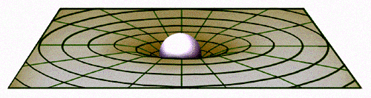

FIGURE 6.2: Curvature of space in two dimensional view

If the space were two-dimensional, the curvature would be like the curvature shown in the picture. It is difficult to draw a three-dimensional sketch of the same curvature. However, it can be visualized with difficulties. But the space is not tree-dimensional. Einstein’s Theory proposes time as the fourth dimension. The proposition has been proved substantially.
If the space was three-dimensional, the Moon would fall into the Earth directly, but it does not fall because of Time. In four-dimensional space-time the Moon is coming straight to the Earth, but in three-dimensional view we see it rotating around the Earth (In the process of rotation, the Moon is closing toward the Earth, but the rate is insignificant).
The curvature of space-time has been proved by the observation as well that the light passing through the side of a massive object (like the sun) bends.
“The General theory extends relativity to gravitational fields. Einstein concluded that the presence of matter distorts space and time, space-time must be regarded together as curved.”
– To the Edge of Eternity by John Gribbin in The Encyclopedia of Space Travel and Astronomy.
Einstein explained gravity as a tendency of matter to move along the curved space-time. In this view, gravity is not a force like other forces; it is felt due to the curvature of space-time.
Time makes the space dynamic. It affects everything.
If a shell is fired from a tank in the direction the tank is moving, then the speed of the tank is added to the velocity of the shell. But, if a person is driving a car putting the headlights on, the speed of the car does not add up to the speed of the light, because the speed of light is the ultimate speed.
If the speed of the light cannot increase, then, to the driver of the car, the speed of the light should be less by the amount of the speed of the car. But, it too does not happen; the speed of light remains constant to the driver of the car as well. How it happens?
It happens because motion slows down the time: As the driver of the car is moving, his watch is running slowly. Thereby, the speed of light remains constant to the driver of the car as well.
Motion not only makes the watches move slowly, all actions and reactions become slow. If a chemical reaction takes one minute at rest, it will take longer time in a moving space ship (but, in the watches of the space ship, it will be one minute, because the watches of the space ship will be running slowly). A man in motion will age slower than a man in rest. However, in our day-to-day speeds the effect is insignificant.
The phenomenon is practically proved:
The atomic watches of the GPS satellites, orbiting the Earth, need correction for accurate navigational fix. Special Relativity predicts that the on-board atomic clocks on the satellites should fall behind the clocks on the ground by about 7 microseconds per day because of the slower ticking rate due to the time dilation effect of their relative motion.
Actually, motion compact the space. In compact space everything moves slowly.
The presence of matter too compact the space. On the surface of the Earth “time” moves slower than on the top of a mountain, because the space is more compact on the surface of the Earth (the amount of slowing down is so less that it is not detectable by normal clock). The space around a black hole is extremely compact, so time is extremely slow over there.
The GPS satellites are in orbits, high above the Earth, where the curvature of space-time due to the Earth's mass is less than it is at the Earth's surface. A calculation using General Relativity predicts that the clocks in each GPS satellite should get ahead of ground-based clocks by 45 microseconds per day.
The combination of these two effects means that the on-board clocks of GPS Satellites should tick faster than identical clocks on the ground by about 38 microseconds per day (45-7=38)! This sounds small, but the high precision required of the GPS system requires nanosecond accuracy, and 38 microseconds is 38,000 nanoseconds. If these effects were not properly taken into account, a navigational fix based on the GPS constellation would be false after only 2 minutes, and errors in global positions would continue to accumulate at a rate of about 10 kilometers each day! The whole system would be utterly worthless for navigation in a very short time.
So, the presence of matter curves space-time. Free moving objects follow the curvature (a free-falling meteorite cannot hit the Earth vertically; it has to follow a curved path to hit the Earth). The tendency of matter to move along the curved space-time is felt by us as gravity.
It is what Einstein taught us. But, how the Earth could know, exactly how the space should be curved to make a perfect path for the Moon? Could an accidental distribution of matter evolve this fine-tuned universe? Actually, some acts of Allah are explained by the scientists as the acts of time.

“Praise be to Allah the Cherisher and Sustainer of the Universes.”
[Al Quran 1: 1]

Allah infused several of His elementary Souls (Force Fields / Ruhh) into the space to sustain and evolve the creations. He is the Creator, Designer, Sustainer and Evolver. We view His acts, as the acts of Time.

“On the authority of Abu Hurayrah, who said that the Messenger of Allah said, Allah says: “Children of Adam inveigh against Time; I am Time; I change the day and night”
[Hadith-e-Qudsi, Bukhari, Muslim]

“Moreover, He established Himself (did istawa) into the Sky, while it had been smoke. He said to it (smoke) and to the lands (formed after His establishment into the Sky), “Come ye together willingly or unwillingly.” They said, “We do come in willing obedience”. So, He completed them as Seven Skies in two Days, and He assigned to each Sky its duty and command. And We adorned the lower sky with lights, and with guard. Such is the Decree the Exalted in Might, Full of Knowledge.” [Al Quran 41:11-12]

Everything obeys the Command of Allah, whether it is smoke or a deposit of heavy matter (land). They move in willing obedience. We view their obedience as the Law of Inertia. The Deeds of Allah is continuously changing the Universe. So, we feel the flow of Time.

“He covers the night with the day, seeking it rapidly, and the sun and the moon and the stars controlled by His deed.” [Al Quran 7:54]

1b. Gravity is a Force as well

According to Einstein, gravity is not a force like other forces; it is felt due to the tendency of matter to move along the curved space-time. However, in the Quantum Physics, the gravity is considered as a Force. And we have discussed in Chapter-2 that the gravity is a Force of Allah. It is one of His extended elementary Souls (Ruhhs).

2. What Al Quran means by the word “Skies”

In the Quran, “Samawaat” (Skies) or “Samawaat-wal-Ard” (Skies and Lands) mean this “Universe”. In later expression, “Ard” is added with “Samawaat” to remove confusion. Otherwise, some people would claim God as the owner of the “Blue Sphere” only.

“Pharaoh said: "O Chiefs! No god do I know for you but myself. Therefore, O Haman! Light me a (kiln to bake bricks) out of clay and build me a lofty palace that I may mount up to the god of Moses, but as far as I am concerned, I think (Moses) is a liar!” [Al Quran 28:38]

Actually, “Samawaat” includes the Lands (the astral objects).
However, in some of the Verses “Samawaat” (Skies) may mean complete Universe except the Earth, as it is in the following Verse:

“Say: Have ye seen ‘Partners’ of yours whom ye call upon besides Allah? Show me what it is they have created in the land (Earth). Or have they a share in the Skies (Samawaat)?” [Al Quran 35:40]

The following Verse clarifies Al Quran’s view about the Skies:

“And built over you Seven Skies”
[Al Quran 79:12]

So, a man standing in India has Seven Skies over his head, and a man standing in America has Seven Skies over his head. Everybody on the spherical planet Earth has Seven Skies over his head. Therefore, the Skies should be spherical in shape, one inside another, like the peels of onion. And our Earth should be located in the First / Innermost Sky.
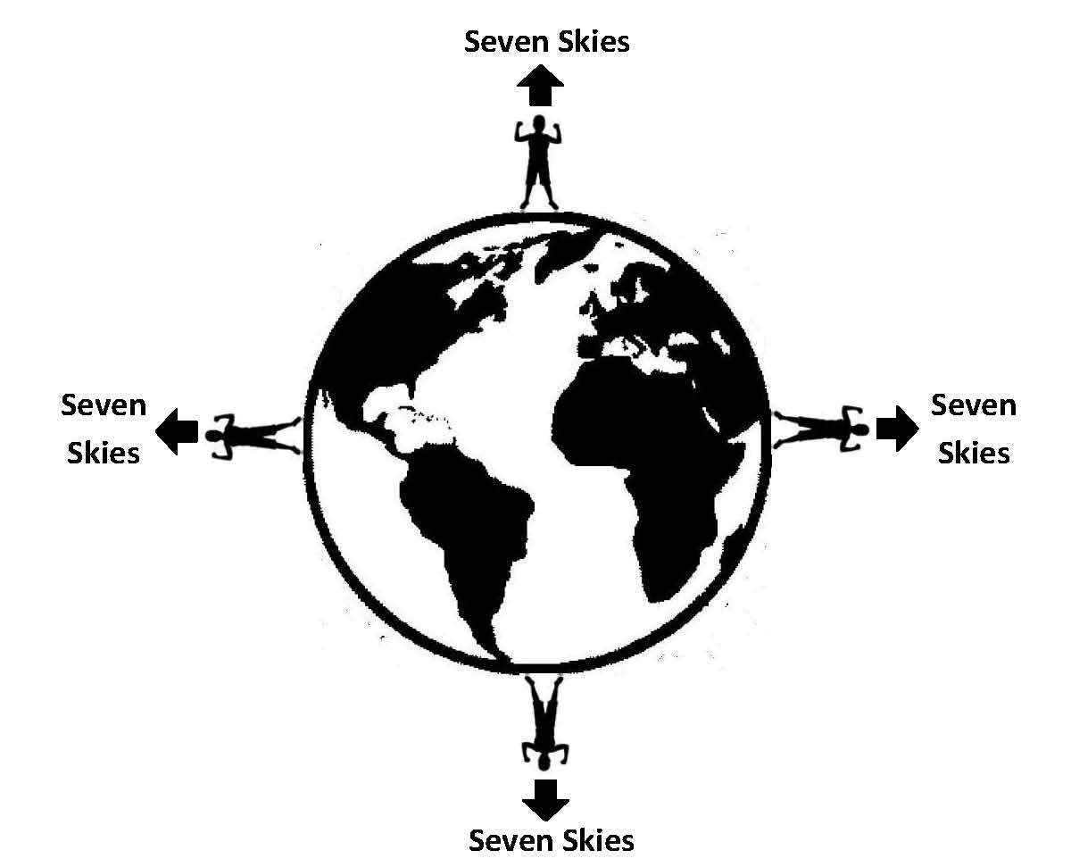

FIGURE 6.3: We are in the Innermost (First) Sky

Therefore, “Samawaat” (Skies) means the Universe as a whole.

3. Construction of the Skies

Space is filled with the extended elementary Souls (Force Fields / Ruhhs) of Allah. The elementary Souls are designed to sustain the subatomic particles, forces, matter and energies given to the creation. He has designed the Universe.
According to Einstein, the presence of matter curves space-time. A star makes a curvature in the space-time. All the stars in a galaxy as a whole make a curvature in the space-time. All the galaxies in a cluster as a whole make a curvature in the space-time. This way, the curvature of the overall Universe may have been determined by the distribution of matter in it.
The Following Verses describe that the formation of Skies, and the distribution of matter were related affair:

“Moreover, He established Himself into the Sky while it had been smoke. He said to it (smoke) and to the lands (formed after His establishment into the Sky), “Come both of you (smoke and lands) willingly or unwillingly.” They both said, “We do come in willing obedience.” So, He completed them as Seven Skies in two days and inspired in each sky its affairs. And We adorned the sky of the Earth (Samah-ud-Dunia) with lights and with guard. Such is the Decree of the Exalted in Might, Full of Knowledge.” [Al Quran 41: 11-12]

So, the Universe has been designed into Skies by curving the space with the distribution of matter (smoke and land). The Skies are spherical waves of space-time, one inside another, like the peels of onion.
The above Verses are discussed below in 4 parts:

Part 1 of the Verses:

“Moreover, He established Himself into the Sky while it had been smoke. He said to it (smoke) and to the lands (formed after His establishment into the Sky), “Come both of you (smoke and lands) willingly or unwillingly.” They both said, “We do come in willing obedience.”
[Al Quran 41: 11-12]

According to this Part of the Verses, when Allah established Himself into the Sky there was smoke only, but when He said, “Come both of you, willingly or unwillingly”, there were lands too. It means that the lands formed after Allah established Himself into the Sky. How lands formed in the smoke?
In the beginning, the radiation turned into matter. It produced hydrogen. Later, 25% of hydrogen turned into helium. When Allah established Himself into the Sky, there was mixture of these two gases (smoke) mainly. The space of the universe (single-sky-universe) was uniform.
At that point of time, Allah established Himself into the Sky by infusing (istawa) one of His elementary Souls (Force Fields / Ruhhs) into the space, which we call Gravitational Force Field. The gravity produced massive stars (First Generation Stars) by concentrating the smoke. The heavier elements produced in the cores of those stars. The stars exploded and scattered the heavier elements into the space. The lands (astral objects) could form with those heavier elements.
Therefore, the “establishment of Allah into the Sky” and the “calling of smoke and lands” are narrated in the same Verse. These were parts of a single process.

Part 2 of the Verses:

“…He said to it (smoke) and to the lands, “Come both of you (smoke and lands) willingly or unwillingly.” They both said, “We do come in willing obedience.” So, He completed them as Seven Skies in two days…” [Al Quran 41: 11-12]

In the expanding Universe, light and heavy elements could not move together, as heavy gets greater momentum. But, Allah ordered both of them to come together, willingly or unwillingly. It produced the Law of Inertia. Thus, the matter said, “We do come in willing obedience.”
One may test it in the laboratory. Take a lump of cotton and a piece of iron. Put those into a glass tube. Remove the air from the glass tube and make the cotton and iron fall downward by turning the tube upside down rapidly. Iron and cotton will fall in the same speed. So, they come together in willing obedience.
Allah orders at the same time helps the creations to follow the order. Therefore, He curved the space into seven spherical waves so that the space could carry smoke and heavier elements together in its super high-speed expansion. These seven waves of space are Seven Skies.
The following Verses say that the space was waved into Seven Skies to expand the Universe rapidly. The expansion was needed to create the darkness. The darkness was needed to create the day and night for the survival of our cattle and us.

“What! Are you more difficult to create, or the sky? He has constructed it. He has raised its thickness and proportioned it. Its night does He endow with darkness, and its splendor does He bring out. And the land moreover has He extended (continental drift). He draws out there from its moisture and its pasture. And the mountains He firmly fixed. For use and convenience to you and your cattle.”
[Al Quran 79: 27–33]

Part 3 of the Verses:

“So, He completed them as Seven Skies in two days and inspired in each Sky its affairs…” [Al Quran 41: 11-12]

The affairs of each Sky were inspired. It means that the initial configuration of single-sky-universe and the initial configuration of multi-sky-universe were different. So, there is a possibility that the Seven-Sky-Universe began from a Big Bounce, discussed in Chapter-4.

Part 4 of the Verses:

“…And We adorned the Sky of the Earth (Samah-ud-Dunia) with lights and protection. Such is the Decree of the Exalted in Might, Full of Knowledge.”
[Al Quran 41: 11-12]

The Sky of the Earth has been adorned with the lights of the sun, moon and stars.
The Earth has magnetic field and layered atmosphere to protect us from radiations coming from outside.
There are protections in the Solar System as well. There is Asteroid Belt. The Giant Jupiter is working as space cleaner. It draws stray asteroids and keeps the orbit of the Earth clean.

4. Structures revealing the Existence of Skies

In the followings, I have discussed walls, filaments, etc. It is needed to describe the construction of Skies.

4a. Wall

Prior to 1989, the Superclusters were known as the largest structures in the Universe. The discovery of “Great Wall” by Margaret Geller and John Huchra has changed the idea. The Great Wall is a sheet of galaxies 750 million light years long, 200 million light years wide and 16 million light years thick.
A Wall can span billions of light years. Superclusters are now understood to be subordinates to the enormous Walls or Sheets.
In 2003, another large-scale structure was discovered, the Sloan Great Wall.
In 2013, the Hercules–Corona Borealis Great Wall (Her–CrB GW) is discovered. It is the largest wall, discovered so far (2013). The wall measures more than 10 billion light years in length. It is 7.2 billion light-years wide and only 900 million light-years thick. It is located in the direction of constellations Hercules and Corona Borealis at a distance of 10 billion light-years, approximately.
Another great concentration, CCLQG, is about 9.5 billion light years away in the direction of Leo. The wall is 2 billion light-years in length and about 1 billion light years in width. The CCLQG may be a part of the Huge-LQG. They are 1.8 billion light years away from each other. The Huge-LQG is 4 billion light years across.
Coma Wall, Sloan Wall, Sculptor Wall, Grus Wall, Fornax Wall, etc., are some of the enormous walls.

4b. Filaments

The Filaments are largest known structures in the Universe. These are thread like structures, with typical lengths of 50 to 80 h⁻¹ mega parsecs, formed out of gravitationally bound galaxies. The Parts of a Filament where large numbers of galaxies are very close to each other are known as Superclusters. Filaments are seen around the boundaries of voids. Followings are examples of Filaments:
The Perseus-Pegasus Filament: It connects the Pisces-Centus Supercluster with the Perseus-Pisces Supercluster.
The Coma Filament: The Coma Supercluster lies within the Coma Filament. It forms part of CfA2 Great wall.

4c. Voids

In more recent studies (2013), the Universe appears as a collection of giant bubble-like voids separated by walls and filaments. This network is clearly visible in the 2dF Galaxy Red Shift Survey. The Voids occur on the scale of 100 MPC.
In 2007, a super-void was discovered in the constellation Eridanus. It coincides with WMAP cold spots. To cause a cold spot in the microwave sky, a void would have to be improbably huge, possibly a billion light years across, which does not favor current cosmological model.
Some of the voids of the near Universe are: Capricornus Void, Sculptor Void, Bootes Void, Culumba Void, Canes Major Void, Corona Borealis Void, Microscopium Void, etc.

4d. The Great Attractor

The Great Attractor is an immensely powerful gravitational anomaly that appears in the direction of Centaurus at about 200 million light years from the Earth. All galaxies within a radius of 250 million light years are flowing toward the Great Attractor on the order of 600 km/Sec.
The large-scale streaming motion is super-imposed on Hubble’s flow. The streaming motion includes the Virgo cluster (including our galaxy), the Hydra-Centaurus Super Cluster, and other clusters.
A mass of 10¹⁶ suns would account for such a powerful attraction. Detail search by astronomers of that region of the sky finds ten times too little visible matter. But, the Great Attractor is certainly there, as its gravitational influence is clearly visible.
The Core of the Great Attractor is in the Norma Supercluster.

5. Observational Evidence

Cosmologists see near galaxies only. Those at great distances are too faint to be visible even with the most powerful telescopes. And it is difficult to perceive the distance.
With painstaking efforts, the cosmologists of NASA have collected enough data of the near universe, depicted in the following figure.
In this figure, I have drawn probable boundary of the First Sky and the Second Sky. The Great Attractor is put in the Center.

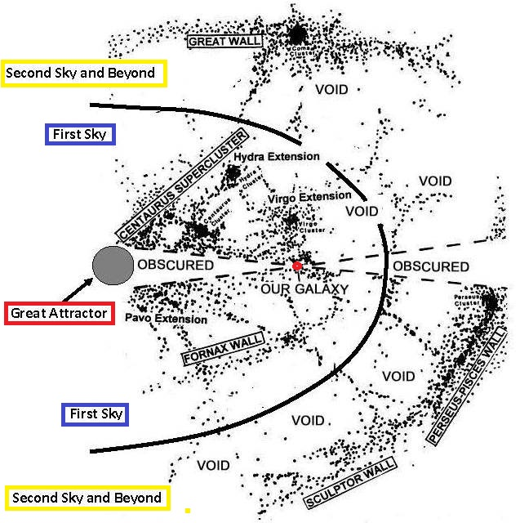

FIGURE 6.4: Likely First Sky and Second Sky

Here, the distribution of matter reveals the Skies as spherical waves of space, one inside another, like the peels of onion.
[I have considered the Great Attractor as the center. If it shifts to Shapley Concentration, the Skies may be re-defined accordingly]

5a: The First (Innermost) Sky

In light of the Quran, we are in the First (Innermost) sky:

“And built over you the Seven Skies”

[Al Quran 79:12]

The Quasars are the oldest objects. Some of them are seen at around 28 billion light years away. They are visible due to their immense brightness. The Quasars are equally distributed in all directions and receding straight backward. It points out that we are in the innermost region of space. The innermost region is the First Sky.
I suppose that the First Sky contains the Centaurus Super-cluster with its extensions like Hydra extension, Virgo Extension, Pavo Extension, Norma Super-cluster, and Fornax Wall. The Great Attractor is the center of the First Sky (fig. 6.4).
All the objects of the First Sky are flowing towards the Great Attractor. The gravity can be explained as the tendency of matter to move along the curved space-time. Thus, from the fringe of the First Sky, the space is slopping down into the center of the First Sky where the Great Attractor is pointed out.
In other words, the fabric of space is denser at the center of the First Sky, and the fabric is thinner toward the edge.
The Great Attractor should not need a mass of 10¹⁶ suns to produce a gravitational force strong enough to pull the objects even at 250 million light years away. The galaxies move in that direction due to the very design of the space-time, which is formed due to the overall distribution of matter in the First (Innermost) Sky.
The First Sky is the core sky of the universe. Here the galaxies should concentrate in the form of Superclusters. In the outer skies, they would form walls / sheets. However, the Centaurus Supercluster with its extensions looks like a Wall (Centaurus Wall). But, it is a circular concentration with Norma Supercluster in the center. The Great Attractor is located in the Norma Supercluster.
As Norma Supercluster is falling rapidly into the Great Attractor, it is associated with a small “Finger of God Effect” in the plots of galactic red-shift velocities when viewed from the perspective of the Solar System. The “Finger of God” is an effect where distribution of galaxies is elongated in red-shift space with the axis of elongation pointed toward the Solar System. It is caused by a Doppler shift associated with the random peculiar velocities of galaxies.
In case of Norma Finger of God, the galaxies in the far side of Great Attractor are blue-shifted and galaxies of the near side are red-shifted producing a small Finger of God in the line of sight.
All matters out to a distance of about 250 million light years are flowing toward the Great Attractor. Therefore, radius of the First Sky should be about 300 million light years, after adding half of the width of the surrounding belt of void (250+50).

5b. The Second Sky

As it is shown in figure 6.4, Great Wall, Perseus-Pisces Wall, Sculptor Wall with co-located other structures are forming the Second Sky. The galaxies of the Second Sky are collected mostly along the central plane (central sphere) of the Second Sky; thereby they are forming walls. The concentration of galaxies indicates that the fabric of space is denser in the central sphere of the Second Sky, and the fabric becomes thinner as the edges are approached.
Therefore, the Second Sky is a super-giant spherical wave of space. From the edges of the Second Sky, the space is slopping down into the central sphere, where the galaxies are sliding down and forming walls.
Only in a waved space, the galaxies should have tendency to move toward the central sphere of a wave and form walls. The formation of walls shows that the space of the Universe is curved as spherical waves (Skies).
The Second Sky looks 400 million light years wide after adding half of the belt of void in each side (50+300+50). The central plane of the Second Sky should be about 500 million light years away from the Great Attractor (Radius of the First Sky + 1/2 of the width of the Second Sky = 500 MLY).
Like Norma Finger of God, the clusters falling into the central sphere of the Second Sky show the Finger of God phenomena.

5c. The Third Sky

In the following figure, the Third Sky looks 600 million light years wide, and its central belt (central sphere) is about 1,000 million light years away from the Great Attractor (300+400+300).

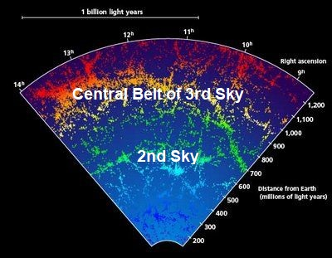

FIGURE 6.5: Likely 2nd and 3rd Sky

So, an outer Sky is wider than the inner Sky. In this scale, the radius of the Universe may be 5 to 7 billion light years at the best. The Universe looks much bigger due to the waved space (Skies) and continuous closing of matter (galaxies) into the central spheres of the waves. The effect is enhanced by Roll-up-Closing-Order of the Universe. The Roll-up-Closing is discussed in Chapter-8.

5d. The Universe with Seven Skies

Seven super-giant waves of space make Seven Skies of the Universe. The waves of space, which form the Skies, are spherical—one inside another, like the peels of onion.
The Skies are not disconnected; the space, though waved, is continuous.

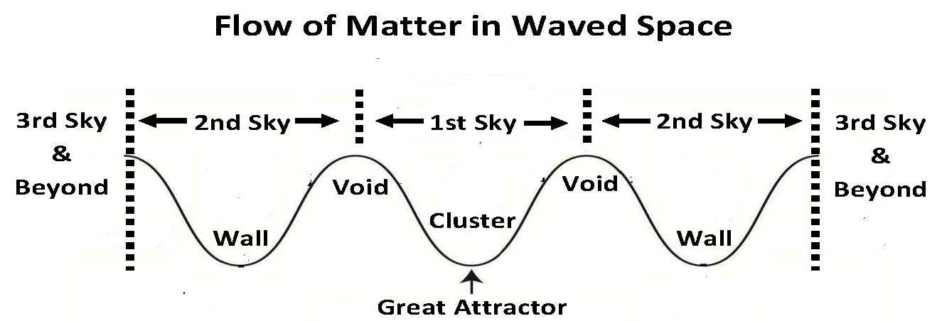

FIGURE 6.6: Skies in two-dimensional Waves

In above figure, the Skies are shown with two-dimensional waves. Outer Skies (Third to Seventh) should be the same as the Second Sky.

5e. Doors and Paths of the Skies

It seems in figure 6.4 that the Filaments are forming nets to hold the galaxies from falling rapidly into the Great Attractor and into the Central Sphere of Second Sky.
It seems as well, that the Filaments are making the paths to cross the belts of voids. As the Skies are waves of space, it should be difficult for anything to move from one sky to another. The Filaments may be used by jinns to move from one Sky to another. The jinn are created from anti-matter. These Paths (Filaments) may contain massive amounts of dark matter.

5f. Dark Matter

The dark matter is invisible matter. Anti-matter is a kind of dark matter. The presence of dark matter is conceivable from its gravitational effect on other matter as well as the particles with which it may be made of, such as neutrinos, have reasonable evidences of its existence. It is assessed that eighty percent of the mass of the Universe is dark matter. Milky Way is believed to have roughly 5 times as much dark matter as ordinary matter. In most regions of the Universe, dark matter and visible matter are together; proportionately balanced with mutual gravitational attraction.
“However, we know that the universe must also contain what is called dark matter, which we cannot observe directly- One piece of evidence for this dark matter comes from spiral galaxies. These are enormous pancake-shaped collections of stars and gas. We observe that they are rotating about their centers, but the rate of rotation is sufficiently high that they would fly apart if they contained only the stars and gas that we observe. There must be some unseen form of matter whose gravitational attraction is great enough to hold the galaxies together as they rotate.”
– Black Holes and Baby Universes by Stephen Hawking.
“Another piece of evidence for dark matter comes from clusters of galaxies. We observe that galaxies are not uniformly distributed throughout the space; they are gathered together in clusters that range from a few galaxies to millions. Presumably, these clusters are formed because the galaxies attract each other into groups. However, we can measure the speeds at which individual galaxies are moving in these clusters. We find they are so high that the clusters would fly apart unless they were held together by gravitational attraction. The mass required is considerably greater than the masses of all the galaxies. This is the case even if we take the galaxies to have the masses required to hold themselves together as they rotate. It follows, therefore, that there must be extra dark matter present in clusters of galaxies outside the galaxies that we see.”
– Black Holes and Baby Universes by Stephen Hawking.
Skilled distribution of matter and dark matter has curved the space into Seven Skies.
Or, the Skies have determined the distribution of matter and anti-matter throughout the Universe.

5g. Conclusion of Serial 5 (Observational Evidence)

Allah has curved the space into Seven Skies. The curvatures of space determine in which directions the galaxies are to move and in which places they are to be collected, as has been observed that the galaxies of the First Sky are closing toward the center of the First Sky (Great Attractor) and the galaxies of the outer Skies are flowing toward the central spheres of the respective Skies. Within the galaxies, the objects move through their orbits following the local curvatures of space.

6. Other Indications of the Skies

In a uniform universe, gas would spread out uniformly. But, as the Universe was structured into Seven Skies, and as the Skies were expanding, the smoke ghettoized into huge conglomerates to form the galaxies.
Only a universe with waved space (Skies) could expand fast and remain balanced and enduring:
“There is another extra ordinary feature pointed out by Stephen Hawking of Cambridge in 1973. If in the primordial fireball the expansion of the universe had differed by only one part in a million millionths from what it actually was, there would have been no possibility of the universe existing as we know it now. If the universe had expanded one million millionth parts faster, then all the material in the universe would have dispersed by now. There would have been no possibility of the gas being drawn together by gravity into stars. And if it had been a million millionth parts slower, then gravitational forces would have caused the universe to collapse within the first thousand million years or so its existence. Again, there would have been no long-lived stars and no life”.
–“Dawn of a New Era” by Sir Bernard Lovell in the Encyclopedia of Space Travel and Astronomy edited by John Man
Hawking calculates that if the speed of expansion deviated by one million millionth parts, the stars could not form, or the universe would collapse by now. Our appearance was never in such grim probability, because the universe was structured into Skies. Here tiny deviation in the rate of expansion would not matter much.
The seven-sky-universe expands due to the Dark Energy as well, not due to the drive of the Big Bang / Big Bounce only.

7. Summary

The space of the universe is curved into seven spherical waves, one inside another, like the peels of onion. The innermost wave of the space is called the First Sky. We are in the First Sky. The Seventh Sky is the outermost wave of space. The space though waved is continuous.

8. Conclusion

I have already talked out the “Large Scale Structure of the Universe”. In this context, I have elaborated a few points given below:

8a. Reality of the Dark Energy

The Big Bang left a residue of radio noise called Cosmic Microwave Background Radiation (CMBR). In 2010s, the Wilkinson Microwave Anisotropy Probe (WMAP) collected the data of CMBR. The Map of the Universe produced from the data shows the physical condition of the universe in the epoch of last scattering (at 379,000 years of its age). It reveals that the universe contains 71.4% dark energy, 24% dark matter, and 4.6% ordinary matter.

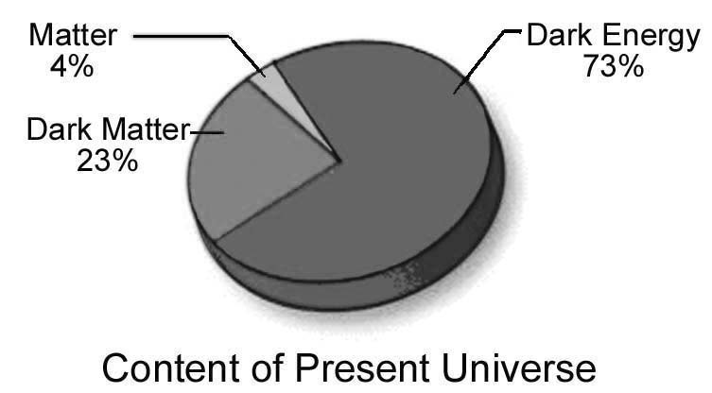

FIGURE 6.7

A seven-sky-universe should require extra energy to expand.

“And the Sky, We constructed it with support (Dark Energy), and indeed We surely are Expanders” [Al Quran 51:47]

[The Dark Energy is an extended elementary Soul (Ruhh) of God, or the energy is held in an extended elementary Soul (Ruhh) of God]

8b. CMB Map of the Universe

The CMB Map does not show the Skies. However, a larva does not look like a creature that would be a butterfly one day.
The CMB Map shows ripples that may be a sign of the Skies.
The scientists have found out the Universe flat by comparing the span of distant wall with the span of related concentration in CMB Map. But we are located in the Innermost Sky. A well-organized seven-sky-universe should look flat from the Innermost Sky. The lights coming from the objects of the outer skies cross the central spheres of the skies longitudinally. So, the lights do not bend significantly to show the space negatively or positively curved.

“He Who created the Seven Skies one above another: Not thou see in the creation of Most Gracious anything uneven. So, return thy vision—see thou any flaw? Again, turn thy vision a second time—vision will come back to thee dull and discomfited in a state worn out.”
[Al Quran 67: 3-4]

In this respect, maps of the Red Shift Surveys carried out in the same period of time (2010s) give better picture of the universe, which I have used to define likely First and Second Skies (Figure 6.4).

8c. Skies, a Scroll for Writings

The space possesses the record of everything. So, it has been compared with a written scroll:

“On the day when We will roll up the Skies (Universe) like the rolling up of the scroll for writings; as We originated the first creation, We shall reproduce it—a promise on Us; surely We will bring it about.” [Al Quran 21:104]

“…The sky disappeared like a scroll being rolled up, and every mountain and island was moved from its place…”
- Revelation 6: 12–14 (GNB)

“Space and time are now dynamic quantities: when a body moves or a force acts, it affects the curvature of space and time and in turn the structure of space time affects the way in which bodies move and forces act. Space and time not only affect but also are affected by everything that happens in the universe.”
– A brief History of Time by Stephen Hawking.
Be aware of the Day of Judgment when the Skies will be rolled up in the Hand of Allah, and each of our acts will be accounted for.

Ref:

- Gribbin, John. To The Edge of Eternity in The Encyclopedia of Space Travel and Astronomy edited by John Man. Great Britain: Octopus Books Limited, 59 Grosvenor Street, London, 1979.
- Russell, Bertrand. A B C of Relativity. New York, United States: Harper Brothers.
CHAPTER-7: Arsh

In previous Chapters, I have talked about the Samawaat (this universe) and the Jannaat (another universe / Paradise). These are separate universes. In human perspective, the Samawaat is hell, because the Objects of Hell are evolving in the Samawaat.
There is a third universe named Arsh. In this Chapter, I have discussed the Arsh under the following headings:
1. The Arsh
2. The Kursi
3. Appearance of the Overall Creation
4. Barzakh
5. Araf

1. The Arsh

The Arsh is the highest universe. It holds Kursi (Thorne of Allah), angels of Arsh, the Pen, the base of Sidratul-Muntaha and other things unknown. The Arsh is greater than the Samawaat and Jannaat. Following two Hadith indicates the location of Arsh.

“After traveling Seven Skies, I was raised to the extreme height. I reached a smooth plain land where the Noise of Pen only was being heard.” [Bukhari]

During the Night Journey (Miraj), Prophet (pbuh) reached the Arsh after traveling Seven Skies (Universe). It means that the Arsh is located beyond the Skies (this Universe).
The Arsh is located beyond the Jannaat too, as it can be understood from the following Hadith:

“All Jannaat have single roof that is the Arsh of Allah” [Hadith]

The Jannaat has eight layers, side by side in ascending order. Since all layers fall directly under the Arsh, the Arsh is located beyond the Jannaat as well.
Therefore, Arsh exists beyond the Samawaat (this Universe) and the Jannaat (another Universe). The Arsh can be considered as the Third Universe.
The Arsh is improbably huge. To express the vastness of the Arsh, it is compared with the Kursi. The Kursi is much bigger than this Universe (Samawaat). And, in comparison to the Arsh, the Kursi is like an iron ring thrown in a vast desert.

"In comparison to the Arsh, the Kursi is no more than an iron ring thrown in a vast desert" [Hadith, Tabari Tafsir]

There are many angels in the Arsh. In general, they are called “Angels of Arsh”. They do not come down to the Samawaat (this Universe). Each of these three domains, Arsh, Samawaat and Jannaat, has dedicated angels.
The events of Samawaat and Jannaat are controlled from the Arsh.

2. The Kursi

The Kursi is the Throne of Allah. It is held in the Arsh. The Kursi is much bigger than this Universe (Samawaat). None can estimate its vastness.

Ibn Jareer said, Yoonus told me that Ibn Wahb informed him that Ibn Zaid said that My father told me that Allah's Messenger said: "In comparison to the Kursi, the Seven Skies (this Universe) are no more than seven dirhams (old Arabian coin) set on a shield." [Hadith]

Allah extends the Kursi into the Universe (Samawaat) as well. So, it is movable, or can extend its tentacles.

"…extends His Kursi over the Skies and Lands (Universe) and not tires Him the guarding of both of them (Samawaat and Jannaat)" [Al Quran 2: 255]

3. Appearance of the Overall Creation

The outlook of overall creation is not given in the Quran or Hadith. But it creates an impression in mind, which is depicted below.
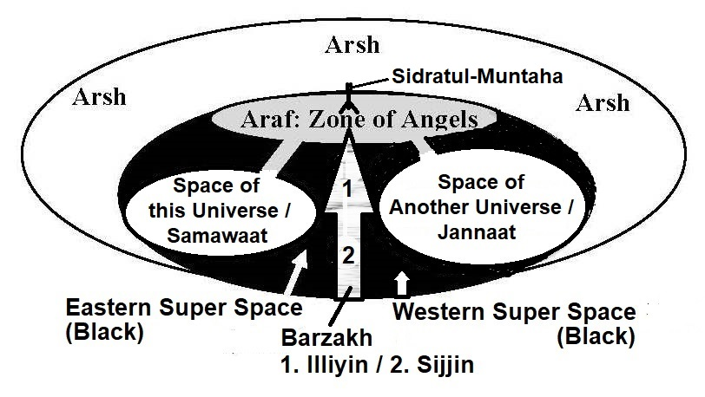

FIGURE 7.1: Overall Creation

The diagram depicts likely positions only. It is drawn with flimsy knowledge.
I have already discussed the Samawaat (this Universe), the Jannaat and the Arsh. The entities related to Barzakh are discussed below:

4. Barzakh

The Barzakh is a kind of veil. It is a barrier at astronomical level. It divides the Super Space—the Eastern Super Space is for the Samawaat, and the Western Super Space is for the Jannaat.
It is likely that the Barzakh is a space with different nature. The extended elementary Souls (Force Fields / Ruhhs) of Allah may not be designed to sustain matter in the Barzakh. Or some of His elementary Souls may not have been infused into the Barzakh at all. So, matter cannot survive in the Barzakh, except in specific domains connected by channels.
Three domains are located in the Barzakh. Those are: the Araf in the High Barzakh, the Illiyin in the High Barzakh but below the Araf and the Sijjin in the Deep Barzakh (see figure above). The souls of dead humans are preserved in Illiyin and Sijjin.
However, the light can pass through the Barzakh, as it is said in the Hadith that the Jannaat is visible from the Seventh Sky like the stars in the horizon.

5. Araf

“Araf” means “elevated land”. It is located in the high Barzakh, closely below the Arsh. The Araf is preliminary sanctuary of the universal angels.
The Sidratul-Muntaha hangs from the Arsh over the Araf. The Sidratul-Muntaha is like an upside-down tree. Its base is in the Arsh, and its branches are over the Araf. It has two main branches—one connects the Eastern Araf, and another connects the Western Araf.
There are two channels through which one can move from this Universe (Samawaat) to the Eastern Araf. The Western Araf is connected to the Jannaat with another two channels.
One needs to go through Sidratul-Muntaha to move from the Eastern Araf to the Western Araf. The Sidratul-Muntaha connects the Arsh as well. So, the Sidratul-Muntaha works as a communication hub of the universes.

CHAPTER-8: Qiyamah (Doomsday)

The Doomsday is inborn in the universal evolution. So, the analysis of related Verses and Hadiths give scientific knowledge about the event. It is discussed in the following sequence:
1. A Scientific Model of the Universe

2. The Collapse and Re-creation of the Universe

3. The Roll-up-Closing of the Seven-Sky-Universe

4. Understanding the Doomsday (Qiyamah)

5. Merging to the “Face of God”

6. Re-initiation

7. The Land of Resurrection - Holy Bible

8. Conclusion

1. A Scientific Model of the Universe

There are more than 170 billion galaxies in the observable universe. The galaxies are seen moving away from each other. It means that the Universe is expanding, or it has been expanded (when we see a distant galaxy, we actually see the past).
The scientists predict that the Universe may start contracting. Finally, it may contract to the state of Big Crunch.
From the Big Crunch (Big Bang-2) a New Universe may be born.

FIGURE 8.1: Cyclic Universe

The Model of the Quran is similar, but it differs in many aspects. The Quran says that the Universe is structured in Seven Skies, and it is already closing by rolling up the Skies from its outer boundary.

2. The Collapse and Re-creation of the Universe

The Universe will collapse by rolling up the Skies. After the Final Judgment, the Universe will be created again, as the first creation was originated.

“On the Day when We will roll up the Skies (Universe) like the rolling up of the scroll for writings; as We originated the first creation We shall reproduce it—a promise on Us, surely We will bring it about.” [Al Quran 21: 104]

At the time of Final Judgment, the Universe will be in the Right Hand of Allah in a rolled-up-state.

“And not they honored Allah—true honor—while the Land (Land of Judgment) is assembling in His Hand on the Day of Resurrection and the Skies (Samawaat / this Universe) rolled-up in His Right Hand. Glory be to Him! And high is He above what they associate (with Him).” [Al Quran 39: 67]

3. The Roll-up-Closing of the Seven-Sky-Universe

The scientists observe that the Universe is expanding. They find the Universe flat. A flat Universe expands forever or contracts only in a remote future. But in light of the Quran, the Universe is already closing by rolling up the Skies from its outer boundary (Seventh Sky).
In the following, I have put forward my arguments that the Universe is closing. But we are seeing it expanding, because it is contracting by rolling up the Skies. The process is explained gradually. Followings are a few realities that form the basis of my explanation:
- To a cosmologist, the Universe is uniform, isotropic and flat. But to us the Universe is waved into Seven Skies. In this respect, we should not give much importance on the Map of CMBR because a larva does not look like a creature that would be a butterfly one day (relate Chapter-6).
- The cosmologists observe that the recession velocities of the farthest objects are increasing with time. Those are objects of the outer skies in our view.
- The cosmologists estimate that the accelerated expansion of the universe has begun roughly about 5 billion years ago.

What would happen if a ‘uniform isotopic positively curved universe’ would start contracting?

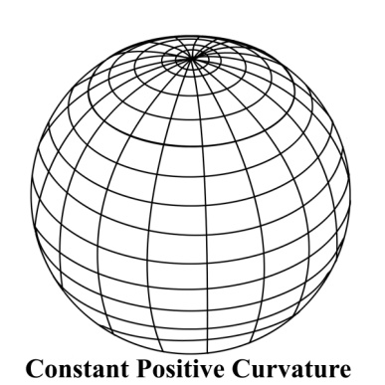

FIGURE 8.2: A ‘uniform isotopic positively curved universe’

We know that in a ‘uniform isotopic positively curved universe’ the space is bent round onto itself; light travelling in an apparently straight line will return to the point of origin. Therefore, in a ‘uniform isotopic positively curved universe’, the objects would be seen going away even if they were returning.

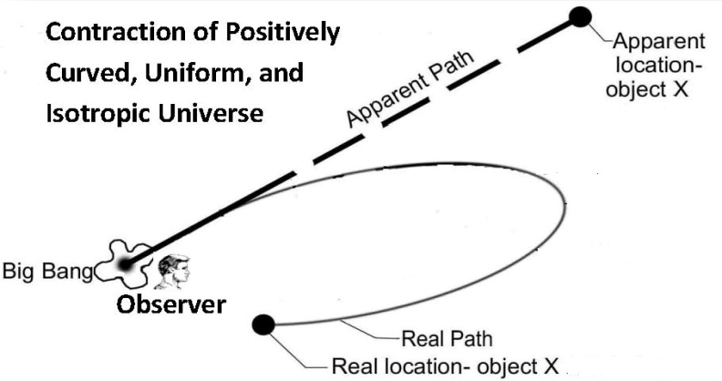

FIGURE 8.3: Object X in a ‘uniform isotopic positively curved universe’

In Figure 8.3, the observer is located in the central region of a ‘uniform isotopic positively curved universe’. The observer sees the distant object “X” in its apparent location. He sees it as receding, though the object is actually approaching him. It is because the light is coming to him following a curved path, and the curvature of space is not visible to him.
In a ‘uniform isotopic positively curved universe’ the speed of an object is supposed to be increasing in the contracting phase, as it (speed) was reducing in the expanding phase. Therefore, in such universe the increasing speed would mean that the universe was contracting.

However, in this case, a great number of distant objects would be seen approaching, as their lights emitted in the approaching phase would reach the Earth. It means that in above figure (8.3), the object X would be seen in its real location also, as approaching the observer.
Now, scientists observe recession rate of distant object as accelerating, but they are not seeing reasonable number of objects approaching them. In a ‘uniform isotopic positively curved universe’ it means that the universe is not contracting—the objects are really receding in accelerating rate.
But, what happens if the universe is waved into Skies, and if it is closing by rolling itself from the outermost Skies?
To understand the rolling Skies, we are to discuss how a spinning universe would look like:

3a. Spinning Universe

A rolling Universe with Skies should have an Axis. Some scientists argue that the Big Bang was spinning. As the Universe expanded, the net angular momentum has dissipated among the galaxies.
If Big Bang was spinning, the Universe has an axis, and it may be rotating now as well, relative to other universes in higher dimensional space.
“For the past few years, Professor Longo has worked primarily in astrophysics, in particular, analyzing data from the Sloan Digital Sky Survey (SDSS). This has led to strong evidence for a cosmic parity violation in the Universe, as indicated by a statistically significant excess of left-handed spiral galaxies toward the North Galactic Pole and an excess of right-handed in the opposite direction. This also suggests that our Universe has a preferred axis and a net angular momentum. Since angular momentum is conserved this means the Universe must have been born spinning. We can't see outside of our Universe, so we'd have to assume it is spinning relative to other universes in a higher dimensional space. Presumably the Big Bang was spinning initially, and as it expanded, the net angular momentum was dissipated among the galaxies. Now we still see it through the preferred spin direction.”
- “Detection of a Dipole in the Handedness of Spiral Galaxies with Redshifts z~0.04, Michael J. Longo, Phys. Lett. B 699, 224-229 (2011).

It should not be possible for us to understand the spin of the universe because we are living inside it.

3b. Axis of the Universe

In the seven-sky-universe, the Axis, most likely, runs through the “Circles of Great Attractions”. There may be total 13 Circles of Great Attractions. The First / Innermost Sky has one circle that is the Great Attractor. Each of other Skies may have two circles. In following figure, the Axes are shown with the Circles of the First Sky and the Seventh Sky.

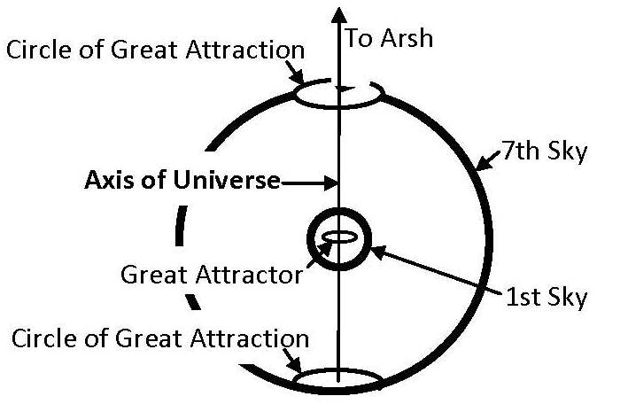

FIGURE 8.4: Axis of the Universe

The axis running through the circles makes a path as well. The Channels coming from the Araf run through this path. This may be only path, through which something can enter the Universe and cross the Skies.
The overall Universe may be rotating around the Axis and contracting.

3c. The Rolling

The closing of seven-sky-universe may include two kinds of rolling:
- The Rolling of Individual Sky
- The Rolling around the Axis of the Universe

3c-I. The Rolling of Individual Sky

The galaxies of a Sky are falling into the central plane (central sphere) of the Sky and forming walls (it is discussed in Chapter-6). But a galaxy cannot settle in the central plane without rolling. Here rolling motion is like the motion of a pendulum. A galaxy swings across the central plane of the Sky and finally settles into the Wall.
Therefore, a Wall shrinks in thickness, as the falling objects swing with ever-reducing amplitude. Thus, a Sky possesses the nature of a crochet (weaving needle with hook):

“By the sky with the nature of crochet (weaving needle with hook)”
[Al Quran 51:7]

The weaving Skies are forming the walls with the galaxies. Thus, the Skies are shrinking in thicknesses.



Figure 8.5: Crochet

The central sphere of a Sky is crowded with galaxies. In the dense space of the central sphere, the galaxies are squeezed like the quasars. Gradually the galaxies get pasted in the Wall. The pasting of galaxies makes the Walls stable. But, the galaxies do not merge with each other; they remain separate in the dense space.
The Walls like Her–CrB GW, CCLOG, Huge-LOG seem located in the Seventh Sky. The walls are billions of light years in lengths and widths, but only 900 million light years in thickness, which is less than the diameter of the Milky Way galaxy. But the walls contain many galaxies, as they are squeezed.
As a Wall shrinks in thickness, every next emitting wave of light is red-shifted to the higher degree. So, its object seems receding.
If a cluster is closely settling into the central sphere of a Sky (into a Wall), it shows Finger of God effect in the red-shift plot due to increasingly powerful gravitational field towards the central sphere.
All galaxies of a Sky will have to fall into the central sphere of the Sky and the whole central sphere will become a continuous Wall made out of extremely compacted galaxies, free dust and gases.
Therefore, a Sky with Wall is like an inflated balloon whose elasticity is continuously increasing. So, a Sky tends to shrink.
Due to increasing shrinking pressure, the rotation of the Skies around the Axis of the Universe is increasing continuously, and the Universe is closing in ever-faster speed.

3c-II. The Rolling of Skies around the Axis of the Universe

The Skies are rolling, and the Universe is contracting. Finally, all the Skies will be rolled up on the Axis of the Universe—the way ancient people used to roll up a long paper on a wooden roller (scroll of a book).

“On the day when We will roll up the Skies (Universe) like the rolling up of the scroll for writings…” [Al Quran 21: 104]

“See they not that We gradually come to the land (Land of Judgment) by reducing it (the Universe) from its outlying border (Seventh Sky)? Allah judges; there is no adjuster of His judgment, and He is swift in calling to account.” [Al Quran 13: 41]

In above Verse, the coming is not related to Allah only. It includes entities that are related to the Final Judgment, such as Arsh, Kursi, Araf, etc. When the Universe (Samawaat) will be rolled up completely, those entities will be in close proximity. The Kursi will descend on the Land of Judgment and Allah in form will appear.
We are living inside the sky, so it is not possible for us to understand the rotation of the Sky.

3c-III. An Additional Drive to the Rolling Contraction

In the expanding phase of the Universe, the rotational speed of the Skies was decreasing. In the contracting phase, the rotational speed is supposed to be increasing. For example, an astral object falls on the Earth through a rotational path; the closer it comes, the higher is the speed.
But this way of contraction should take extraordinarily long time. For example, the Solar System is contracting as its planets are rotating. But the rate of closing is insignificant.
So an additional drive of contraction is applied to the universe:

“See they not that We gradually come to the land (of Judgment) by reducing it (the Universe) from its outlying border (Seventh Sky)? Allah judges; there is no adjuster of His judgment, and He is swift in calling to account.” [Al Quran 13: 41]

“Soon after the trouble of those days (end-time events), the sun will grow dark, the moon will no longer shine, the stars will fall from the sky, and the powers in space will be driven from their courses.”
– Matthew 24:29, Holy Bible (GNB)

“In the days after that time of trouble the sun will grow dark, the moon will no longer shine, the stars will fall from the sky, and the powers in space will be driven from their courses.”
– Mark 13: (24–25), Holy Bible (GNB)

Thus, an addition drive of contraction is applied from the Seventh Sky (as the powers of space are driven from their courses (from the outer boundary).
A Sky is balanced by the pull of flanking Skies. And the innermost Sky (First Sky) is balanced by the pull of Great Attractor in the center and the Second Sky at the outer side. But the Seventh Sky being the outermost sky is imbalanced. So, an additional drive of rotational collapse began from the Seventh Sky.
The additional drive of the Seventh Sky is forcing the Universe to rotate faster. The drive is also forcing the inner Sky to contract faster. Subsequently, the same was done by the inner Sky. It seems that the drive has reached the Third Sky.

3c-IV. Timing of Rolling Contraction

In 1990s, the “Supernova Cosmological Project” and the “High-Z Supernova Search Team” measured the distances and recession velocities of Ia supernovae. They consider the Universe uniform and isotopic, so their analyses hardly have any value in this discussion. However, their observations give some information.
They found the distant supernovae relatively fainter. Those are the objects of the outer Skies in our view. It means that the supernovae have settled in the central spheres of their Skies. It increases the elasticity of a Sky. And if the elasticity of an inflated balloon increases, it tends to shrink.
The Teams found that the supernovae beyond the mid-point were relatively fainter. So, the Skies up to the 3rd Skies are shrinking in increasing speed. It is likely that the additional drive of closing too, has reached up to the 3rd Sky.
How long the Universe would need to collapse?
In Chapter-6, we discussed the Large-Scale Structure of the Universe where we came to a conclusion that the seven-sky-universe should be 10 to 14 billion light years across. The Universe looks bigger due to the increasing red-shift caused by the rolling Skies (waved space) and the shrinking Walls mainly.
Therefore, the Doomsday is not far; it may occur within a few hundred earthly years only; even in the next week the Sun may rise from the west because, we do not know the actual present state of the outer Skies—when we see five hundred million light years away (the Second Sky), we actually see five hundred million years past.

3c-V. To conclude the mechanism of Rolling:

We are not capable to feel the rotation of the Universe around its Axis, because we are living inside the Universe. From our point of view, the Universe looks expanding because of the rolling Skies, shrinking Walls and galaxies, which are increasing the red shift of light coming to the Earth continuously.
As the Universe as a whole is rotating around its axis, the galaxies are not coming to us directly; they are coming through a spiral path—the way the Earth is moving to the Sun through a spiral path. Therefore, we are living in expanding space, though the Universe as a whole is contracting in diameter.
In other words, the contraction has not put the evolution of universe in reversed order; the Universe is evolving to higher form. The Arrows of Time has not changed the directions because the space is not contracting; it (the space) is being rolled up, and the Universe as a whole is contracting in diameter.
Finally, we do not know the exact structure of the Universe. So, my understanding of the rolling Skies may be wrong. But the Quran is true. On the Day of Judgment, we will find the Skies rolled up in the right hand of Allah—whatever may be the technique of rolling. Allah knows; we know not.

“And not they honored Allah—true honor—while the Land (the Land of Judgment) is assembling in His hand on the Day of Resurrection, and the Skies (the Universe) rolled-up in His right hand. Glory be to Him! And high is He above what they associate.” [Al Quran 39: 67]

3d. The Benefits of Roll-up-Contraction

We cannot comprehend the roll up of three-dimensional space. Therefore, in the Quran and Holy Bible the roll up of Skies has been compared with the roll up of scroll for writing.

“On the day when We will roll up the Skies (Universe) like the rolling up of the scroll for writings…” [Al Quran 21: 104]

“…The sky disappeared like a scroll being rolled up…”
– Revelation 6 (12–14), Holy Bible.

The Skies will be rolled up on the Axis of the Universe like a scroll for writing. In the Rolled-up Skies, the galaxies may not merge with each other. Each galaxy may be squeezed to the state of a singularity and may be fixed in its relative position in the super-dense space. Mathematically, a singularity is a point. Thus, the rolled Skies may look like a rolled paper with many points (collapsed galaxies) retaining information.
Allah will have vision of the next universe, and He will re-program the super compact universe to revive. When the Universe will be un-rolling, the galaxies will be resurrecting just by regaining the masses.

4. Understanding the Doomsday (Qiyamah)

The Day will start with the First Blow of Soor (Trumpet) when all humans, angels, jinns and other creatures will die.
The Universe will continue rolling. Finally, it will be super compact. The super compact Universe will be re-programmed and re-initiated by Allah. Soon the Resurrection of the Dead will occur. The Universe will then be halted temporarily for the Final Judgment.
Therefore, the Dooms Day includes the end-part of this cycle of the Universe and the leading part of the next cycle—thus the Day is called Day of Forwarding (Yawmu I-bathi). The Day is called “Day of Deen (Law)” as well.
In relation to humans, the Day has two important times, those are:
  - Time of Doom by the First Blow of Soor (Trumpet).
  - Time of Resurrection, Final Judgment and Salvation.
If we discuss these two times, the whole Day will be clear. These two times are highlighted in the Verses given below:

“And the Day you stand—the Hour—the transgressors will swear that they tarried not but an hour; thus they were deluded! But those endued with knowledge and faith will say: "Indeed ye did tarry by God's Decree until the 'Day of Forwarding' (Day of Doom by the First Blow of Soor) and this is the 'Day of Forwarding' (continuation of the same Day / said at the time of standing for Judgment), but ye were not aware!"
[Al Quran 30:55-56]

In this Chapter, I have discussed the ‘Doom by the First Blow of Soor’ and the ‘Resurrection of the Dead’. The Judgment and the Salvation are discussed in Chapter-9.

4a.The Sunrise from the West

The signs of impending Doomsday:

“Qiyamah will never dawn upon you prior to your observing ten signs: Ad-Dukhaan (the smoke), the sinking of the earth in three places: in the East, West and Arabian Peninsula, the beast that will emerge from the earth, Dajjal, the descent of Isa (Jesus), the breakout of Gog-Magog, the sun rising from the west and finally the eruption of a fire from Yemen that will drive the people to their place of gathering.” [Mishkaat, Mazaahir-e-Haqq]

Among these signs, the rising of the Sun from the west relates to the cosmology and opens a scope of scientific analysis. The Sun will not rise from the west suddenly. It will be lost for about three nights, and then it will rise from the west. It is said in the following Hadith.

Hadith: Abdullah-b-Abu-Owfa reported that I heard the Messenger of Allah (pbuh) said, "Verily a night will come upon the people, which will be equivalent to three of your nights. When it will come, those that engage themselves in worship during the night will recognize it. One of them will stand in prayer, read his Hizb, and then go to sleep. Thereafter, he will wake up, read his Hizb in prayer, and go to sleep. While this is the situation, the people will begin to shout, scream, and call one another. They will say, "What's this?" They will run to the mosque in fear. To their surprise, they will see that the Sun has risen from the West. When it will reach the middle of the sky, it will return and sit in the West. He (pbuh) said, "That is when Imaan (Faith) will not benefit anyone (who brings faith after seeing the sign)." [An-Nihaya]

Following Hadith talks about another aspect of the western-sunrise:

“Oh Abu Jarr! Do you know where the Sun goes?” I answered, “Allah and His Messenger (pbuh) know it better.” He said: “She goes to ask permission to fall on prostration to Allah. Thereafter, it is given permission. One day it will be told to return to the point from where it came, so the Sun will rise from the West.” Thereafter, Prophet (pbuh) recited following Verse of the Quran: “And the Sun runs its course for a period determined for it; that is the decree of the Exalted in Might, the All-Knowing (Al Quran 36:38)” [Tirmizi]

Above Hadith says that the sunrise from the west is related to the movement of the Sun. The Sun has different kinds of motions. It is moving around the center of Milky Way Galaxy at a rate of 220 km/second approximately. Simultaneously, it is moving toward the Solar Apex at a rate of 16.5 km/second. According to the Hadith, immediately before the Doomsday, the Sun will be ordered to return to the point from where she came. The Sun moving back to the point of origin means Milky Way galaxy moving back to the point of origin.
Therefore, the Sun will rise from the west when the space will start contracting.
We are in the First (Innermost) Sky, and the Milky Way galaxy is already moving towards the center (Great Attractor). However, the space is not contracting. The Sky is reducing in diameter by rolling up the stretching space. We cannot perceive the rotation of sky around the Axis of the Universe; we only view the drift of galaxies toward the Great Attractor.
The rotation of the overall Universe is supposed to increase continuously. But, when the additional drive of contraction will reach the Second Sky, the filaments coming down to the First Sky will break, and the order of the First Sky will change rapidly.
The First Sky will then start “Independent Contraction” defying the roll-up-closing-order of the overall Universe. The rotation of the First (Innermost) Sky will be slowing down, and the galaxies will change their directions of move straight toward the Great Attractor. Thus, the space of the First Sky will start shrinking. The First Sky will be cut off from the overall space of the Universe.
I call it “Independent Contraction of the First Sky”. As a result of rapid change, the Sun will rise from the west.
The sunrise from the west will mark the beginning of Independent Contraction Phase. Only the First Sky will undergo Independent Contraction.
The Independent Contraction Phase will last for 40 years. After 40 years, the First Sky will be cleft asunder by the First Blow of Soor (Trumpet). So, the objects of the First will return to the harmony of overall Universe, and the terminal doom will begin. Nature of these 40 years helps us understand the phase. Following I have discussed the Nature of this Time.

4b.The Nature of Time in the Last 40 Years

We know from the Hadith that after 40 years of western-sunrise, people will start hearing the first blow of Soor. The following Hadith talks about the nature of these 40 years.

“By the name of Allah, in Whose hands is my life, the Qiyamah (Doomsday) will not take place until animals talk to humans. Tips of sticks, his shoelaces will express out the secrets. His thigh will inform him whatever his family members did in his absence.” [Muslim, Tirmizi]

Prior to the Doomsday, people will start knowing the secrets from the things like shoelace, stick, etc. In Islamic concept, the “future” is secret. Only Allah knows the future; He is called Alim-ul-Ghaaib.
The Hadith should be considered as a Hadith-e-Qudsi because here Prophet (pbuh) is telling something which he must have been informed. The Hadith expresses the end time phenomena in a sequence as under:

4b-I: Talking by Animals

The Hadith says that the animals will talk to humans. If animals can talk, they will express out some secrets. We know from the Hadith that some animals, such as a donkey, can see the jinns. Some animals can see the angels as well.
Structure of an angel exposes his task and indicates related future—if the angels related to the sinking of a ship are visible at the port, the rats leave the ship immediately. The angels start working from the port—if one is not supposed to die in the sea, one is not allowed to board on the ship. If Captain of a ship had a talking dog, the dog could inform him what is happening behind the scene.
Animal languages may not be as broad as human languages. They may have expressions limited to their simple lives. Solomon could understand the languages of animals; why others should not be able to learn?
Talking of animals may as well mean reading of their brain data. There is no early warning system of the earthquake. If brain data of a dog could be read, it would give the warning.

4b-II: Shoelace and Stick will express out Secrets.

The Hadith says that the stuffs like shoelace, stick, etc., will express out secrets. Most likely, it will happen due to the Reversed Arrows of Time. At that time, looking at an object one will know its future.
Time will reverse in the First (Innermost) Sky only. It is discussed subsequently.

4b-III: Thigh will inform whatever a man’s family members would have done in his absence

A man’s thigh will inform whatever his family members would have done in his absence (now, he is coming to know the immediate past as well). It may be a phenomenon of the fag end, when one will not have to look at an object to know its future. One will just concentrate by looking down (looking at the thigh) and will come to know the unknown. After coming back home, one will not ask one’s wife what she has cooked—one will just sit in the dinning chair, look down and concentrate, and will come to know what she has cooked.

4c. Arrows of Time

We need knowledge about the direction of time to discuss how people would know the “future” from the things like shoe-lace, sticks, etc.
Time appears to have direction where future lies ahead. The laws of physics do not provide Arrow of Time. But there are exceptions. Stephen Hawking in his book A Brief History of Time discusses following arrows of time:

- Cosmological Arrow of Time: This is the direction of time that points away from the Big Bang. In this direction of time, the Universe is expanding rather than contracting.

- Thermodynamic Arrow of Time: Entropy (disorder) increases over time. For example, the energy in the Sun is in a higher degree of order. It always radiates. So, the disorder increases with time.

- Psychological Arrow of Time: We feel time passes. In this direction of time, we remember the past, not the future.

“There are at least three different arrows of time. First, there is the thermodynamic arrow of time – the direction of time in which disorder or entropy increases. (Energy in the Sun is in a higher degree of order. It always radiates. That means disorder increase with time. A cup may fall down and break, but a broken cup never gathers themselves together off the floor and jump on the table). Then, there is the psychological arrow of time. This is the direction in which we feel time passes; the direction in which we remember the past but not the future. Finally, there is the cosmological arrow of time. This is the direction of time in which the universe is expanding rather than contracting.”
– A Brief History of Time by Stephen Hawking.

Cosmological and Thermodynamic Arrows of Time point in the same direction, when the Psychological Arrow of Time points opposite. In this arrangement, the universe expands– the disorder increases– we remember the past, not the future.
An old idea of Stephen Hawking suggests that the contracting phase of the universe would be the time reverse of the expanding phase. All events of the expanding phase would be replayed backward in the contracting phase of the Universe.
“At first I believed that disorder would decrease when the universe re-collapse. This was because I thought that the universe had to return to a smooth and ordered state when it becomes small again. This would mean that the contracting phase would be like the time reverse of the expanding phase. People in the contracting phase would live their lives back ward: They would die before they were born and get younger as the universe contracted.”
– A Brief History of Time by Stephen Hawking.

If the universe starts contracting, the “Cosmological Arrow of Time” will reverse. As a result, other Arrows of Time may turn in opposite directions. Then the entropy (disorder) would start decreasing, instead of increasing. People in the contracting phase would live their lives backward; they would get younger as the time would pass. People would remember the future instead of remembering the past. This looks like the phenomena stated in the Hadith.

“By the name of Allah, in Whose hands is my life, the Qiyamah (Doomsday) will not take place until animals talk to humans. Tips of sticks, his shoelaces will express out the secrets. His thigh will inform him whatever his family members did in his absence.” [Muslim, Tirmizi]

In expanding phase of the universe, one remembers the past. By looking at a thing, one often remembers the events related to that thing. For instance, by looking at one’s shoe, one may remember from where one bought it; it may remind many things of the past spontaneously. But, in the contraction phase of the First Sky, the opposite will happen. At that time, by looking at a thing, one will remember its future instead of remembering its past.
Then, by looking at a stick, one would remember that one will kill a snake with that stick on the next day—and it will really happen. Then, the future is disclosed. The things like stick, shoelace, etc., may express out the secrets in this way.
However, Stephen Hawking later changed his idea working with his students.
“This idea is attractive because it would mean a nice symmetry between the expanding and contracting phase. However, one cannot adopt it on its own, independent of other ideas about the universe. The question is: Is it implied by the no boundary condition? As I said, I thought at first that, the no boundary condition did indeed imply that disorder would decrease in the contracting phase. I was misled partly by the analogy with the surface of the Earth. If one took the beginning of the universe to correspond to the North Pole, then the end of the universe should be similar to the beginning, just as the South Pole is similar to the North. However, the North and South poles correspond to the beginning and end of the universe in imaginary time. The beginning and end in real time can be very different from each other. I was also misled by work I had done on a simple model of the universe in which the collapsing phase looked like the time reverse of the expanding phase. Further, one of my students, Raymond Laflame, found that in a slightly more complicated model the collapse of the universe was very different from the expansion. I realized that I had made a mistake: no boundary condition implied that disorder would in fact continue to increase during the contraction. The thermodynamic and psychological arrows of time would not reverse when the universe begins to re-contract.”
– A Brief History of Time, by Stephen W. Hawking.
“The inflation in the early stages of the universe, which no boundary proposal predicts, means that the universe be expanding at very close to the critical rate at which it would just avoid re-collapse, and so will not re-collapse for a very long time. By then all the stars will have burned out and the protons and neutrons in them will probably have decayed into light particles and radiate. The universe would be in a state of almost complete disorder. There would be no strong thermodynamic arrow of time. Disorder couldn’t increase much because the universe would be in a state of almost complete disorder already. However, a strong thermodynamic arrow is necessary for intelligent life to operate. In order to survive, human beings have to consume food, which is an ordered form of energy, and convert into heat, which is a disordered form of energy. Thus, intelligent life could not exist in the contracting phase of the universe. This is the explanation of why we observe that the thermodynamic and cosmological arrows of time point in the same direction. It is not that the expansion of the universe causes disorder to increase. Rather it is that the no boundary condition causes disorder to increase and the condition to be suitable for intelligent life only in the expanding phase.”
– A Brief History of Time by Stephen W. Hawking.
It means that Hawking cancels his idea if the universe is flat, but is the Universe really flat? A well-organized seven-sky-universe is not flat.
The Universe is closing by rolling up the Skies, but the Arrows of Time have not changed direction because the space is not contracting—the Universe is contracting in diameter by rolling up the stretching space.

4d. The Independent Contraction of the First (Innermost) Sky

The First Sky maintains harmony with the outer Skies by the Filaments coming down from the Second Sky. When the galaxies of the Second Sky will be wrapped up rapidly into its Walls, the Filaments will be broken, and the influence of the Second Sky will reduce on the First Sky. The First Sky will then break up from the overall space, and its “Independent Contraction” will begin. Then, the rotation of the First Sky will be slowing down, and its space will start contracting directly towards the center (Great Attractor). It is the “Independent contraction of the First Sky”.
The Independent Contraction will reverse the Arrows of Time in the First Sky only. Initiation of this motion will cause the Sun to rise from the west.
The Hadith says that the Sun will be lost for about three nights. Due to the sudden acceleration of the Milky Way galaxy toward the Great Attractor, the distance of the Sun from the Earth may increase temporarily, and the Sun may seem lost, or it may be dimmed due to increased distance and look like the moon, or some objects may fall in the line of sight and the Sun may be lost. The Sun will remain lost for about three nights. During this changeover, the Earth will rotate in opposite direction for a short duration of time as a corrective move. So, the Sun will rise from the west.
The changes may cause a strong wind, which will through the people into the sea.

Hadith: “The Tenth sign of the Qiyamah is a strong wind that will through them into the sea.” [Tirmizi]

The people will start knowing the future. The more the time will pass, the more clearly the people will know the future.
The Reversed Psychological Arrow of Time will be fully effective after forty years, when people will completely forget the past. The good people will die before that time; only the unbelievers will be living. So, Allah will be forgotten totally. One will not call Him even in great danger. Then the Soor (Trumpet) will be blown. According to Hadith, the Soor will not be blown so far a single person remains on the Earth to call “Allah”, even in a great danger.
The birth will stop. The Thermodynamic Arrow of Time will take forty years to be fully effective in the reversed direction. As the Thermodynamic Arrow of Time will become effective gradually, the Sun will be growing dark. A time will come when its light will be so dimmed that the moon will not be shined.

“Soon after the trouble of those days, the sun will grow dark, the moon will no longer shine, the stars will fall from heaven (sky)...”
– Matthew 24:29, Holy Bible (GNB)

“In the days after that time of trouble, the sun will grow dark, the moon will no longer shine, the stars will fall from heaven (sky)...”
– Mark 13 (24–25), Holy Bible (GNB)

The First Blow of Soor (Trumpet) will start after 40 years of the western-sunrise. The Blow will continue for a long time. It will grow from the extremely low to the extremely high pitch. The Great Attractor will become weak due to the First Blow of Soor, and the First Sky will explode.
The objects of the First Sky will then be taken over by the overall universe that will be collapsing violently at that time. The Arrows of Time will return to the harmony of overall universe. Humans will die at one stage. The angel blowing the Trumpet (Israfil) will die at the end.

Note:

The performance of Allah is perceived as Time. Allah is not dependent on the expansion or contraction of space. However, He would not change the order of the First Sky for the people of that time, as the test of the people will end after the western-sunrise. No repent will be accepted after that event, so the glimpses of the future will not be protected from them.

4e. The First Blow of Soor (Trumpet)
“It is narrated by Abu Hurayrah that Prophet Muhammad (pbuh) said: The Qiyamah will not come unless the Sun rises from the direction it sits. When that will happen, everyone will see, then whole mankind will accept Iman (Belief on One God and the Last Day). But the faith accepted after that event will not pay any benefit to an Unbeliever. Those who would not have repented for their sins before that time, their repentance (Tawbah) after that time will not pay any benefit. Of course, the Qiyamah will take place, so fast that suppose a buyer and a seller would have opened a cloth—will not get time to complete the sell or fold the cloth again; the Soor will be blown. Listen more, someone would have milked the cow—will not get time to drink; the Soor will be blown. Listen more, someone would have plastered his water tank—will not get the opportunity to use it; the Soor will be blown. Listen more, one would have risen a lump of food near one’s mouth—will not get the scope to eat; the Soor will be blown.” [Al Bukhari]

After forty years of the western-sunrise, people will start hearing the sound of Soor. How sound will travel to the Earth through empty space? Allah must have made special arrangement for the sound to travel. Let us refer to the following Hadith.

Hadith: “It is narrated by Hazrat Ibne Abbas that Prophet (pbuh) said: Among the angels, Israfil was created by Allah at first. Angel Israfil has four giant wings (or hands). Among those wings/hands, one is extended towards the East—up to the end; one is extended towards the West—up to the end; one is extended below; and one is spread over his head. His body is so big that if the water of the seven seas were poured on his head, not a single drop would fall on his feet; all would be dried up on his body”
[Dakaikul Akhbar]

Hadith: “The whole body of Israfil, from the head to the feet, is covered with innumerable reddish hairs. Each hair has innumerable mouths, and each mouth has innumerable tongues” [Dakaikul Akhbar]

So, the body of Israfil is very big. The sound of Soor may travel through his body. Or, the Soor may be very big and may have many branches to deliver the sound to the zones of destruction.
The angels are not supposed to breathe air like us; they are created out of light. Therefore, the blow of Israfil may be electro-magnetic waves that would create different destructive energies in the Soor and flow out. It may produce heat, sound and electromagnetic emissions. The effects of the blow are said in the following Verses:

- When the sun is wrapped up.
- When the stars fall losing their luster.
- When the mountains vanish.
- When the she-camels ten months young are left untended.
- When the wild beasts are herded together (in the human habitations).
- When the oceans boil over with a swell.
[Al Quran 81: 1–6]

In above Verses, the greatest event is told at first, and then the narration has moved back in time to tie up other events of the series. Otherwise, the Verses are describing the events of the reversed time. To understand the Verses, one has to go from the bottom. So, at first, I will talk about the last Verse: “(6) When the oceans boil over with a swell”

4e-I. Verse (6):“When the oceans boil over with a swell”

The blow of Soor may produce many frequencies, as it is designed to destroy everything. Initially the Blow of Soor will not produce audible sound, but the water of the oceans will be heated up and expand. Water will swell on the coastal people. They will see that the water is coming up like Tsunami. But still they will not hear the sound.
We see similar effect in a microwave oven. Our food contains water molecules. Water molecules have north and south poles, so it tries to align with the electromagnetic field. In changing electromagnetic wave, the water molecules rock back and forth rapidly, and the molecular frictions produce heat. The electromagnetic emission of the Soor may be directed to the oceans to cause such effect. It will kill the sea creatures by overheating the water. But humans and other land animals will not die.
It is the first visible effect of the Blow.

4e-II. Verse (5):“When the wild beasts are herded together”

The Blow will produce sound in the air. Initially the sound will remain below the human hearing range, but other animals will hear. They will be scared and come into the human habitation, which is said in the second last Verse: “When the wild beasts are herded together”.
Animals will come to humans, because humans are intelligent creatures and potential Vicegerents of God. So, in extreme danger, they will come to humans for shelter and courage.

4e-III. Verse (4): “When the she-camels ten months young are left untended”

Gradually the sound will increase; humans will start hearing the sound; they will be scared. Mental condition of the people hearing the sound is expressed in this Verse, “When the she-camels ten months young are left untended”.

4e-IV. Verse (3):“When the mountains vanish;”

According to the Hadith, initially the intensity of the sound will be low, but it will gradually increase.
Eventually, the sound will be so loud that eardrums of the people will burst. All living creatures will die. The increasing sound will set out sustained vibration in everything. Mountains will melt to dust. It is said in the Verse under discussion, “When the mountains vanish;”
The same is said in another Verse too:

“One Day the Earth and the mountains will be in violent commotion. And the mountains will be as a heap of sand poured out and flowing down.”
[Al Quran 73:14]

4e-V. Verse (2):“When the stars fall losing their luster;”

The sound of the First Blow will spread from the Great Attractor. The Great Attractor will be weak. As the Great Attractor will be weak, the galaxies of the First Sky will be scattered. Subsequently, the galaxies (of the First Sky) will be taken over by the contracting outer Skies, rolling down violently at that time. So, the Independent Contraction of the First Sky will end. The Arrows of Time will return to its original directions; it will be harmonious to the overall universe. The terminal rolling contraction of the Universe will be violent. So, the time will run fast, and the children will be hoary-headed:

“…A day that will make children hoary-headed, where on the sky will be cleft asunder. His promise needs must be accomplished.” [Al Quran 73: 17–18]

I will make the Verse clear by the story of a 42-year-old man, facing the First Blow of Soor:
The Hadith tells us that no child will be born after the Sun will rise from the west. It indicates that the Thermodynamic Arrow of Time will reverse. Babies will stop growing in the mother’s womb—they will start becoming small and will be aborted at the end.
A 42-year-old man will start getting young after the Sun will rise from the west. If the Soor is blown after 40 years, he will be 2-year-old child at the time of the first blow.
Due to the First Blow of Soor, the First (Innermost) Sky will be cleft asunder and the Time will return to its original direction. The time, reversed back to the original direction, will run fast due to the rapidly rolling universe contracting violently. So, within days, the child will be hoary headed (within days, he will attain the age of 82).
Soon the sound of Soor will start reaching the Earth and the hoary headed child will die.
Finally, in the collapsed universe, the stars of the First Sky will fall on each other, which is said in the Verse under discussion: “When the stars fall losing their luster”.
The Universe will rapidly collapse, and the objects of the First Sky will join together in the center of the compact universe.

4e-VI: Verse (1):“When the sun is folded up;”

The First Blow of Soor will continue for a long time. At one stage the Planets and Moons will fall into the Sun.

“Then when the first blast is sounded on the Soor. And the Earth is thrown off and its mountains, and they are crushed to powder at one stroke”
[Al Quran 69: 13–14]

“When the planets (Kawkab) are scattered. When the oceans are suffered to burst forth.” [Al Quran 82: 2–3]

Eventually, the collapsed Solar System will fall into the center of the Universe with other stars of the Milky Way galaxy.

“When the stars fall losing their luster.”

[Al Quran 81:2]

At one stage, the matter of the Solar System will be folded with something, probably with a force field, so that it remains intact and ready to form the Land of Judgment in due time.
Or, the matter of the Solar System will be folded while the Universe will revive from the Face of God to the State of Thaqal (discussed in the next serials). The Solar matter will be ejected from the Thaqal to form the Land of Judgment in the Super Space.
Israfil will die at one stage, and the First Blow will stop. None will remain alive, except ever living Allah.
The Sound of Soor will be effective in this universe only. The sound will not reach Arsh, Jannaat, and other creations at the outside of this Universe (Samawaat). The sound will have no effect on the Kursi.

5. Merging to the “Face of God”

The Universe will be contracted to the extreme level and will return to the Face of God.

“All that on it will perish. But will abide the Face of thy Lord, Full of Majesty, Bounty and the Honor.”
[Al Quran 55: 26–27]

The Universe is created from the Soul (a Soul Single / Nafsin-Wahidatin / GUT force+) provided by Allah. Allah provided the Soul from His own Body. So, going back to a state where the “Face of thy Lord” only will survive means the annihilation of matter.
The Universe will continue rolling and contracting for a long time. Finally, it will return to the Face of God. Then, the Universe may be in a state of Singularity (Big Crunch) pasted on the Forehead of God like a bright spot.
However, it may not be a unified Singularity. It may be a band of many singularities (each from a galaxy) pasted on His Face like bright spots.
Each galaxy may collapse into its super-massive black hole and form a singularity preserving all information (photons).
The black holes are points of intense gravitational force. And the Gravitational Force Field is an extended elementary Soul of Allah. Thus, the super compact Universe will return to Allah as bright spot(s) on His Face.

Allah will have vision of the next Universe and will re-program the super-compact-universe accordingly. When the super-compact Universe will be projected out from His Face, it will start un-rolling and gaining mass. The galaxies will revive just by getting the volumes of space. Thereby, the gains of present Universe will be carried forward.

6. Re-initiation

Allah will purify and reprogram the super-contract universe. He will determine the Initial Configuration and the Laws of the new Universe. So, He is the Master of the Day of Deen (Day of Law).

“Praise be to God, the Cherisher and Sustainer of the universes. Most Gracious; Most Merciful. Master of the Day of Law” [Al Quran 1:2-4]

He will re-program and re-initiate the Universe in a twinkling of an eye—like a Big Bang re-initiation.

“To Allah belong the mystery of the Skies and Lands. And the decision of the Hour is as the twinkling of an eye, or even quicker. Indeed, Allah has power over all things.” [Al Quran 16:77]

A seed makes a tree. Similarly, the re-programmed universe will be designed to evolve a new Universe.

“And call not besides God on another god. There is no god but He. Everything will perish except His own Face. To Him belongs the Command, and to Him will ye be brought back.” [Al Quran 28:88]

In the new beginning from the Face of God, the Universe will move into His right hand. It will gain mass. As soon as the universe will gain mass, the Resurrection of the Dead will occur.

“And when the Land is enlarged and casts forth what is within it and becomes empty, and hearkens to its Lord, and it must need” [Al Quran 84: 3-5]

The Universe at that state is called “Thaqal”. Thaqal means “Heavy Mass”.
The folded matter of the Solar System with resurrecting living creatures will be thrown out from the Thaqal through the Axis of the Universe. The matter of the Solar System will form the Land of Judgment in the Super Space. The Land of Judgment will move to the Junction Point of As Sirat (the Path).

“And not they honored Allah—true honor—while the Land (Land of Judgment) is assembling in His hand on the Day of Resurrection and the Skies (the Universe) rolled-up in His right hand (in the form of Thaqal). Glory be to Him! And high is He above what they associate (with Him).”
[Al Quran 39: 67]

“Verily, the Doom of thy Lord will indeed come to pass. There is none can avert it. On the Day when the Skies (in the form of Thaqal) will be rolling and the mountains will pass on flying (the solar matter ejected to form the Land of Judgment).” [Al Quran 52:7-10]

Further evolution of the Universe (Thaqal) will be halted for the Judgment. It is said in the following Verse:

“And among His signs is this that Sky and Land (Super Sky and Thaqal) stand-still on His command. Then when He calls you by a single call from the land, behold ye come forth” [Al Quran 30:25]

The Resurrection of the living creatures will occur in the Thaqal. They will be moved into the Land of Judgment with the solar matter.
After the Final Judgment and Salvation, the Thaqal will be left in its normal course of evolution. The Thaqal will then un-roll, and the universe will be created again with the sinners scattered in the galaxies as forgotten Vicegerents of God.
I will discuss the Final Judgment and Salvation in the next Chapter.

7. The Land of Resurrection - Holy Bible

Holy Bible gives similar idea about the Resurrection of the Dead. The Revelation-6 below says that all the stars will fall, and the Revelation-7 talks about Final Judgment. The sequence of narration indicates that these are subsequent events.

“And I saw the lamb break open the sixth seal…The stars fell down to the earth, like unripe figs falling from the tree when a strong wind shakes it. The sky disappeared like a scroll being rolled up, and every mountain and island was moved from its place”
– Revelation 6 (12–14), Holy Bible.

In Holy Bible, sky means universe. The above Verses clearly say that the universe will be rolled up.

“After this I looked, and there was an enormous crowd... And God will wipe away every tear from their eyes”
– Revelation 7 (9–17), Holy Bible, GNB.

There will be enormous crowd. It means that the Resurrection will occur after the Universe will be rolled-up.

8. Conclusion

In this Chapter, I have discussed likely technique of rolling the seven-sky-universe. The Skies may be rolled in some other way as well. But there should not be any confusion about the Day of Judgment. On the Day of Judgment, the Universe will be in a ‘Rolled up State’ whatever may be the technique of rolling.
There may be questions. I think following discussion would answer a few of those.

8a. When the Sun will rise from the West?

“It is Allah Who has sent down the Book in truth and the balance, and what will make thee realize that perhaps the hour is close in hand?” [Al Quran 42:17]

We have discussed that the walls, such as Sloan Wall, Great Wall, etc., lie in the central sphere of the Second Sky. We have discussed as well, that the radius of the First Sky should be about three hundred million light years.
The space of the First Sky is harmonious to the overall universe. So, the Arrows of Time are harmonious to the overall universe. The First Sky is in a state of balance.
When the Walls of the Second Sky will be thin, and the belt of void between the First Sky and the Second Sky will be lacking full Filaments, and the outer Skies will mount on the Second Sky with the additional drive of catastrophic collapse, the First Sky will disjoint from the overall universe and its Independent Contraction will begin. Within three nights, the Sun will rise from the west.
After forty years, the Soor (Trumpet) of Doom will be blown. The sound of Soor will explode the First Sky, and the First Sky will re-join the overall Universe. Soon the Universe will collapse completely.

8b. The Objects of Hell

We discussed in Chapter-5 that the universe is producing the Objects of Hell. Those are galaxies and quasars.
Finally, on the Face of God, the galaxies will be squeezed absolutely, but still they will be holding their entities as commands / information (photons) wrapped around their super-massive black holes.

“And call not besides God on another god. There is no god but He. Everything will perish except His own Face. To Him belongs the Command, and to Him will ye be brought back.” [Al Quran 28:88]

The Universe will be re-programmed and re-initiated. The reviving Universe will be halted temporarily in the state of Thaqal (Heavy Mass). In the Thaqal, the objects of hell (galaxies) will remain in nascent states; each waiting for a ‘Vicegerent of God’ (human). A galaxy is a huge creation and has right to get a Vicegerent.
After the Final Judgment, the Universe (Thaqal) will re-start unrolling and the objects of hell (galaxies) will be reviving. The galaxies will catch their men. Eventually, the galaxies will regain their matured shapes just by gaining the volumes of space.
In the revived Universe, each sinner will own a complete galaxy forever, as a forgotten Vicegerent of God.

Ref:

- Gribbin, John. To The Edge of Eternity in The Encyclopedia of Space Travel and Astronomy edited by John Man. Great Britain: Octopus Books Limited, 59 Grosvenor Street, London, 1979.

- Hawking, Stephen. A Brief History of Time. United States: Bantam Dell Publishing Group, 1988.
CHAPTER-9: The Final Judgment

It is a Model of the Judgment Day. If one accumulates the Verses of the Quran related to the Day of Judgment, and put those into a logical sequence, they support each other and make this model.
In this model, I have put all available Hadiths too. Independently, some Hadiths look bizarre, but the Hadiths fit into the model nicely. For example:

Hadith: “The Land will be squeezed, and beside it, in another land, mankind will be assembled for Judgment”
[Tafsir-e-Mazhari]

A reader will find that the above Hadith fits into the Model nicely. So, the Hadiths give credibility to the Model.
There are many lateral talks. Therefore, the framework of the model is given below so that one does not lose the main track of discussion:
- The Quran and Holy Bible state that the Universe (Samawaat) will collapse being rolled up from the outermost boundary. Subsequently, the Universe will revive. The dead will be resurrected in the initial Universe and their Judgment will be carried out.
- After the Judgment, rewarded people will be shifted to another Universe named Jannaat, where they will live forever in peace and satisfaction, as the empowered Vicegerents of God.
- The sinners will be left in the reviving Universe. Eventually, they will be scattered in the galaxies. They will live in the galaxies forever, as forgotten Vicegerents of God. The Galaxies are the Objects of Hell.
The Model is described under the following headings:

1. Good-bye Science

2. A Misconception about the Land of Judgment

3. The Roll-up-Closing of the Universe

4. State of the Thaqal (Heavy Mass)

5. Step-1 of the First Blow of Soor (Trumpet)

6. Amal-Nama

7. Resurrection and Rebooting the Brain

8. Major Safayat

9. Marshaling for the Judgment

10. The Judgment
11. Moving to the Final Destinations

12. New / Re-created Universe

13. Destination

14. Re-created Universe in Holy Bible

15. Conclusion

16. Summary

1. Good-bye Science

The Quran supports the Cyclic Universe Model to some extent, which suggests that the Universe will collapse and reborn.
“But it is also possible that expansion will be reversed by the pull of gravity, that all matter will collapse once again into a super-dense ‘singularity’, and that another universe will be born in another Big Bang- a cycle that could be repeated forever.”
– To the Edge of Eternity by John Gribbin in The Encyclopedia of Space Travel and Astronomy edited by John Man

FIGURE 9.1: Cyclic Universe

The Resurrection and the Judgment are events of the reviving Universe when one’s fate of the next determined term will be decided.

“He it is Who created you from clay and then decreed a stated term, and there is in His presence another determined term; yet ye doubt within yourselves!”
[Al Quran 6:2]

A part of the Day is discussed in Chapter-8. In this Chapter, I have discussed the Final Judgment and the Salvation mainly.
It is the Day of Change. Present science cannot predict the Day, so Good-bye Science.

2. A Misconception about the Land of Judgment

Many have idea that the Final Judgment will be carried out on the Earth. The idea is wrong:
- There is a Hadith that says that the Ground of Arafat is like the Ground of Final Judgment. But the Hadith does not say that the Ground of Arafat itself is the Ground of Final Judgment.
- There is another Hadith that talk about a driving fire, but the Hadith does not specifically say that the fire will assemble people for the Judgment.

In this aspect, one should look into the Verse at first, which talks about the Land of Judgment clearly.

“One day the land will be changed to a different land, and so will be the Skies, and will be marshaled forth before Allah, the One, the Irresistible”
[Al Quran 14: 48]

The above Verse clearly says that the Final Judgment will not be carried out on the Earth. It will be carried out on a different land, where there will be a different sky.

The followings are the supporting Hadiths:

“The Land of Final Judgment will be a new land; the color of that land will be white like silver.”
[Mashnad-e-Ahmed / Tafsir ibnZarir]

“On the Day of Final Judgment, mankind will be resurrected on a land that is clear and white like bread”
[Bukhari and Muslim]

Therefore, the Final Judgment will not be carried out on the Earth.

3. The Roll-up-Closing of the Universe

The Universe (Samawaat) is closing by rolling up from the Seventh Sky.

“See they not that We gradually come to the land (future Land of Judgment) reducing it (this Universe) from its outlying border (Seventh Sky)? Allah judges; there is no adjuster of His judgment, and He is swift in the reckoning.” [Al Quran 13: 41]

As the Universe (Samawaat) is rolling and contracting from its outlying border (Seventh Sky), it is offering the way for the entities related to the Judgment, such as Arsh, Araf, As Sirat, etc., to come down.

It is not possible to visualize the rolling of three-dimensional space. However, the rolling of the Skies (Universe) has been compared with the rolling of the 'scroll for writing':

“On the day when We will roll up the Skies (Universe) like the rolling up of the scroll for writings...” [Al Quran 21: 104]

If we consider a piece of paper as a two-dimensional entity, it becomes one-dimensional line after it is rolled. If we roll the paper from two directions, it becomes a one dimensional point. Similarly, the space may be an entity with many dimensions, but in the rolled-up state, it will be a point.
If we roll up a piece of paper, the written words do not distort. If we un-roll the paper, we get the words back. As the rolled-up paper bears the writings, the rolled-up space will bear the history of everything as imprinted information in the points of singularities (collapsed galaxies), or in the unified singularity (Big Crunch). The absolutely rolled-up-universe may appear as bright spot(s) on the Face of Allah. He will re-program the collapsed universe according to His vision and power.
So, when the Universe will be un-rolled, the objects will revive to the reprogrammed state, just by gaining the volumes of space.
The rolling of Universe is deliberately discussed in Chapter-8.

3a. On the “Face of God”

The Skies (Samawaat / this Universe) will be rolled-up. Ultimately, it will be squeezed to a state that the matter will be annihilated. Only the information (photons) wrapped around the super-massive black hole(s) will survive.
To understand the state, we may discuss what happens to an object when it undergoes extreme gravitational collapse:
If a space ship is falling into a black hole, it is elongating like spaghetti due to the difference between the gravitational force on its tip and tail. The ship like a long thread will wrap around the spinning black hole. Ultimately, the neutrons (anti-matter) will fall into the black hole, and the light of the space ship will be frozen in the compact space wrapping the event horizon—it (frozen light) can never fall into the black hole, because, the more it approaches the black hole, the slower the time is. Thus, a stripe of space wrapped around the event horizon will bear the complete information (photons) of the ship. Thereby, the matter will be annihilated but the ship will exist as information.
The light frozen on the Event Horizon belongs to Allah, and it is returned to Allah, because a black hole is a point of intense gravitational force, and the gravitational force is one of His extended elementary Souls.
Information cannot be destroyed—if the time is reversed, the space ship will come out to its original state.
The tide of evolution is revealed to us as Time. Allah as Evolver is Time.

“On the authority of Abu Hurayrah who said that the Messenger of Allah said, “Allah says: Children of Adam inveigh against Time; I am Time; I change the day and night.”
[Bukhari, Muslim (Hadith-e-Qudsi)]

The rolled-up-Universe may form a Singularity (Big Crunch). Or, each galaxy may form a Singularity in the super-rolled space. The Singularity / Singularities would look like bright dot(s) on the Face of Allah.
Thus, the super compact Universe will return to Allah.

“All that on it will perish. But will abide the Face of thy Lord, Full of Majesty, Bounty, and the Honor.”
[Al Quran 55: 26–27]

The light (photons) will bear the information. The commands (force fields / ruhhs) belong to Him:

“And call not besides God on another god. There is no god but He. Everything will perish except His own Face. To Him belongs the Command, and to Him will ye be brought back.” [Al Quran 28:88]

Everything including humans will be taken to Him as information and commands wrapped around the super-massive black hole(s).

“And indeed, the wicked surely in Hellfire. They will burn it.
The Day of Deeni (Law), and not they are absent from it.
And, what can make you know what the Day of Deeni is!
Then, what can make you know what the Day of Deeni is!
The Day not will have power a soul for a soul, anything, and the command that Day with Allah”
[Al Quran 82: 14-19]

Allah will have vision of the future universe and will reprogram the collapsed universe (on His Face) accordingly. He will do it in the flick of an eye.

“To God belongs the mystery of the Skies and Lands (this Universe). And the Decision of the Hour is as the twinkling of an eye, or even quicker; for God has power over all things.” [Al Quran 16:77]

Thus, collapsing into the Face of Allah and bouncing back out into the existence would look like a Big Bang. But within that time, one’s fate will be decided and designed forever. He is the Master of the Day of Deen. Wa hua ala kulley Shaiin-Kadir.
However, subsequently, there will be a formal Judgment. Allah can always adjust.

4. State of the Thaqal (Heavy Mass)

The Universe will expand and gain mass in the process of resurrection from the Face of God. The Universe at that state is called Thaqal. “Thaqal” means “Heavy Mass”. The Thaqal will move into His right hand.
The Resurrection of the Dead will occur when the reviving universe will be moving into the right hand of Allah:

“And when the Land is enlarged (in the form of Thaqal) and casts forth what is within it and becomes empty and hearkens to its Lord, and it must need”
[Al Quran 84: 3-5]

The enlargement will occur with a great sound. It will be a deep mighty sound. Most likely, it is the sound of the Universe resurrecting from the Face of God and gaining mass.

“The day when they will hear a Blast; in truth that will be the Day of Resurrection.” [Al Quran 50:42]

“Then it will be a single cry, and behold, they will begin to see!”
[Al Quran 37:19]

The Thaqal (reviving Universe) will be halted temporarily for Judgment and Salvation.

“And among His signs is this that the Sky and Land (Super Sky and Thaqal) stand-still on His command. Then when He calls you by a single call from the Land (Thaqal), behold, ye come forth”
[Al Quran 30:25]

So, I define “Thaqal” as the un-rolling universe, evolving from the Face of Allah, but halted temporarily for Judgment and Salvation.
We have discussed in Chapter-5 that the objects of hell, such as the galaxies, are created in this universe. The objects will exist in the Thaqal in squeezed forms. After the Final Judgment, the Thaqal will re-start un-rolling and expanding. The objects will then be reviving again just by gaining the volumes of space. Eventually, the universe will be re-created with all its objects revived and receding from one another.
The Scientists would never find a Thaqal beyond the end of this Universe. However, they may calculate the probability of its accidental creation; it would be more probable than the creation of DNA Molecule that actually exists.
The metamorphosis of the reviving Universe into a state of Thaqal associated with the Resurrection of the Dead would be evident if we had adequate knowledge.

“By the wrapped sky, truly ye are in a differing theory, through which are deluded, such as will be deluded. Woe to the falsehood mongers—those who heedless in a flood of confusion (derailed scientists). They ask, “When will be the Day of Judgment and Justice?” A Day when they will be tried over the Fire”
[Al Quran 51: 7–13]

So, one may wait with incomplete theories. Or, believe in the Messages sent to Prophet Muhammad (pbuh).

4a. Thaqal in the Hadith

The “Thaqal” is mentioned in the Hadith as “Seven Layers of Lands”.
The Quran calls the Universe as Samawaat-wal-Ard (Skies and Lands), or Samawaat (Skies), or Samah (Sky) in cases. The Quran never talks about “Seven Layers of Lands”.
However, there is a Verse in the Quran that talks about equivalent lands (seven). Some people wrongly explain it as Seven Layers of Lands. The Verse is given below:

“Allah is He Who created Seven Skies and the lands an equivalent (seven). Through the midst of them descends His command that ye may know that Allah has power over all things, and that comprehends all things in knowledge.”
[Al Quran 65:12]

It is clearly mentioned in above Verse that these lands are related to the descent of commands. Angels and commands are descended in groups. There are seven special astral objects (lands) in Seven Skies where the groups of angels and commands (ruhhs) are primarily descended. From these objects the angels are sent to their job stations in turn,
Then what is “Seven Layers of Lands” mentioned in the Hadith? Following are some of the Hadith that talk about “Seven Layers of Lands”.

“Prophet (pbuh) said: A man who would acquire even half a cubit of land by oppression, on the Day of Final Judgment, Seven Layers of Lands will be hanged on his neck” [Bukhari]

Hadith: “On the Day of Final Judgment, Hell will be brought with the Seven Layers of Lands” [DakaikulAkhbar]

One may consult all the Hadith. It will be clear that all the Hadiths that talk about the “Seven Layers of Lands” are related to the Day of Judgment only. So, it is the Land of that Day.
Now, the lands are scattered in the Skies, so the Universe is called Skies and Lands (Samawaat-wal-Ard). At the time of Judgment, the objects will be closed into the Thaqal. So, the Thaqal is called 'Seven Layers of Lands' in the Hadith.

4b. The Land of Judgment

The Resurrection of the Dead will occur in the Thaqal, but the Final Judgment will not be carried out over there.
The matter of the Solar System with resurrecting living creatures will be ejected from the Thaqal. The matter will move apart and will form the Land of Judgment in the Super Space (Space beyond the Universe).

“The day when they will hear a blast, in truth, that will be the Day of Qiyamah.
Verily, it is We Who give life and death, and to Us is the final goal.
On the day, the Land (Thaqal) breaks away from them, quickly (leaving the solar matter and resurrected creatures in the Junction Point of As-Sirat)—that will be a gathering together; quite easy for Us.”
[Al Quran 50: 42-44]

“Verily, the Doom of thy Lord will indeed come to pass. There is none can avert it. On the Day when the Skies will be rolling (un-rolling Thaqal) and the mountains will pass on, flying (solar matter ejected to form the Land of Judgment).” [Al Quran 52:7-10]

“And not they honored Allah, true honor, while the Land (Land of Judgment) is assembling in His hand on the Day of Resurrection, and the Skies rolled-up in His right hand (in the form of Thaqal). Glory be to Him! And high is He above what they associate.” [Al Quran 39: 67]

The Barzakh (Barrier) divides the Super Space into two parts, Eastern and Western. The Thaqal and the Land of Judgment will be in the Eastern Super Space.
Thus, there will be two Thaqals in the Eastern Super Space, which are: the Main Thaqal (the Rolled-up Universe) and the Satellite Thaqal (Land of Judgment).

Soon shall We settle your affairs, O both ye Heavy Masses (Thaqalani). Then which of the favors of your Lord ye deny?” [Al Quran 55: 31–32]

“The Land (Main Thaqal / Rolled-up Universe) will be squeezed and beside it in another land (Satellite Thaqal / Land of Judgment) mankind will be assembled for Judgment” [Hadith, Tafsir-e-Mazhari]

Note:

In my discussion, by the word “Thaqal”, I always mean the “Main Thaqal”. The “Land of Judgment” is always written as “Land of Judgment” or as “Land of Final Judgment”.

The Land of Judgment will be moved higher toward the Araf, into the junction point of As Sirat.
As-Sirat is a channel through Super Space, which links the Eastern Super Space with the Western Super Space via Araf.
From the Land of Judgment, in one direction, As Sirat will connect the Araf (then to Jannaat); in another direction, As Sirat will be divided in Seven Tracts. The Tracks will connect the Thaqal. The sinners will be moved into the objects of hell (galaxies) through these Tracts.

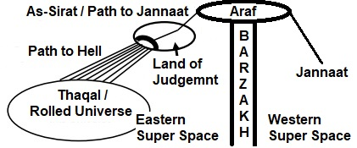

FIGURE 9.2: The Path (As-Sirat)

5. Step-2 of the First Blow

The Universe will be resurrected to the state of Thaqal (Heavy Mass) when the living creatures too will be resurrected.
Right after resurrection, Angel Israfil will start blowing the Soor—as he died in course of blowing. So, this blow can be considered as the continuation of the First blow. I call it “Step-2 of the First Blow”. All resurrected creatures will be fainted due to this blow.

“The Trumpet will be sounded (Step-2 of the First Blow), when all that are in the Skies and Lands will faint, except such as it will please God. Then will a Second One be sounded (the Second Blow) when, behold, they will be standing and looking on!” [Al Quran 39:68]

Above Verse is talking about two blows. Those are:
- Step-2 of the First Blow
- The Second Blow

5a. Step-2 of the First Blow

The Verse is talking about Skies and Lands (Universe in present form) while talking about the “Step-2 of the First Blow” because it is talking about all creatures that lived in previous cycle of the Universe (Skies and Lands), which includes the jinns and the universal angels too. They (angels and jinns) will be resurrected in the Thaqal on their points of death. Later they will be brought into the Land of Judgment.

“The angels and the ruhhs ascend unto him in a Day. The measure where of is fifty (thousand years).” [Al Quran70: 4]

The Blow (Step-1of the First Blow) began when the Skies and Lands existed. It is another cause of using “Skies and Lands” in this Verse.
Due to the tremendous Sound of Soor (Step-2 of the First Blow) the resurrected humans will be fainted. The matter of the Solar System will be ejected from the Thaqal. The piles of solar matter carrying fainted living creatures will be flowing through the Super Space like flying mountains—fly to the Junction Point will be the motto of the time. The flying piles of matter will join together and form the Land of Judgment in the junction point of As Sirat safely away from the main Thaqal.

“You see the mountains and think them firmly fixed, but they shall be moving as the clouds—the artistry of God who disposes of all things in perfect order; for He is well acquainted with all that ye do”
[Al Quran 27: 88]

Due to tremendous sound, the land of Final Judgment will be absolutely level and smooth. It will look like a white disc floating in the Super Space. According to the Hadith, if an egg is put in the center of the Land, it will be visible from the fringe.

“They ask thee concerning the mountains, say: “My Lord will uproot them and scatter them as dust. He will leave them as plains smooth and level. Nothing crooked or curved will thou see in their place.” [Al Quran 20: 105–107]

The atmosphere on the Land of Judgment will be clean. The atmospheric pressure will be within a bearable limit. The gravity on the Land of Judgment will be as such that people will be able to move comfortably. Even, there will be water in the Kawthar.

“To thee have We granted the Kawthar. Therefore, to thy Lord turn in prayer and sacrifice. For he who hates thee, He will be cut off” [Al Quran 108: 1–3]

The jinns and universal angels will be resurrected in their points of death. They will be moved to the Land of Judgment after its formation—they need not to move with solar matter, as they can fly. It will be difficult to bring some bad jinns, especially the Chief Satan (Iblis) who will be hiding deep into the Thaqal.

5b. The Second Blow of the Soor (Trumpet)

The blow that is called “Second One” is the “Second Blow”:

“The Trumpet will be sounded (Step-2 of the First Blow), when all that are in the Skies and Lands will faint, except such as it will please God. Then will a 'Second One' be sounded (the Second Blow) when, behold, they will be standing and looking on!” [Al Quran 39:68]

After the Land of Final Judgment will be prepared, Angel Israfil will blow the Soor for the second time, when everybody will regain his / her sense and stand on foot.
The time between two blows of Soor is forty. The time is supposed to be short.

Hadith: “Time between two blows of Soor is forty. Sahabah said, ‘Is it forty days?’ Prophet (pbuh) said, ‘I do not agree’. Sahabah again said, ‘Is it forty years?’ Prophet said, ‘I do not agree’. Sahabah again said, ‘Is it forty months?’ Prophet said, ‘I do not agree’.” [Bukhari]

The second blow will not be intense. After the second blow, the Final Judgment will begin.
The Day of Judgment will be equal to fifty thousand earthly years. It will start with the First Blow of Soor (Step-1) and end with the Salvation.

“The angels and the ruhhs ascend unto him in a Day. The measure where of is fifty (thousand years).” [Al Quran70: 4]

Though the Day will be fifty thousand earthly years long, it will be short to the Believers, because the Day includes a long period of time from the Step-1 of the First Blow to the Resurrection of Dead. Again, just after Resurrection, everybody will become unconscious due to the Step-2 of the First Blow. They will not feel the passing of time so far they will remain unconscious. People will become conscious with the Second Blow. Then within a short time, equivalent to the time between Zahr and Asr prayer, the Final Judgment will be carried out, and the Believers will move into As-Sirat.

Hadith: “To the Believers, the Day will be like the time between Zahr and Asar prayer.” [Tafsir-e-Mareful Quran]

6. Amal-Nama

The Amal-Nama is a book of record. One’s deeds are recorded in one’s Amal-Nama. Two angels, Keraman and Katebin, are invested for each individual to write.

“And certainly, We created man and We know what whispers to him (into) his soul (nafs), and We are nearer to him than jugular vein. When receives, the two receive; (one) on the right and (one) on the left, seated. Not he utters any word but with him an observer ready.”
[Al Quran 50: 16–18]

The Amal-Nama is preserved in Illiyin or Sijjin after the death of a person.
After the Resurrection, two angels will be appointed for each human being; one will drive the person to the Land of Judgment and beyond, and the other will bear the record of his deeds (Amal-Nama).

“And there will come forth every soul; with each will be an (angel) to drive and an (angel) to bear witness (Amal-Nama)”
[Al Quran 50:21]

Before the Judgment, a readable Amal-Nama will be given to a person in his left or right hand so that others can see it, and it can be used for the Judgment.
However, the Amal-Nama is not a complete record of one’s life. Many sins are not written in the Amal-Nama. After doing a sin, if a person does a good deed or repent, the sin may not be written.

7. Resurrection and Rebooting the Brain

The nafs (a composite soul) is the main soul of a person. A nafs is a combination of known and/or unknown force fields (elementary souls / ruhhs). It is given in the womb soon after the fertilization. A nafs grows and takes shape as the baby grows. A human body is like a mold and a nafs is like a cast. The nafs gets designed; it gets imprinted with all physical information of the person—it becomes a program of formation. A person can be recreated with his programmed nafs and a Set of DNA molecule (46) collected from the remains of his earthly body.

“What! When we die and become dust that is a return far! We already know how much of them the earth takes away; with Us is a Record Guarding”
[Al Quran 50: 3–4]

Above Verses talk about two things with which a human will be recreated. One is “something that the earth does not take away”, and another thing is the “record guarding”.
What is the thing that the earth does not take away? It is the DNA molecule. A DNA molecule survives in the nature for several hundred thousand years. A Set of DNA molecule (46) is enough to recreate a human. Some scientists think that one day they would be able to re-create dinosaurs with their DNAs still available in their fossilized eggs.
The DNA of each individual is preserved by Allah in the natural storage:

“It is He Who has produced you from a Soul Single; here is a place of dwelling and storage; We detail Our signs for people who understand.” [Al Quran 6:98]

However, only the genome cannot create a human; his soul (nafs) is necessary. A zygote put into a test tube in the most favorable condition does not form a perfect physique.
Allah shapes up a human body in the mother’s womb, because the nafs is raw at that stage; it cannot help the formation. But the nafs of a created human gets matured. It will assist the genome to form the body perfectly at the time of resurrection.
A human will be recreated with a Set of DNA Molecule (46) collected from his earthly body so that he cannot deny him to be the same person that committed the sins on the Earth.
On the Day of Resurrection, a Set of DNA Molecules (46) will be attached to his Nafs. The DNAs will form the cell, and the cell will multiply by absorbing suitable substances supplied in the surroundings. So, a human will grow like a plant.

“It is He Who sends the winds like heralds of glad tidings going before His mercy when they have carried the heavy-laden clouds. We drive them to a land that is dead; make rain to descend thereon and produce every kind of harvest therewith; thus We shall raise up the dead so that you may remember.” [Al Quran 7:57]

Otherwise, the cell of a plant, and the cell of an animal are similar. If a plant can grow on the earth, why an animal cannot? The job of 98% DNA is unknown and thought to be Junk DNA. Maybe, it has the ability to form a cell and resurrect the body.
Thus, a man will be re-created with his fingerprint intact.

Yes, We are able to put together in perfect order the very tips of his fingers.”
[Al Qur'an 75:4]

And the nafs of a human is a combined force field; it gets designed and programmed to form, sustain and resurrect a body. So, a resurrected human will never die, even in extreme fire.
However, the brain of a resurrected human will suffer memory loss because a nafs does not preserve the data of memory. So, to return the memory into the brain, the “Record” is needed:

“What! When we die and become dust that is a return far! We already know how much of them the earth takes away; With Us is a Record Guarding (his memory data)” [Al Quran 50: 3–4]

The “Record Guarding”, mentioned in above Verse, is not “Amal-Nama”. It is another record preserved in the Lawh-Mahfuz. The record includes complete brain data that is collected every night when a person sleeps. So, it does not miss anything.

“It is He who does take your ruhhs (souls) by night and has knowledge of all that you have done by day; by day does He raise you up again that a term appointed be fulfilled. In the end, unto Him will be your return. Then He will show you the truth of all that you did” [Al Quran 6:60]

The angels collect the brain data and deposit it in the Lawh-Mahfuz. It is a multidimensional video record of each day (sleep to sleep). Ironically, one’s own eyes, ears and brain act as CCTV to hang one on the Day of Judgment!
However, Allah often hides one’s sin. He is Merciful. Mainly, the data of Amal-Nama will be used for Judgment. Many sins are not written in the Amal-Nama.
The brain data will be used to return the memory of a resurrected person; it will not be exposed. Allah is great; He is honored; He protects one’s honor. Even on the Day of Judgment, a person will be called with his Mother’s Name.
However, the Lawh-Mahfuz is located in the Arsh, and on the Day of Judgment the Arsh will be near. The Book (Lawh-Mahfuz) will be opened for some great sinners.

“And the Book (Lawh-Mahfuz) will be placed, and thou will see the sinful in great terror because of what is therein. They will say, "Ah! Woe to us! What a Book is this! It leaves out nothing small or great but takes account thereof!" They will find all that they did placed before them, and not one will thy Lord treat with injustice.” [Al Quran 18:49]

A human will lose his sense just after resurrection when his brain data will be fed directly into his brain, like the feeding of data into a computer hard disc. When the person will regain his sense (with the Second Blow) he will know himself. He will remember everything of his earthly life.
People will regain their senses on the Land of Judgment with their full memories of the Earth. Initially, they will have earthly Faith in mind—some will be Hindus, some Muslims, some Buddhists, some Christians, and some will have Faith on other religions.
One will feel that one day one slept (died) on the Earth, and in the next day one is standing on the Land of Judgment.

8. Major Safayat

Many will recognize the Day of Final Judgment. The Land of Judgment will be hot; everybody will be sweating. Some will know that the Land of Judgment is a temporary entity; soon it will merge with the main Thaqal, as it (the main Thaqal) will restart evolving.
So, the people will start seeking for salvation from that place. They will go to Prophet Adam, Noah, Abraham, Musa and Isa one after another (still do not know, whom to go!). But, none will request Allah for the Judgment. Finally, people will come to Prophet Muhammad (pbuh). He will pray for the Judgment and Salvation.

9. Marshaling for the Judgment

Allah will accept the prayer for Judgment and Salvation. Then the marshaling will start. The angels will come and line-up. These are universal angels. They will come from the Thaqal, as they died in the Universe.
A Field Court will be established by placing a Balance.
Allah will appear for the Judgment when all will be ordered (most likely by a Mighty Angel) to prostrate before Him (Allah) as soon as His shin will be visible, but the Unbelievers will fail:

“The Day that the Shin shall be laid bare, and they shall be summoned to bow in adoration, but they shall not be able; their eyes will be cast down; ignominy will cover them seeing that they had been summoned aforetime to bow in adoration, while they were complete”
[Al Quran 68: 42–43]

The idolaters that were mounts of satan jinns will be resurrected in devil-human shape. They will not be complete. They will be recognizable by the marks only.
The mounting of a jinni deforms a nafs (soul). After death, the nafs gets hardened with devil-human program of creation. So, the person will resurrect in devil-human shape. He will be suitable to interact with the Jinns. He will not be able to prostrate himself before God.
Satan jinns cannot mount on the believers of one God (Mumins); they can whisper only. The angels guard the Believers:

“He is the Irresistible from above over His worshippers, and He sets guardians (angels) over you. At length, when death approaches one of you, Our angels take his soul (nafs), and they never fail in their duty.” [Al Quran 6:61]

“Say: I seek refuge with the Lord and Cherisher of Mankind, the King of Mankind, the God of Mankind from the mischief of the Whisperer, who withdraws, who whispers into the breasts of Mankind—among Jinns and among men." [Al Quran 114: 1-6]

The marshaling for Final Judgment is discussed below:

9a. The Jannaat will be brought Near

The Jannaat will be brought close to the Land of Judgment in an orderly fashion. The planets/objects of the Jannaat will not destroy each other by collision.

“When the sky is removed (closed into the Thaqal), when the Blazing Fire is kindled to fierce heat (the Thaqal igniting for the preparation of re-initiation) and when the Jannaat is brought near, each soul shall know what it has put forward.”
[Al Quran 81: 11-14]

The Jannaat will be brought near, but it will stay beyond the Veil (Barzakh).

“Between them shall be a Veil...”

[Al Quran 7:46]

The Barzakh will be thin at that time and look like a transparent veil. So, the objects of Jannaat will be visible from the Land of Judgment.

9b. The Hell will be brought Near

At the time of Judgment, the Objects of Hell will be in the Thaqal in a compact state. The angels will tie the Thaqal with the chains and will pull it near the Land of Judgment.
The un-rolling of the Thaqal will remain halted till the end of Judgment, but the contracted galaxies (the objects of Hell) in the Thaqal will be kindled to fierce heat. They will start producing fire.

“When the Sky is removed (collapsed into the Thaqal); When the Blazing Fire is kindled to fierce heat”
[Al Quran 81: 11-12]

The sparks produced in the Thaqal will fall into the Land of Judgment, and the fire will spread around the people. It will be felt that whole mankind is about to be grasped by the fire.

“Indeed, it throws about sparks as forts, as if there were yellow camels. Ah, woe that day to the rejecters of Truth!”
[Al Quran 77: 32–34]

Some of the living creatures of hell will also be thrown into the Land of Judgment. It is narrated in the Hadith that a big snake will be thrown. It will frighten the people.

9c. Araf and As-Sirat

“Araf” means “Elevated Land”. The Land is elevated above the Samawaat and the Jannaat.
The land is located in the high Barzakh, but its eastern part is in the Eastern Super Space, and western part is in the Western Super Space. One can move from one part to another part through As-Sirat.
The Sidratul-Muntaha hangs from the Arsh. It has two branches. One branch connects the East Araf, and another branch connects the West Araf (see Figure).

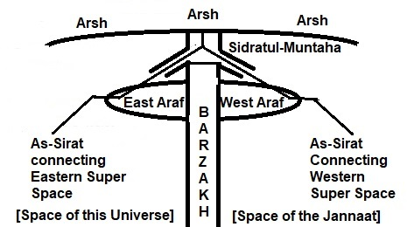

FIGURE 9.3: As-Sirat

The Sidratul-Muntaha checks the passage of everything instrumentally. Some of the people will be unsuitable for Jannaat in its calculation. So, it will halt them on the Araf. They will be taken to the Jannaat later.
According to the Hadith, As-Sirat will be comfortable and safe for some people, whereas it will be dark, narrow and rolling for some.
People will cross As-Sirat in different speeds. Some will cross it at the speed of light, and some will be slow. The last person that will cross As-Sirat successfully will require twenty-five thousand earthly years.
The people whose good deeds will be heavier than the sin will pass into the Jannaat.
The people, whose sin and good deeds would be equal, will be halted on the Araf by Sidratul-Muntaha. They will be taken into Jannaat later.

“Between them shall be a veil, and on the Araf will be men who would know everyone by his marks; they will call out to the Companions of the Jannaat, "Peace on you". They will not have entered, but they will have an assurance.”
[Al Quran 7:46]

Down from the Land of Judgment, As-Sirat is divided in Seven Tracts, connecting the unrolling Skies (halted Thaqal at that time).

“Again, on the Day of Judgment, will ye be raised up. And We have made above you Seven Tracts, and We are never unmindful of creation”
[Al Quran 23: 16–17]

The Tracks will have gates on the Land of Judgment. In front of the gates, there will be reception enclosures guarded by angels.
The sinners whose sin will be heavier than their good deeds will be driven into the enclosures after the Judgment.
Subsequently, the sinners will be driven into the Tracks that will guide them into the objects of hell (galaxies).
The sinners will be allowed to rest in the enclosures for sometimes when they will utterly repent.

9d. Overall Layout

Likely overall layout is shown in the figure below.

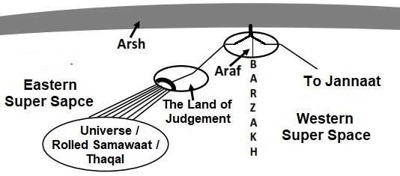

FIGURE 9.4: Relative Positions

10. The Judgment

On the Day of Judgment, Allah will be visible. People will see Him clearly.

“It is narrated by Abu Hurairah: Once a few people asked, ‘Oh Prophet (pbuh), will we see Allah on the Day of Judgment?’ To answer, Prophet (pbuh) said, ‘In a cloudless full moon night, do you find any obstruction to see the Moon?’ They said, ‘No, Oh Prophet (pbuh)’. Prophet (pbuh) again said, ‘In a cloudless clear sky do you find any obstruction to see the Sun?’ Everybody said, ‘No, Oh Prophet’. Then Prophet (pbuh) said, ‘On the day of Judgment, exactly in this way you will see Allah, without any obstruction” [Bukhari]

Allah will address all complaints; even an animal without horn will get opportunity to take revenge against an animal with horns.
All oppressors will be dealt severely:

“When the souls are sorted out; when the female buried alive is questioned: “For what crime she was killed?””
[Al Quran 81: 7–9]

Allah will select the people for Salvation with utmost Mercy and Forgiveness. A minute good deed will be taken into account and many major sins will be forgiven.

“And the Land will shine with the Glory of its Lord; the Record will be placed; the prophets and the witnesses will be brought forward; and a just decision pronounced between them—and they will not be wronged. And to every soul will be paid in full of its Deeds; and (God) knows best all that they do.”
[Al Quran 39: 69–70]

11. Moving to the Final Destinations

Each individual will start for his destination after the Judgment. Each will have a driving angel to drive him/her from the point of resurrection to the point of destination.

“And there will come forth every soul; with each will be an (angel) to drive and an (angel) to bear witness (Amal-Nama)”
[Al Quran 50:21]

Hadith: “On the day of Final Judgment, Allah will assemble whole mankind. Then Allah will say, ‘People will follow whom they worshipped; he must go with him’. Accordingly, those who used to worship the Sun, they will be compelled to follow the Sun; that means that they will be compelled to go there where the Sun will reach. Those who used to worship the Moon, they will be compelled to follow the Moon. Those who used to worship different idols, they will be compelled to follow the idols; that means that they will be compelled to go there where the idols will reach.” [Bukhari]

“The Unbelievers will be led to Hell in crowd until when they arrive there. Its gates will be opened. And its keepers will say, "Did not apostles come to you from among yourselves rehearsing to you the Verses of your Lord and warning you of the meeting of this Day of yours?" The answer will be: "True, but the Decree of Punishment has been proved true against the Unbelievers!" Will be said: "Enter ye the gates of Hell to dwell therein, and evil is Abode of the Arrogant!"”
[Al Quran 39: 71–72]

To receive the residents of hell, the channels (Seven Tracts) connecting the Thaqal will have reception enclosures on the Land of Judgment. The angels will guard the gates of the enclosures. The channels will lead one into the Thaqal that will ultimately unfold the objects of hell (galaxies).
The Universe (Thaqal) will not be satisfied with small number of people; it will be asking for more. Three times humans will be thrown into the Thaqal (Universe), yet it will not be satisfied. To satisfy it, Allah will put His leg into the Universe. Then it will be satisfied and “its one part will be squeezed with another part”; it means that the universe will be closed within itself.

“After the Judgment, a group of people will be thrown into the hell (Samawaat / this Universe), and the hell will be asked, ‘Is she satisfied?’ The hell will say, ‘Are there any more?’ Then another group will be thrown into the hell, and the hell will be asked, ‘Is it enough?’ The hell will say, ‘Are there any more?’ Then another group will be thrown into the hell, and the hell will be asked, ‘Is it enough?’ The hell will say, ‘Are there any more?’ Then Allah will put His leg into the hell. Then the hell will be satisfied and say, ‘enough, enough, enough’ and its one part will be squeezed with another part” [Tirmizi]

After People will set out for their destinations, the Land of Judgment will be thrown into the Thaqal that will then be reviving violently to flare up the Skies harboring the Objects of Hell (galaxies).

Hadith: “On the Day of Final Judgment, the Sun and the Moon will be thrown into the hell” [Mashnad-i-Ahmed]

The Land of Final Judgment will be created with the matter of Solar System. So, “the Sun and the Moon will be thrown into the hell” means that the Land of Judgment will be thrown into the hell. It will be thrown into the Samawaat reviving from the state of Thaqal.
The matter of the Solar System (except the Earth) will rejoin the Milky Way galaxy (an object of hell), as the Thaqal will unfold.

Each human will reach his destination determined, as each will be attached to a driving angel from the time of Resurrection.

“And those who feared their Lord will be led to the Jannaat in crowds until, behold, they arrive there. Its gates will be opened, and its keepers will say: "Peace be upon you! Well have ye done! Enter ye here to dwell therein." They will say: "Praise be to God Who has truly fulfilled His Promise to us and has given us lands in heritage; we can dwell in the Jannaat as we will—how excellent a reward for those who work. And thou will see the angels, surrounding the Arsh on all sides, singing Glory and Praise to their Lord. The Decision between them will be in justice and the cry will be, "Praise be to God, the Lord of the Universes!"
[Al Quran 39: 73–75]

After the Judgment, a person awarded Jannaat will be given a light because the Path (As-Sirat) leading to Jannaat is dark.

“One Day shall thou see the believing men and the believing women, how their Lights run forward before them and by their right hands. Good News for you this Day, Jannaat, beneath which flow rivers, to dwell therein for aye!”
[Al Quran 57:12]

Peaceful planets of Jannaat will be distributed among them. Each individual may become owner of one, two, or more number of planets. They will get such power that their verbal orders will be materialized instantly. They will get an endless life of honor, pride and joy.

12. New / Re-created Universe

The following Hadith indicates that when people will be moving through As-Sirat, the creation of New Universe will begin.

Hazrat Aisha (R) narrated, I said, ‘Oh Messenger of Allah, the day when the Land (Thaqal) will be changed where the people will stay?’ Prophet (pbuh) said, ‘Oh Aisha, you have asked me about a great event; none before you asked me this question; on that day, people will be in As-Sirat’.” [Hadith]

The above Hadith is related to the Day of Judgment. Therefore, in this Hadith, the word “Land” means the “Thaqal”. The Thaqal will restart unrolling when the people of Jannaat will be moving through As-Sirat and the people of hell will be moving to hell through the Seven Tracts. The unrolling Thaqal will engulf the Land of Final Judgment.
In scientific understanding, this universe came into existence from the Big Bang. It will collapse. From the collapsed universe, a new universe will be born.

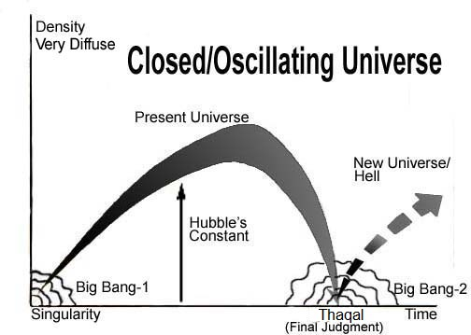

FIGURE 9.5: New Universe/Hell

“But it is also possible that expansion will be reversed by the pull of gravity, that all matter will collapse once again into a super-dense ‘singularity’ and that another universe will be born in another Big Bang a cycle that could be repeated forever”.
– To the Edge of Eternity by John Gribbin in the Encyclopedia of Space Travel and Astronomy, edited by John Man.

13. Destination

From the Land of Judgment, a sinner will move to his destination like a flying Superman.

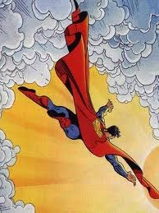

FIGURE 9.6: Dragged on Face

“The day they will be dragged through the fire on their faces, “Taste ye the touch of hell …” [Al Quran 54: 48–50]

They will move through the Seven Tracts. The Tracks will ultimately connect the Skies (Samawaat). The guiding angels will lead them to their galaxies released from the Thaqal.
Finally, each human will fall into the galaxy determined for him on the Day of Deen (Law). That is his final destination—an immortal human left alone forever in a giant object of this Universe (Samawaat).
Though the speed of change will be like an explosion in our view, each will reach his destination determined—nothing ever goes beyond the control of Allah.

“The day they will be dragged through the fire on their faces, “Taste ye the touch of hell!” Verily, all things have We created in proportion and measure. And Our command is but a single like the twinkle of an eye”” [Al Quran 54: 48–50]

When the Land (Thaqal) will be changed, the people of hell will be under the influence of the black holes. The black holes are the points of absolute darkness.

Hadith: “A Jew came to Prophet (pbuh) and asked, ‘On the Day when the Land will be changed, where the people will stay?’ He (pbuh) said, ‘Inside a darkness near As-Sirat’.” [Muslim]

[Above Hadith does not mean that all Jews will go to hell. Prophet (pbuh) was angry on the Jews of Madinah—their opposition made the preaching of Islam difficult and the lives of Muslims risky in cases. So, he (pbuh) just expressed the other side of the story. However, my explanation may be wrong—better be a Muslim]
If a sinner is lucky, he may ultimately find a planet in his galaxy, but the formation of planets will take time. In the initial days, he will be held by the super-massive black hole of his galaxy directly.

“But he whose balance will be light, their mother will be endless-hole (super-massive black hole). And what will explain to thee what this is—a fire blazing fiercely.” [Al Quran 101: 6–11]

The ‘endless hole blazing with fierce fire’ is nothing but a super-massive black hole / quasar—mother of a sinner. Those will be released from the un-rolling Thaqal with adequate forces and energies to produce the objects in course of time. Eventually, the galaxies will revive.
A man will be given a galaxy according to his deeds:

“We created not the Skies and Lands and all between them (this Universe) merely in sport. We created them not except for just ends. But most of them do not understand. Verily, the day of sorting out is the time appointed for all of them.”
[Al Quran 44: 38–40]

“Allah created the Skies and Lands (this Universe) for just ends, and in order that each soul may find the recompense of what it has earned and none of them be wronged.” [Al Quran 54: 22]

“Behold in the creation of the Skies and Lands (this Universe) and the alternation of night and day; there are indeed signs for men of understanding. Men who celebrate the praises of Allah standing, sitting, and lying on their sides and think on the creation in the Skies and Lands: “Our Lord, not for naught hast Thou created this! Glory to Thee! Give us salvation from the penalty of the fire. Our Lord, any whom thou dost admit to the fire, truly, Thou cover with shame, and never will wrong doers find any helpers”!” [Al Quran 3: 190–792]

Eventually, each person in hell (Samawaat / re-created Universe) will own a galaxy. In a galaxy, the more is the distance from the central super-massive black hole, the less is the hostility of nature. A galaxy is divided in seven regions according to the level of hostility. Each region has an entry point (door).
Each galaxy has seven entry points (doors). But it does not mean that there will be more than one person in a galaxy—one person will own one galaxy; he will have no companion except the Jinns.

“…And your abode is the fire, and no helpers have ye!” [Al Quran 54: 34]

“…I will fill Hell with jinns and men all together” [Al Quran 11:119]

“…I will fill Hell with jinns and men all together” [Al Quran 32:13]

There are about 170 billion large galaxies in the visible universe. Therefore, a large part of the Universe will remain vacant. Allah will put His leg into the Universe. So, the Universe will be filled up and satisfied.

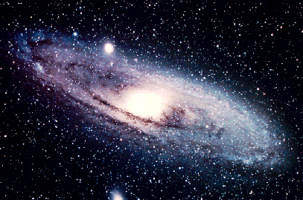

FIGURE 9.7: A Galaxy (Andromeda)

The sinners will be forgotten, as they forgot Allah in the life of the Earth.

“It will also be said: “This day We will forget you, as ye forgot the meeting of this day of yours! And your abode is the fire, and no helpers have ye!”
[Al Quran 54:34]

The hell-dwellers will be robust and strong. The body of a hell-dweller will be compatible to the object (an object of his galaxy) where he will live.

Hadith: Abu Hurairah narrated that Prophet (pbuh) said, “Distance between two shoulders of a Kafir will be three-day journey distance of a fast-moving horse.”
[Bukhari]

Three-day journey distance of a fast-moving horse should be 90 kilometers at least. In normal ratio, the person should be 300 kilometers tall. Such a huge person should melt due to his inner body heat, but he will not melt, as his flesh and bones will be different, and his nafs will be matured.
The nafs (soul) of a hell dweller will be so strong and dynamic that he will never be destroyed or die (except in the process of salvation in cases; it is discussed subsequently). However, their skins will be burned. And the burned skins will be changed. The process of resurrection by DNA and Nafs will remain effective forever (by the design and will of Allah).
One’s strong nafs will be able to keep one’s body functional whatever may be atmospheric pressure. On the Earth, one inhales oxygen to produce heat in one’s body. In the hell, the external heat may keep one active.
However, people in the extreme punishment will be in between life and death.

“Who will enter the great fire, in which they will then neither die, nor live.”
[Al Quran 87: 12–13]

Note:

I have often mentioned this Universe (Samawaat) as hell. Actually, whole Universe is not hell. There are objects in this Universe, which will be given to good jinns as rewards. And there are Exalted Assemblies of the universal angels. To a human only, an object of this Universe (Samawaat) is hell.

14. Re-created Universe in Holy Bible

The Holy Bible also gives the idea of re-created universe as hell, and the events are described in the same sequence.

14a. Revelation 6

The Revelation 6 narrates the formation of Thaqals:

“And I saw the lamb break open the sixth seal…The stars fell down to the earth (main Thaqal), like unripe figs falling from the tree when a strong wind shakes it. The sky disappeared like a scroll being rolled up, and every mountain and island was moved from its place (to form the Land of Judgment)”
– Revelation 6 (12–14) Holy Bible, GNB

A giant star cannot fall on our Earth; rather than our Earth can fall on a star. So, the Verses are not talking about our Earth. The Verses are talking about the collapse of the universe. The stars will fall into the center of the Universe. They will join with each other and form a huge object that is called earth in above Verses. So, the earth of above Verses is the main Thaqal.
The above Verses say that every mountain and island will be moved from its place. The matter of the Solar System will be moved away from the main Thaqal. The solar-matter will move through super-space like floating mountains and islands to form the Land of Judgment safely away from the main Thaqal.
[The Book (Revelation) came as vision that Prophet expressed in his own language. So the description is like this. The Verses of the Quran came as brain-data (ruhhs), and the Torah came as written Book]

14b. Revelation 7

The Revelation 7 talks about the Salvation of some people to the paradise (Jannaat).

“After this, I saw four angels standing at the four corners of the earth (the Land of Judgment)…After this, I looked, and there was an enormous crowd…Never again will they hunger or thirst; neither sun nor any scorching heat will burn them...And God will wipe away every tear from their eyes.”
– Revelation 7, Holy Bible, GNB

14c. Revelation 8

The Revelation 8 talks about the transformation of the Thaqal into the hell (re-created Universe).

“Another angel who had a gold incense burner came and stood at the altar...Then the angel took the incense burner, filled it with fire from the altar, and threw it on the earth (Land of Judgment). There were rumbling and peals of thunder, flashes, and lightning; and an earth quake.”
– Revelation 8 (3–5), Holy Bible, GNB

After the Salvation of good people, the Land of Judgment (satellite Thaqal) will be thrown into the main Thaqal, when the main Thaqal will be un-rolling violently.
Eventually, the reviving Universe will regain its matured shape with the sinners scattered in the galaxies as its permanent residents.
In subsequent Verses of Revelation 8 and 9, we get description of blowing seven trumpets. The events of seven trumpets are the events of the recreated Universe (hell).

14d. Revelation 8

Holy Bible at this stage talks about the death of some people.

“Then the third angel blew his trumpet. A large star burning like a torch dropped from the sky and fell on a third of the rivers and the springs of water. A third of the water turned bitter, and many people died from drinking the water because, it had turned bitter.”
– Revelation 8 (10–11), Holy Bible, GNB

The Verses are talking about a time when the Universe has been re-created. There will be rivers and springs of boiling water in the planets of recreated universe (hell). Good sinners, who will have marks of God’s seal, will die in the recreated universe (hell) after they are punished for their sins. Then, they will be resurrected in proper form and will be taken to the Jannaat.
The Hadith does not talk about the Second Death, because sinful Muslims going to hell will have different way of Salvation.
However, the Hadith says that a time will come when “death” will be slaughtered in the space between Samawaat and Jannaat (in the Barzakh) and nobody will die after that.
So, the Salvation through Second Death will end.
Only the great sinners will never die and will remain in the hell (Samawaat) forever.

14e. Revelation 9

Often the planets of the sinners will face disaster. Bad things will be poured into their planets from the sky. The disasters will be so violent that the suns and the moons of their planets will be struck. Alien creatures looking like locusts with faces like human faces will attack them.

“Then the fifth angel blew his trumpet. I saw a star, which had fallen down to the earth, and it was given the key to the abyss. The star opened the abyss, and smoke poured out of it, like the smoke from a large furnace; the sunlight and the air were darkened by the smoke from the abyss. Locusts came down out of the smoke upon the earth, and they were given the same kind of power that scorpions have”
– Revelation 9 (1 –3), Holy Bible, GNB

14f. Revelation 9

The great sinners will never die. They will remain in this Universe (hell) forever.

“The rest of the humanity, all those who had not been killed by these plagues, did not turn away from what they themselves had made. They did not stop worshipping demons, nor the idols of gold, silver, bronze, stones, and wood, which cannot see, hear, or walk. Nor did they repent of their murders, their magic, their sexual immorality, or their stealing”
– Revelation 9 (20–21), Holy Bible, GNB.

Nothing is meaningless. A man does not think without the will of Allah. A child watching “Star Trek” or “Battle Star Galactica” may not be just fun; maybe it is a lesson for the next life. Huge budget is expended for the space programs, but nobody complains, because in the depth of our hearts we know that for many of us the Space is the Final Frontier.

14g. Different Understanding

Christians do not explain above Verses of Holy Bible in this line, because their knowledge of religion is little different, as they have not accepted the Last Prophet (pbuh). They do not have clear idea about Judgment, Hell and Paradise. They believe that when Jesus will return (Second Coming) Jerusalem will become a bigger Jerusalem, where they will be resurrected and live forever like their Holy Fathers.
However, some people (related to Jesus Christ) will be resurrected when Jesus will return, but it is not General Resurrection for the Final Judgment. The General Resurrection will occur beyond this cycle of the Universe.

15. Conclusion

To conclude, I want to elaborate two points as under.

15a. Humans as Vicegerents of God

Humans are Vicegerents of Allah. But, they are under test and development on the Earth. Here, they are not empowered Vicegerents. After the Final Judgment, they will achieve their domains in the Samawaat or in the Jannaat. The people of Jannaat will be powerful. Their verbal orders will be materialized instantly. The animals will obey their commands. If a person orders his river to shift, it will shift then and there, because he is a Vicegerent of God.
People of the Samawaat (Universe) will not have any divine power. However, they will be given robust bodies, fit to survive. According to Hadith, if a person from the hell is put into the fire of the Earth, he will fall asleep due to excessive comfort. They will be in pain due to the extreme nature of their objects. But, Allah knows the future. A time may come when a man in the Samawaat would gain reasonable control over his galaxy through physical means using scientific knowledge, as we have gained on the Earth.

“And He has subjected to you, as from Him, all that is in the Skies and Lands (this Universe), behold, in that are signs indeed for those who reflect.”
[Al Quran 45: 13]

“Do ye not see that Allah has subjected to your control all things in the Skies and Lands (this Universe) and has made His bounties flow to you in full, seen and unseen. Yet there are among men those who dispute about Allah without knowledge, and without guidance, and without a book to enlighten them!”
[Al Quran 31:20]

The people will be in vigorous torments in the hell. There will be poisonous snakes and insects as well as vigorous fire all around. Their food will be the fruits of Zukkum. Their development will be very slow. But a human is not a creature to sit idle and get punishment forever. He is created as the Asraful Makhlukat (best of creatures). He is a Vicegerent of Allah. A day may come when he would rule his galaxy with dignity and might.

“Prophet (pbuh) said, ‘There is a place in the hell named, hub-hub, where the mighty hell dwellers will live’” [Hadith]

So, there will be mighty people in the hell.
A person in hell will live in a planet of his galaxy, as it is indicated in the following Hadith.

Hadith: “On the Day of Final Judgment, the Earth will urge to Allah saying, ‘Oh Allah, put me in one of your servant’s hand who might be the worst among all.’ Answer will come from Allah, ‘You don’t talk; I never liked that any of them should earn you; will I like it today? Never!’”
[Kimia-i-Shahadat]

The Planet Earth will not be given to anybody. On the Day of Judgment, the Planet Earth will be transformed into bread and will be eaten by the people determined for the Jannaat.

Hadith: “On the Day of Final Judgment, the land of the Earth will be like bread. Mighty Allah will rotate it with His power—the way one rotates one’s bread on the mat of food. It will be food of gesture for the people of Jannaat.”
[Bukhari]

On the Land of Final Judgment, the sinners will see that the Earth is eaten up. So, in the re-created Universe (Samawaat), a person will not spoil time by searching the Earth, even if he could make a space ship (it would always be difficult for a human to forget the memories of the Earth).
However, the Earth will declare its tidings before becoming bread, as the following Verses say:

“When the earth is shaken to her convulsion,
And the earth throws up her burdens,
And man cries: 'What is the matter with her?'
On that Day will she declare her tidings; for that thy Lord will have given her inspiration.
On that Day will men proceed in companies sorted out, to be shown the deeds that they (had done).
Then shall anyone who has done an atom's weight of good, see it!
And anyone who has done an atom's weight of evil, shall see it.”
[Al Quran 99]

Initially, the matter of the Earth will be falling on the Land of Judgment. It (the Earth) will behave like a readable CD, as the above Verses say: On that Day will she declare her tidings: for that thy Lord will have given her inspiration.
There will be no way to hide a truth. The space containing the energies bears the record of everything; it is like a written scroll. So, when Allah will inspire, the Earth will declare its tidings. If one committed a crime, the related stripe of space will reveal when and how one committed.
After the Judgment, Allah will rotate the Earth with His Power. He will transform the Earth into eatable bread, as the Hadith says: “It will be food of gesture for the people of Jannaat.”

15b. Control of Fire

Though humans are Vicegerents of God, the angels will remain in control of the fire.

“Soon will I cast him into hell-fire! And what will explain to thee what hell-fire is? Naught doth it permits to endure, and naught doth it leaves alone! Darkening and changing the color of man! Over it are Nineteen. And We have set none but angels as guardians of the fire”
[Al Quran 74:26-31]

The fire around the super-massive black hole of a galaxy will remain under control of the angels. A human of a galaxy (a forgotten Vicegerent of God) will never gain control over it.
However, a time will come when humans will start gaining control over other things, and the Jinns will be their intimate associates:

“If then they have patience, the Fire will be a home for them! And if they beg to be received into favor, into favor will they not be received. And We have destined for them intimate companions who made alluring to them what was before them and behind them, and the sentence among the previous generations of jinns and men who have passed away is proved against them; for they are utterly lost.”
[Al Quran 41: 24-25]

15c. Form the hell to the Jannaat

Many humans will be forgiven during the Judgment. In later times also, many will be salvaged from the hell.

15c-I. Salvation through Second Death

Some people will be salvaged from hell through the Second Death:

“They will say: "Our Lord! Twice has Thou made us without life, and twice has Thou given us Life! Now have we recognized our sins; is there any way out? This is because, when God was invoked as the Only, ye did reject Faith, but when partners were joined to Him (in form of Trinity) ye believed! The Command is with God, Most High, Most Great!"
[Al Quran 40: 11-12]

“He looked down (from the Jannaat) and saw him in the midst of the Fire. He said: "By God! Thou were little short of bringing me to perdition! Had it not been for the Grace of my Lord, I should certainly have been among those brought (there)! Is it that we shall not die, except our First Death, and that we shall not be punished?” Verily, this is the supreme achievement! [Al Quran 37: 55-60]

Their nafses will be corrected with intense fire. So, after the Second Death, they will resurrect in proper form. A nafs is a combination of force fields; it needs immense heat for alteration. They joined Partners with God, so satan jinns mounted on them; a mounted jinn deforms one’s nafs.
An idolater (that joins partner with God) is supposed to live in the hell forever. Actually, these are Christians who believed in one God but at the same time believed in Trinity, as the above Verses say: “This is because, when God was invoked as the Only, ye did reject Faith, but when partners were joined to Him ye believed!”
Initially, God was preached in Rome as the Only God when the response was less, but after about a few hundred years when Jesus was declared as the Son of God many believed. Subsequently, the concept of Trinity developed.

15c-II. Salvation of Sinful Muslims

The Hadith does not talk about the Second Death because sinful Muslims will have different way of Salvation from hell:
After a time will pass, Muhammad (pbuh) will remember his sinful followers living in the hell. He will pray to Allah, and Allah will allow him to bring them out. Prophet Muhammad (pbuh) has means to visit the Samawaat (Burak and Raf Raf). He will personally salvage his followers who will have marks of Udhu.
They will not need Second Death, because they did not join Partner with God. So, the satan jinns could not mount on them, and their nafses were not deformed; they went to the hell for committing great crimes, such as murder, adultery, etc.

15c-III. Eternal Hell

A time will come when “death” will be slaughtered in the Barzakh. Thereafter nobody will be rescued. The great sinners will remain in the hell forever.

“They will dwell therein for all the time that the ‘Skies and Lands’ endures, except as thy Lord wills; for thy Lord is the accomplisher of what He plans.”
[Al Quran 7: 40]

However, the above Verse includes words “…except as thy Lord wills...” which indicates that scope of rescue will never end.

“To those who reject Our signs and treat them with arrogance, no opening will be there of the gates of the Skies (this Universe), nor will they enter the Jannaat, until the camel can pass through the eye of the needle; for those in sin”
[Al Quran 7: 40]

The ‘passing of a camel through the eye of a needle’ is a parable. It looks like passing of matter through a black hole. The black holes suck matter from its surrounding space. A super-massive black hole will need billions of years to devour all the matter of a galaxy. It is like the passing of a camel through the eye of a needle.
Therefore, when a galaxy will be devoured by its black holes, the person who was destined to live in the galaxy may be corrected and brought into the Jannaat.

15d. Animals

All creatures will be resurrected. There is no death after resurrection (except for Salvation in cases).
The Hadith says that the animals will be merged with the earth after the Final Judgment. It means that they will be left free in the Thaqal. Subsequently, the animals will be scattered in the galaxies. They will be robust, and they will not be in pain.

16. Summary

The Universe (Samawaat) will collapse and revive. The Resurrection of the Dead will occur in the reviving initial Universe. The Final Judgment will be carried out in a specially created land. After the Judgment, good people will be shifted to another universe named Jannaat.
The sinners will be scattered in the galaxies of the re-created universe. Those galaxies are the objects of Hell.

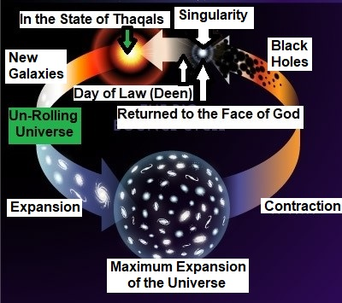

FIGURE 9.8: The Un-Rolling Universe

A huge object of the Jannaat or a complete galaxy of the Samawaat will be given to an individual. He will live there forever as a rewarded / forgotten Vicegerent of Allah.

“Soon shall We settle your affairs, O both ye Thaqalani (Two Heavy Masses). Then which of the favors of your Lord ye deny?
O ye assemble of jinns and men! If it be ye can pass beyond the zones of the Skies and Lands (this Universe), pass ye! Not without authority shall ye be able to pass! Then which of the favors of your Lord will ye deny?
On you will be sent a flame of fire and a smoke; no defense will ye have. Then which of the favors of your Lord will ye deny?
When the Sky (Collapsed Universe / Thaqal) is split (into two Thaqals), and it (main Thaqal) becomes red like red hide. Then which of the favors of your Lord will ye deny?
On the day, no question will be asked of man or jinn as to his sin. Then which of the favors of your Lord will ye deny?
The sinners will be known by their marks, and they will be scired by their forelocks and their feet. Then which of the favors of your Lord will ye deny?

This is the hell which the sinners deny.”
[Al Quran 55: 32-43]

The End

